REFIR

User manual

v.19.0

15/02/2019

**REFIR 19.0**

Software package

Copyright (C) 2019 Tobias Dürig, Fabio Dioguardi

===========================

REFIR 19.0 contains the following programs:

- FIX.py (version 19.0)

- FOXI.py (version 19.0)

- refir_config/FoxSet.py (version 19.0)

- FoxScreen.py (version 19.0)

- REFIR.py (version 1.0)

- radar_converter.py (version 1.0)

- weather/calc_wt_par.py (version 1.0)

- weather/read.py (version 1.0)

- weather/retrieve_data.py (version 1.0)

These programs are free software: you can redistribute them and/or modify them under the terms of the GNU General Public License as published by the Free Software Foundation, either version 3 of the License, or (at your option) any later version.

This software package is distributed in the hope that it will be useful, but WITHOUT ANY WARRANTY; without even the implied warranty of MERCHANTABILITY or FITNESS FOR A PARTICULAR PURPOSE. See the GNU General Public License for more details.

You should have received a copy of the GNU General Public License along with REFIR. If not, see <https://www.gnu.org/licenses/>.

If you wish to contribute to the development of REFIR or to reports bugs or other problems with the software, please contact [tobias.durig@otago.ac.nz](mailto:tobias.durig@otago.ac.nz) or [fabiod@bgs.ac.uk](mailto:fabiod@bgs.ac.uk).

**Contents**

1 REFIR: Introduction and spectrum of tasks 5

1.1 New functionalities included in version 19 5

2 General Description of the multi-parameter system REFIR 7

2.1 Overview 7

2.2 System requirements 8

2.3 Main Components of REFIR and Intercommunication Structure 9

2.4 Overview of Input Files (Example: setup for Iceland) 11

2.5 Overview of FOXI Output Files 13

3 How to set up REFIR 15

3.1 General remarks 15

3.2 Installation 15

3.2.1 Option 1 –manually creating the “.ini” files by using a text editor 16

3.2.2 Option 2 – Using FoxSet.py to generate the “.ini” files semi-automatically. 20

3.3 How apply changes or modifications to an existing setup 22

3.3.1 Use case 1: Adding a new sensor to the REFIR system 22

3.3.2 Use case 2: Adding a new volcano to the REFIR system 23

3.3.3 Use case 3: Changed location of one of the sensors 23

4 FIX 24

4.1 Initialization –Selection of the operation mode 24

4.1.1 Reanalysis mode 24

4.2 Selection of Eruption Site 25

4.3 The Operation Control Board 25

4.4 “Set Model Parameters” 27

4.4.1 Automatically-retrieved weather data 29

4.5 “Plume Height Sensors” 32

4.5.1 Controlling the plume height data channels 33

4.5.2 Overview panel for sensor status and ash plume detectability 34

4.6 “Calibration” 36

4.7 “Analysis Mode” 37

4.8 “Set Time Base” 37

4.9 “Add Plume Heights” 39

4.10 “Conv MER Models” 41

4.11 “Exp. MER Systems” 43

4.12 “FMER” 44

4.13 “Add MER Estimate” 45

4.14 “Output Control” and REFIR maps 46

5 Functionality of FOXI 49

5.1 Step 1: Initializing the Program 49

5.2 Step 2: Loading the Configuration Settings 50

5.3 Step 3: Retrieving and Copying Files from Auto-Stream servers 50

5.4 Step 4: Retrieve, Sort and Store Plume Height Data 51

5.4.1 Plume Height Data from Non-automatic Stream Sources 51

5.4.2 Plume Height Data from Automatic Stream Sources 53

5.4.3 Format of plume height data from radar and cameras 54

5.4.4 The Output Files *\*_plh_log_tmp.txt* and *\*_plh_log.txt* 56

5.5 Step 5: Constraining the Current Plume Height 57

5.5.1 Plume Height Constraining Procedures 57

5.5.2 The Files *\*_hbe_15.txt,* *\*_hbe_30.txt, *_hbe_60.txt, *_hbe_180.txt* and *\*_QUO_LOG.txt* 59

5.5.3 The Output File “*Foxi_hbe.txt*” 61

5.5.4 The “Auto30” Setting 61

5.6 Step 6: Computing Interim Mass Flux (RMER) 61

5.6.1 FOXI-Internal Plume Models 61

5.6.2 Situational Accuracy of Models 63

5.6.3 Statistical Characterization of Model Outputs - Computing RMER 64

5.6.4 The Analysis Mode 65

5.7 Step 7: Compute MER Based on All Conventional Models 66

5.8 Step 8: Compute FMER by Including Experimental Sensors 67

5.8.1 Processing Data from Experimental MER Sensors 67

5.8.2 Importing Manually Added MER Estimates 68

5.8.3 Computing the FMER 68

5.8.4 Saving Results to *\*_mer_LOG.txt* and *\*_mer_NOW.txt* 69

5.8.5 The output files “*_FMER.txt*” and “*_PLH.txt*”. 70

5.8.6 Other optional output files. 70

5.9 Step 9: Compute Total Mass Erupted 72

5.10 Step 10: Outputs - Plots and Results 72

5.10.1 The “*.log*” file 73

5.10.2 The Status Report 73

5.10.3 Plume Height Plots 75

5.10.4 Plots showing Source Stats 77

5.10.5 Mass Eruption Rate Plots 79

5.10.6 Total Erupted Mass Plots 82

5.10.7 The status records 84

5.11 Resting and Closing the Loop 86

6 FoxScreen 87

7 References 89

Appendix A: List of Parameters in fix_config.txt 91

Appendix B: Data Flow Chart of FOXI 94

Appendix C: REFIR – Setup for Iceland 95

Appendix D: Automatic plume tracking web-cameras at Hekla 97

Appendix E: Suggested settings for weight factors (FutureVolc setup) 98

Appendix F: List of entries in a *_mer_LOG.txt 99

Appendix G: Example for a Status Report 101

Appendix H: Notation 102

# REFIR: Introduction and spectrum of tasks

Volcanic ash injected into the atmosphere poses a serious threat to aviation. Forecasting the concentration of ash requires detailed knowledge of parameters that describe conditions at the volcanic source, referred to here as the eruption source parameters. Of particular importance is the rate at which material is delivered from the volcano, known as the mass flux or the “mass eruption rate” (MER). However, monitoring an ongoing eruption and quantifying MER in real-time is a considerable challenge. Due to the large uncertainties affecting the current state-of-the-art models that predict MER (e.g. *Dürig et al., 2015*; *Woodhouse et al. 2015*; *Devenish 2016*), efforts are being made towards the development of integrated approaches in order to reduce these uncertainties. The accuracy of MER estimates can, for example, be improved by linking satellite based automatic ash plume analysis methods (e.g. *Gouhier et al*., 2012, 2015; *Pouget et al.*, 2016) with ground based plume tracking methods (see e.g. VOLDORAD 2B, a Doppler radar integrated into the Etna monitoring system, *Donnadieu et al*., 2016).

Within the FutureVolc project, a FP7 Supersite project funded by the European Commission [futurevolc.hi.is], a quasi-autonomous real-time multi-parameter system, called REFIR (**R**eal-time **E**ruption source parameters **F**utureVolc **I**nformation and **R**econnaissance system), has been developed, by following the strategy of integrating a wide-ranging set of sensors capable of providing information on the eruption source. The system is tailored for the current and near-future demands in Iceland. However, this system can, in principle, be implemented at any observatory that receives information useful for MER estimates.

The system has been developed to process streaming data from a suite of sensors, including C- and X-band radars, web-cam based plume height tracking systems, imaging ultra-violet and infrared cameras and electric field sensors. A best estimate of source parameters, including the mass eruption rate, is provided in near real-time (within a time interval of 5 minutes) as soon as an eruption has started, based on selected models that relate the plume height to MER that also consider the current wind and other local atmospheric conditions.

Since neither the time nor the location of the next Icelandic eruption is known, the system has been developed under the guideline of maximum flexibility and it can easily be implemented elsewhere, needing minimum adaptation to local conditions. Furthermore, REFIR is designed to be easily upgraded, allowing future extensions of the existing monitoring network to be incorporating into this system, and refinements to be made from future experience, new technologies and model improvements. During eruptions MER estimates from REFIR will be publically available at an open webpage.

It is expected that REFIR will be updated as needed to incorporate data from new sensors, further developments in models and advances in the processing and merging of multi-disciplinary data.

## New functionalities included in version 19

In v19.0, new functionalities have been implemented. These will be detailed in the next paragraphs and are briefly anticipated here:

* **Reanalysis mode.** This mode allows the user to analyse datasets of plume height data from different sensors during past eruptions as well as simulated data sets. This is designed for research purposes, e.g. for calculating time-dependent MER estimates of past eruptions, testing plume models and their implementation, etc.
* **Automatic weather data retrieval.** Weather data needed for running REFIR calculations of MER (e.g. atmospheric temperature at the source, buoyancy frequency, wind speed) can now be retrieved from different sources, which depend on the REFIR usage mode (real-time or reanalysis) and, for reanalysis mode, on their availability. This mode is strongly recommended since it gives the opportunity to use realistic weather conditions and hence to reduce one of the sources of uncertainty. The user can still choose to manually specify weather data. This option, which was the default one in v18.1, has been left since it can be useful for testing the influence of weather conditions on MER estimates.
* **New plume model**. The simplified wind-affected model of Woodhouse et al. (2013) has been implemented and it is now used for calculating MER.
* **Unified codes for volcanoes**. The Smithsonian Institute (SI) database volcano code is now used as unique identifier of the volcano. When specifying the new volcano, the user is asked to write the SI code, and refir_config.py will extract data like location and vent height from the database SI_volcanoes_list.xlsx, which is provided in the folder “refig_config”.
* **radar_converter.py.** This script allows to use the radar data streamed by the Icelandic Met Office in their new format. It converts the IMO format to a REFIR-readable one, hence it defines a REFIR standard format for radar data. This “observatory-specific” approach was selected since it is unpractical to write a script that is able to use radar outputs for all the observatories in the world. Hence, the user wanting to install REFIR and use new radar data with a different format has to write a format-specific converter script.
* **REFIR.py**. This script controls the parallel execution of FIX.py and FOXI.py.
* **Time-averaged outputs.** A new option is included allowing the user to save REFIR outputs (plume height and MER) at user-selected time intervals (from 15 minutes to 6 hours). The outputs are time-averaged over the selected time interval. This is useful, e.g., for creating time series of eruption source parameters that can be employed as input data for ash dispersion simulations. An option for creating time-averaged time series of eruption source parameters that can be interpreted by NAME (Jones, 2007) has also been made available.

# General Description of the multi-parameter system REFIR

## Overview

REFIR is designed for regularly receiving and combining observational data from various sensors and sources, and processing this data in order to provide the best estimate on the current MER. Figure 1 outlines the principal flow of information and highlights the three fundamental levels on which data is processed. Once REFIR is initiated, the procedure is iterated every five minutes, meaning that the final best estimate of MER (denoted FMER) is constantly updated in near-real time. In the following the three fundamental data processing levels are described (see Figure 1):

1. At the first level (marked in green) information on the magmatic properties and relevant atmospheric data at the vent is obtained. Furthermore, a best estimate for the plume heights is computed on the basis of data provided by C- and X-band radar stations, automatic plume tracking web-cams, and additional observational information from aircraft and ground teams. These constrained data are used as input parameters for level II.
2. At the second level (marked in blue) a specified set of up to five plume height models within REFIR is used to compute predictions of MER. Models’ solutions define a range of possible mass eruption rates. This range is further constrained by a routine, which provides a first (interim) estimate of the currently expected MER, denoted “RMER” (i.e. REFIR-internal MER estimate).
3. The RMER values are further constrained in a third processing level (marked in red) by considering MER estimates made by models external to REFIR. The latter are provided by a wind-affected external plume model (“PlumeRise”, see *Woodhouse et al.* 2013) and by experimental sensors which will potentially play a major role in future monitoring of volcanic plumes. Sensor-based MER methods for which REFIR is specifically designed to incorporate are infrasound sensors (see e.g. *Ripepe et al.*, 2013), electric field sensors (see e.g. *Büttner et al*., 2000), microwave scattering models (see e.g. *Marzano et al*., 2013) and pulse analyses using near-field videos of the vent (see e.g. *Dürig et al*., 2015). This results is the best estimate of the current MER, FMER, which can be continuously displayed on an open webpage during an eruption.



Figure 1. Schematic illustrating the flow of information within the multi-parameter system REFIR as implemented in Iceland. The three levels of data processing, consisting of the initial observational data processing (level I), computation of estimates of MER us a suite of models (level II), and refinement of MER using external models and sensors (level III), are marked in green, blue and red, respectively. The tephra, airborne and ground teams that acquire observational data are expected to be manned by the University of Iceland. (Abbreviations of cooperating Futurevolc partners: IMO: Icelandic Met Office; GFZ: Geoforschungszentrum Potsdam, NICA: Nicarnica Aviation; CHALM: Chalmers University; BRIS: University of Bristol; UFI: University of Florence; UWUE: University of Würzburg; CETEMPS: University of L’Aquila).

## System requirements

The REFIR system has been developed in Python 3.7, which guarantees a platform-independent application. The routines have been successfully tested on Windows and Linux operating systems. It is important to note that Python 3 is not automatically backwards compatible. Although the codes have been developed under the principle of maximum compatibility, we cannot exclude the possibility that compatibility issues might occur when using interpreters of Python 2.6 and previous versions. It is therefore strongly recommended that a Python 3 interpreter is used to run the programs.

Additional software is needed when using the Automatic weather data retrieval functionalities. These are:

* **Wgrib2** (<http://www.cpc.ncep.noaa.gov/products/wesley/wgrib2/>). This program is needed for interpreting and extracting data from GFS (Global Forecasting System by NCEP) forecast gridded data, which are in grib2 format. In the current version, REFIR assumes that the executables are in the system path.
* **Grib-tools**. A collection of scripts that is used for interpreting and extracting data from weather data saved in grib1 format (like ERA-Interim). In Linux, these can be obtained by installing Eccodes and including the binaries folder in the system path; in Windows, grib-tools is a Chocolatey package that can be retrieved from <https://chocolatey.org/packages/grib-tools>.
* **ECMWF Client Key**. In order to download ECMWF data like ERA-Interim reanalyses that are used by REFIR, the user needs to register to the service on <https://www.ecmwf.int/en/forecasts/datasets/archive-datasets/reanalysis-datasets/era-interim>. Once the registration is complete, data can be retrieved following these instructions: <https://confluence.ecmwf.int/display/WEBAPI/Accessing+ECMWF+data+servers+in+batch>. In particular, the user’s personal key has to be saved in a .ecmwfapirc file, which has to be saved in a system-specific folder (e.g. in /home for Linux OS).

## Main Components of REFIR and Intercommunication Structure

REFIR consists of the following main components:

* **The folder “refir_config”**:Located in the REFIR working directory, this subfolder contains a script, **FoxSet.py**, which, when launched, creates a set of five “.*ini*” files with information on the locations, vent heights, and distances of each radar sensor to the volcanoes.

1. "*volcano_list.ini*"
2. "*Cband.ini*"
3. "*Xband.ini*"
4. "*Cam.ini*"
5. "*volc_database.ini*"

These files can be edited by using any ASCII text editor. Additionally, an Excel file **SI_volcanoes_list.xlsx**, is included, which contains all the volcanoes of the world with the Smithsonian Institute IDs, locations and summit elevation. This is used by FoxSet.py when including a new volcano for REFIR execution.

* **FIX** (current version: 19.0): A python program which provides the system operator with a graphical user interface (GUI) that controls the operation mode (real-time or reanalysis), displays the status of data sources (e.g. radar stations) and allows the control of the input and boundary parameters needed for the computation of the current MER. FIX generates and updates the configuration file “*fix_config.txt*”. Furthermore, FIX provides an interface to add plume height and MER information manually. (For example information which reached the operator via telephone.) These data and MER inferred from them are stored in separate files, named “*fix_OBSin.txt*” and “*fix_MERin.txt*”. When initiated, FIX retrieves the relevant parameters of the selected volcano from the *“.ini”* files within the “refir_config” folder.
* **fix_config.txt**: ASCII file that is generated by FIX. It contains 171 parameters, including the entrainment coefficients, atmospheric data, and weight factors for specific models (see Appendix A for a complete list), and provides key information required for the data processing performed by the routine FOXI. Hence this file can be regarded as the data link between the operator (using FIX) and FOXI (processing data to compute MER). Although it is strongly recommended to use only FIX for changing the parameters while running REFIR operations, the fact that the configuration file is a human-readable plain txt file with an intuitive fixed structure and format, illustrated in the table in Appendix A, provides the user with the ability to directly modify entries manually in fix_config.txt. We emphasize that this should be considered as a back-up method of interacting with the REFIR system (e.g. to be used if FIX is not available), since a single erroneous entry in fix_config.txt would corrupt the whole file and result in an error of FOXI.
* **FOXI** (current version: 19.0): This python program is the core of the REFIR system and performs the computation of MER by following the key strategy depicted in Figure 1. Once initialized, FOXI constantly iterates a sequence of processes (described below in chapter 5 and illustrated in detail in Appendix B), with a repetition rate of 5 minutes in real-time mode. This procedure implies that changes within the observed signals as well as modifications provoked by the operator will take effect with a maximum time lag of 5 minutes. Hence FOXI can be considered to be a monitoring system that reflects the situation in quasi real-time.
* **FoxScreen** (current version: 19.0): A python script which bundles the output files of FOXI and displays them in an overview window (an example for such a created overview window is presented in Figure 2).
* **REFIR** (current version: 1.0): A python script which runs FIX and FOXI in parallel.
* **radar_converter.py**: A python script which is used to convert the plume height data streamed by the Icelandic radars into a format readable by FOXI. This script is site-specific, so it has to be changed each time other radar data with a different format have to be used.
* **The folder “weather”**: it contains three python scripts, **retrieve_data.py**, **read.py**, **calc_wt_par.py**, which are used by FIX and FOXI for retrieving and processing weather data above the volcano of interest as to calculate weather conditions (e.g. pressure and temperature at the volcano source, average wind speed over the plume height, etc.) that are needed by the plume models run by FOXI.



Figure 2. Screenshot showing the overview window generated by FoxScreen, which displays the output of FIX and FOXI. Details about and close-ups of the presented plots are described in section 5.10 and in chapter 5.

The communication structures between these components are illustrated in Figure 3.

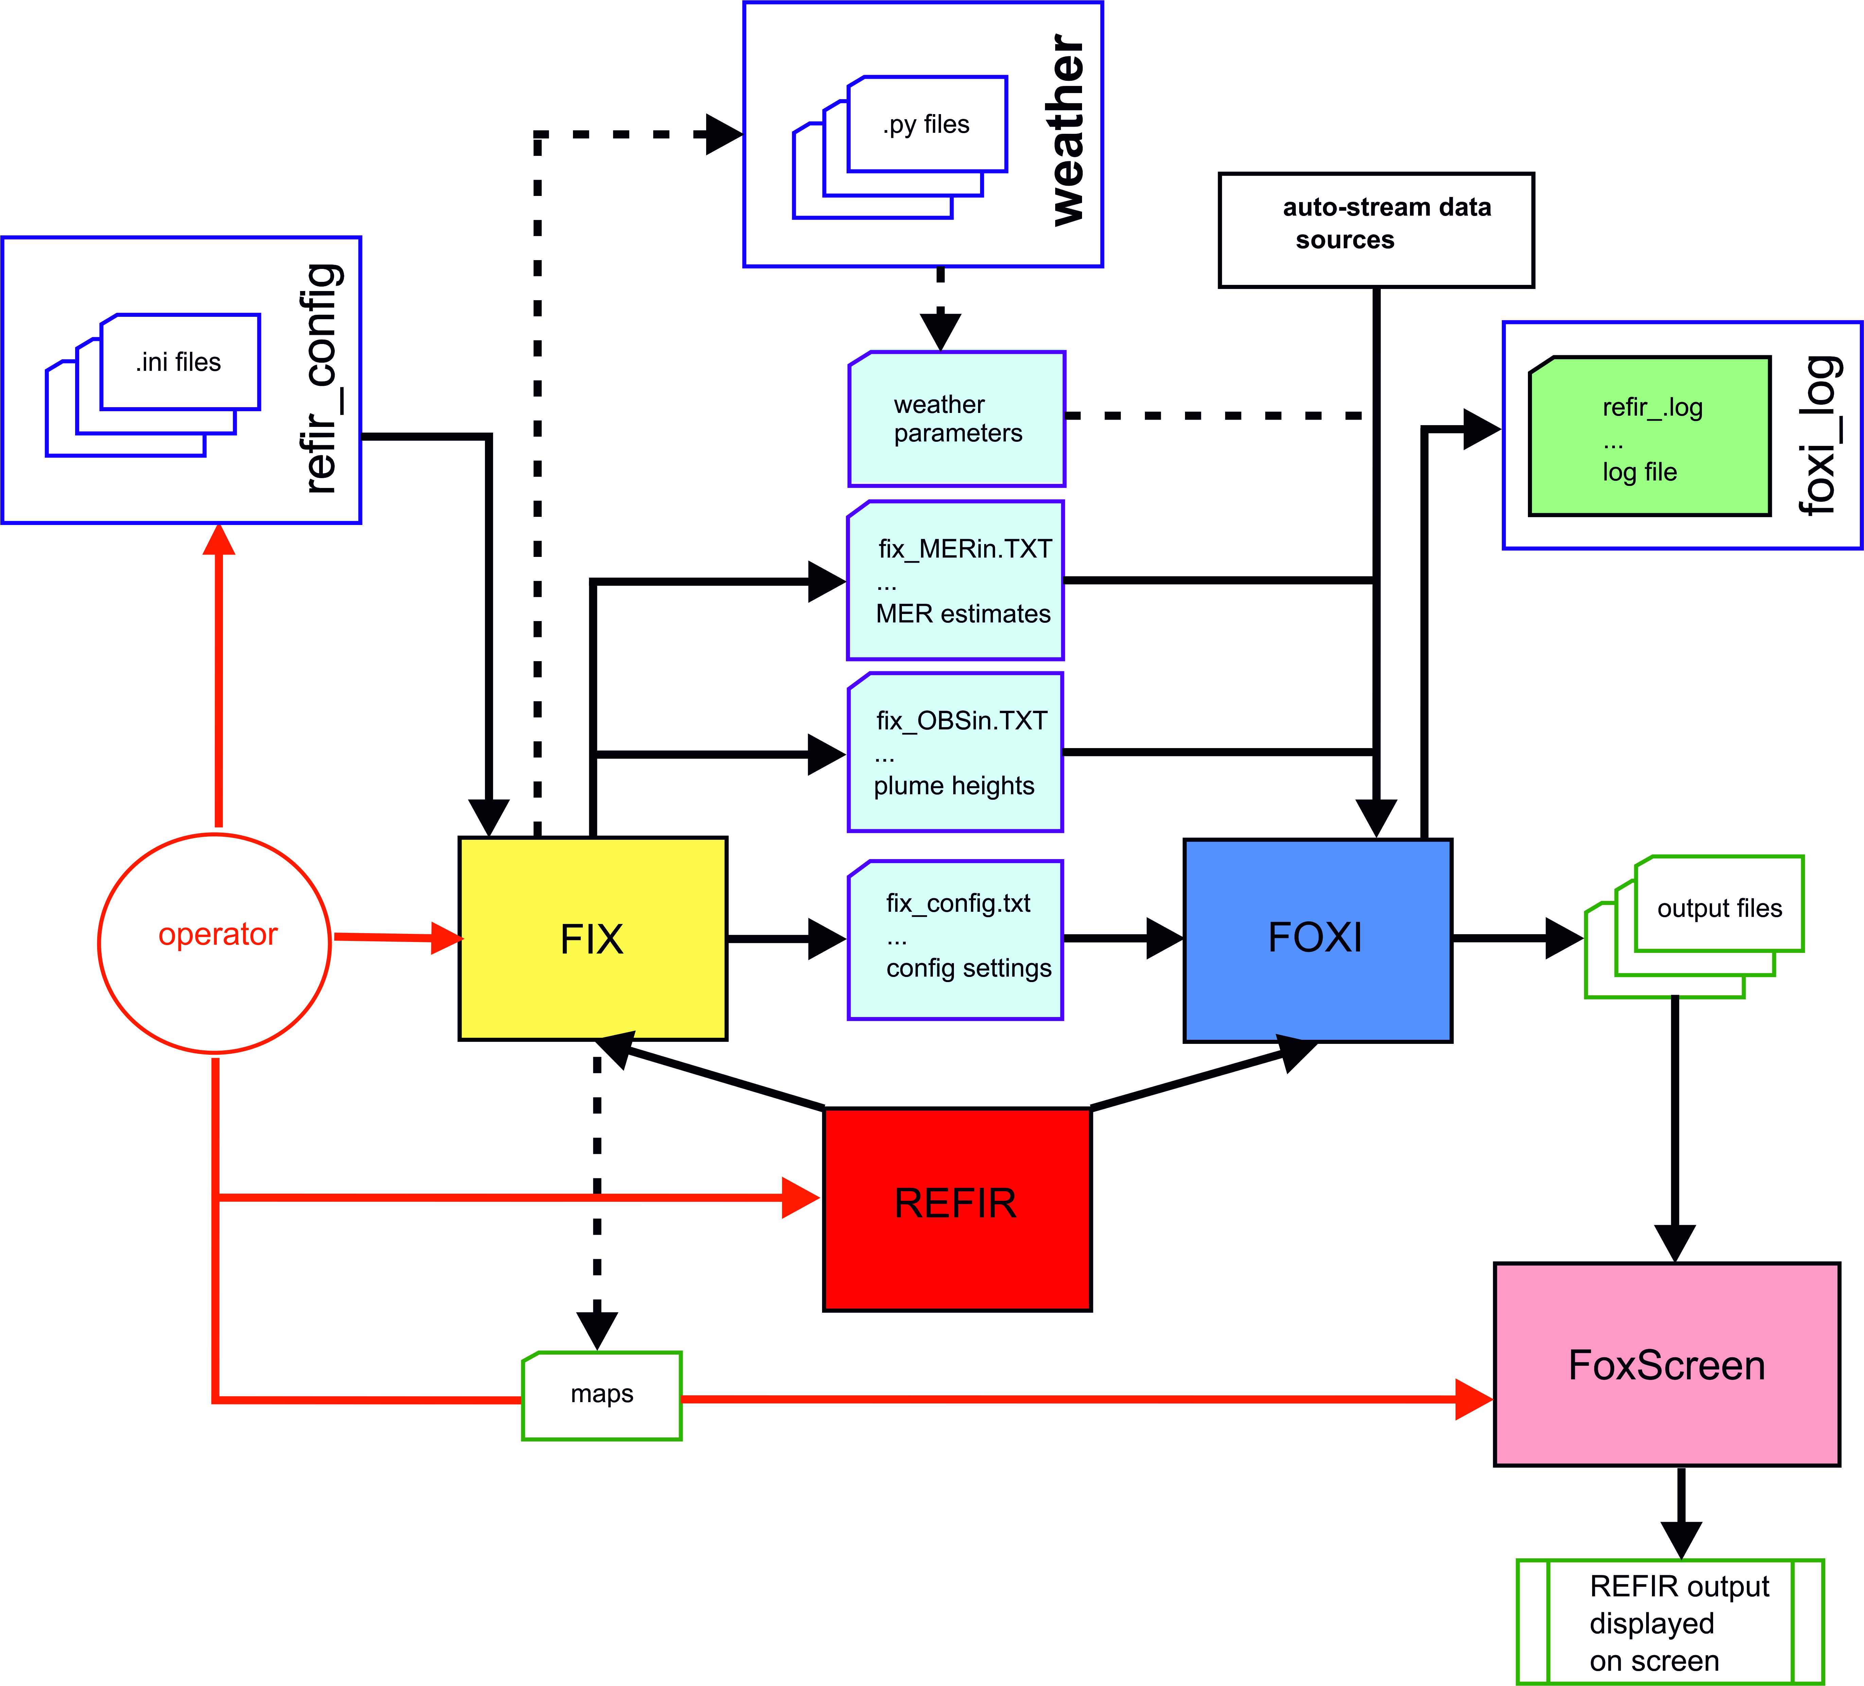

Figure 3. Communication structure of REFIR components in real-time monitoring mode.

Alongside the “*.ini*” files, the programs FIX and FoxScreen are the main interfaces between the operator and the system. The actual data processing, however, is conducted within the program FOXI. The communication link between FIX and FOXI is provided by the configuration data file (*fix_config.txt*). Plume height, plume diameter and MER data that are manually added by the operator using FIX are saved and transferred to FOXI via text files denoted *fix_OBSin.txt* and *fix_MERin.txt*, respectively. The script REFIR sits above FIX and FOXI and runs them in parallel.

By using FIX the operator can also create two maps showing the current monitoring setting. These maps are locally stored as “*map1.png*”, “*map1.svg*”, “*map2.png*” and “*map2.svg*”. The files “*map1.png*” and “*map2.png*” are displayed in the overview window provided by FoxScreen.

## Overview of Input Files (Example: setup for Iceland)

Table 1 summarizes all files which are used by FOXI to read relevant input data. The files marked in red are observatory-specific for the Icelandic setup (“Futurevolc setting”, see Appendix C), which includes data streams from two C-band radar stations, two mobile X-band radar stations and three automatic plume tracking web cams focused on Hekla volcano (see Appendix D).

If installed in another observatory, REFIR could be easily adjusted to files from any kind of sensor that provides real-time estimates for plume heights or mass eruption rates. The system is developed to read real-time data streams from up to six C-band radar stations, six X-band radar stations and six web cams.

Table 1: Input files for FIX and FOXI. Files marked in red are specific for the Icelandic set-up.

|  |  |  |  |
| --- | --- | --- | --- |
| **file** | **content** |  |  |
| *volcano_list.ini* | location and vent heights of volcanos | generated by FoxSet | necessary  for FIX |
| *Cband.ini* | boundary parameters of C-band radar stations | generated by FoxSet | necessary  for FIX and FOXI |
| *Xband.ini* | boundary parameters of C-band radar stations | generated by FoxSet | necessary  for FIX and FOXI |
| *Cam.ini* | boundary parameters of web cams | generated by FoxSet | necessary  for FIX and FOXI |
| *volc_database.ini* | distances between volcanos and sensors | generated by FoxSet | necessary  for FIX and FOXI |
| *fix_config.txt* | control parameters for FOXI | generated by FIX | necessary  for FOXI |
| *fix_OBSin.txt* | manually added plume height data via FIX | generated by FIX | optional for FOXI |
| *fix_MERin.txt* | manually added MER data via FIX | generated by FIX | optional for FOXI |
| *radar_ISKEF.txt* | auto-stream plume height data from C-band radar at Keflavík (ISKEF) | provided by ISKEF | optional for FOXI |
| *radar_ISEGS.txt* | auto-stream plume height data from C-band radar at Egilsstaðir (ISEGS) | provided by ISEGS | optional for FOXI |
| *radar_ISX1.txt* | auto-stream plume height data from mobile X-band radar station ISX1 | provided by ISX1 | optional for FOXI |
| *radar_ISX2.txt* | auto-stream plume height data from mobile X-band radar station ISX2 | provided by ISX2 | optional for FOXI |
| *cam1.txt* | auto-stream data from automatic plume tracking web camera system in Búrfell | provided by CAM1 | optional for FOXI |
| *cam2.txt* | auto-stream data from automatic plume tracking web camera system in Rauðaskál | provided by CAM2 | optional for FOXI |
| *cam3.txt* | auto-stream data from automatic plume tracking web camera system in Mjóaskarð | provided by CAM3 | optional for FOXI |
| *MW_ini.txt* | atmospheric parameters (put on PlumeRise server) | provided by BRIS* | optional for FIX  (deactivated for v 19.0) |
| *PlumeRise_out.txt* | MER estimates and range of plume radii resulting from PlumeRise model | provided by BRIS** | optional for FOXI |
| *esens_out.txt* | MER estimates based on electric field sensors | provided by IMO** | optional for FOXI |
| *isound_out.txt* | MER estimates resulting from infra sound signal analysis | provided by IMO** | optional for FOXI |
| *mwave_out.txt* | MER estimates based on microwave scattering analysis | provided by IMO** | optional for FOXI |
| *pulse_out.txt* | MER estimates based on near-field video analysis | provided by UI** | optional for FOXI |

Notes: *location of server might be changed from University of Bristol to Icelandic Met Office in future REFIR versions. ** future option, but reading routine already implemented in current (REFIR 19) version (UI: University of Iceland).

## Overview of FOXI Output Files

To facilitate archiving of output files for subsequent analysis, the names of the output files produced by FOXI and POSTFOX can be decided by the system operator. The user specified output name, denoted here by <outputname>, is supplemented by additional identifiers. Table 2 presents the output files that are generated by FOXI.

Table 2: List of FOXI output files (those files containing data displayed to the operator by using FoxScreen are marked in red)

|  |  |  |
| --- | --- | --- |
|  | ***Identifier appended to <outputname>*** | **content** |
| 1 | *_plh_log_tmp.txt* | all obtained plume height information in each run |
| 2 | *_plh_log.txt* | list of all newly updated plume height data |
| 3 | *Foxi_hbe.txt* | provides PlumeRise model with plume height information |
| 4 | *_hbe_15.txt* | outcome of plume height analysis considering the last 15 min |
| 5 | *_hbe_30.txt* | outcome of plume height analysis considering the last 30 min |
| 6 | *_hbe_60.txt* | outcome of plume height analysis considering the last 60 min |
| 7 | *_hbe_180.txt* | outcome of plume height analysis considering the last 180 min |
| 8 | *_mer_NOW.txt* | REFIR-internal MER results of last run (constantly replaced) |
| 9 | *_mer_LOG.txt* | log of used input parameters together with all MER results for each run |
| 10 | *_mass_log.txt* | log of integrated mass |
| 11 | *_APH_plot.png /.svg* | plot showing individual plume heights from each sensor |
| 12 | *PHSec_plot.png /.svg* | plot showing individual plume heights from each sensor separated by sector |
| 13 | *_SRC_stat.png /.svg* | plot displaying the age of latest plume height data separated by sensors |
| 14 | *_SRCtotal_stat.png /.svg* | plot showing total number of plume height data retrieved by sensors |
| 15 | *_status1.txt* | current plume heights status |
| 16 | *_status2.txt* | current status of MER predictions |
| 17 | *_status3.txt* | current status of total erupted mass |
| 18 | *_status4.txt* | currently used REFIR input parameters |
| 19 | *_status5.txt* | current stream data accuracy (quality factors) |
| 20 | *_status6.txt* | current stream data accuracy (uncertainties) |
| 21 | *_status7.txt* | sensor locations (Eastern or Western sector) |
| 22 | *_status8.txt* | current auto-stream sensor settings |
| 23 | *_status9.txt* | current manual input channel settings |
| 24 | *_status10.txt* | radar sensor calibration factors |
| 25 | *_status11.txt* | current REFIR model settings |
| 26 | *_status12.txt* | current output settings |
| 27 | *_PH_plot.png /.svg* | plot of plume heights as a function of time |
| 28 | *_CMER_plot.png /.svg* | plot of MER as a function of time based on the suite of MER models used in FOXI |
| 29 | *_N_plot.png /.svg* | plot presenting the number of considered plume height data per run |
| 30 | *_Cmass_plot.png /.svg* | plot of total mass erupted as a function of time based on the suite of MER models used in FOXI |
| 31 | *_FMER_plot.png /.svg* | plot of final best MER estimate determined by FOXI for each time interval, FMER, as a function of time |
| 32 | *_Fmass_plot.png /.svg* | plot of total mass erupted (final estimate, based on FMER) in each time interval, as a function of time |
| 33 | *_STATUS_REPORT.txt* | status report giving an of current plume height, MER and total erupted mass |
| 34 | *QUO_log.txt* | a flag that indicates quality of processed data in each run |
| 35 | *_FOXI_out.txt* | log of final results |
| 36 | *_FOXI_NOW.txt* | log of current results (constantly replaced) |
| 37 | *_EMER_LOG.txt* | statistics from all experimental MER considered |
| 38 | *_FMER.txt* | time series of FMER (average, maximum and minimum) updated every 5 minutes |
| 39 | *_PLH.txt* | time series of plume height (average, maximum and minimum) updated every 5 minutes |
| 40 | *_tavg_FMER.txt* | time-averaged time-series of FMER (average, maximum and minimum) updated at the user selected time-interval. Optional |
| 41 | *_tavg_PLH.txt* | time-averaged time-series of plume height (average, maximum and minimum) updated at the user selected time-interval. Optional |
| 42 | *_NAME_sources_avg.txt* | Comma separated source file of eruption source parameters for the ash dispersion model NAME; average solution. Optional |
| 43 | *_NAME_sources_max.txt* | Comma separated source file of eruption source parameters for the ash dispersion model NAME; maximum solution. Optional |
| 44 | *_NAME_sources_min.txt* | Comma separated source file of eruption source parameters for the ash dispersion model NAME; minimum solution. Optional |

Most of the output files are intended for the operator, to provide sufficient information, monitor the system during operation and to optimize the input settings (e.g. adjusting the time base and model weight factors). The most important file for control (and also for post-processing) purposes is the *<outputname>_mer_LOG.txt* file (line 9) which lists in detail all input and output parameters of each run.

The plots are generated in both .png (raster graphics) and .svg (vector graphics) format.

Output files used by the FoxScreen program to be displayed on the overview screen are marked in red in Table 2: the plotted graphs (lines 11-14 and 27-32) and the various status files (lines 15-26). In the Futurevolc version run by University of Iceland, these files will be uploaded onto a webpage and constantly updated with every run of FOXI (i.e. every five minutes).

In addition to the files above, FOXI can be run in an “analysis mode” in which the model results for four time base settings are logged. The results are logged in 8 additional files (see Table 3).

Table 3: List of additional FOXI output files generated by FOXI when “analysis mode” is activated

|  |  |
| --- | --- |
| ***Identifier appended to <outputname>*** | **content** |
| *_allmer_15.txt* | all individual MER model results with time base 15 min |
| *_allmer_30.txt* | all individual MER model results with time base 30 min |
| *_allmer_60.txt* | all individual MER model results with time base 60 min |
| *_allmer_180.txt* | all individual MER model results with time base 180 min |
| *_statmer_15.txt* | statistical MER model summary with time base 15 min |
| *_statmer_30.txt* | statistical MER model summary with time base 30 min |
| *_statmer_60.txt* | statistical MER model summary with time base 60 min |
| *_statmer_180.txt* | statistical MER model summary with time base 180 min |

# How to set up REFIR

## General remarks

In order to allow world wide application, REFIR was designed to guarantee a high degree of flexibility. Before becoming operative, a set of five “.ini” files have to be created, containing information about the monitored vents and specifying the auto-stream data sources. These files have to be located in a subfolder named “refir_config” from where FIX and FOXI can access their content (see **Error! Reference source not found.**).

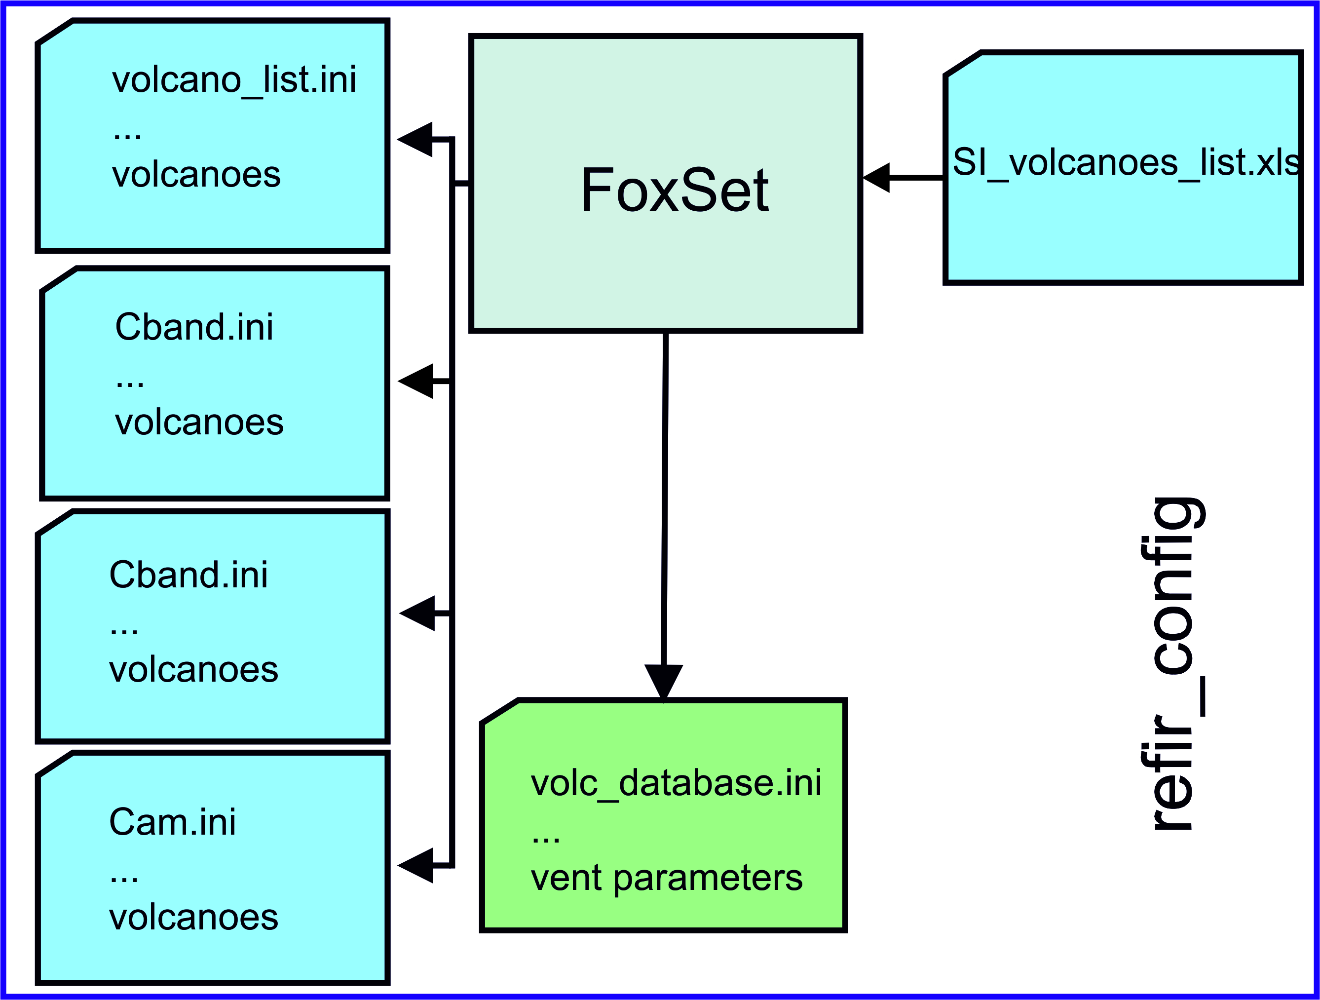

Figure 4. Content of the folder refir_config: This folder needs to include all five mandatory ".ini" files. In addition it can contain the ".ini" file generator FoxSet. Finally, the spreadsheet containing the Smithsonian catalogue of volcanoes (with name, location and vent height) is available (“SI_volcanoes_list.xlsx”).

## Installation

To setup REFIR, follow the steps listed below.

1. Install the dependencies

Install Wgrib2, Grib-tools and the ECMWF Client Key (see section 2.2 for more details).

1. Install a Python interpreter

The Python script are compatible with Python 3.6 or above. The user can install the standard Python release (<https://www.python.org/>) or Anaconda (<https://anaconda.org/>). The latter option is suggested (see next step).

1. Install Python packages

The following Python packages are needed: *ecmwfapi*, *basemap*, *future*, *pandas,* *xlrd* and *pillow*. For managing packages, it is recommended to set up a Conda virtual environment. In this way it is possible to create a project-specific environment with the needed packages, without altering the original Python installation. The command that is suitable for REFIR is:

*conda create --name name_of_environment python=3.7 basemap pandas xlrd future pillow*

Once the environment has been successfully created, is has to be activate before starting REFIR. This can be done by the command *source activate name_of_environment* (Linux) or *conda activate name_of_environment* (Windows). Finally, the package *ecmwfapi* needs to be installed separately with pip: *pip install --user https://software.ecmwf.int/wiki/download/attachments/56664858/ecmwf-api-client-python.tgz* (note that, if the Conda environment solution is being used, the command above has to be run from inside the virtual environment). The environment can be de-activated by the command *source deactivate* (Linux) or *conda deactivate* (Windows).

1. Assembling the Python scripts

Place the following scripts and the subfolder “weather” in a working folder of your choice (e.g. C:\programs\refir):

* *FIX.py*
* *FOXI.py*
* *FoxScreen.py*
* *REFIR.py*
* *radar_converter.py*

1. Create the configuration files

Place the subfolder named "refir_config", which includes the FoxSet.py script and the Smithsonian Institute list of volcanoes (SI_volcanoes_list.xlsx), in the working folder

(In this example: C:\programs\refir\refir_config). Within the subfolder “refir_config” generate create the following five files either by running FoxSet.py or a text editor:

* volcano_list.ini
* Cband.ini
* Xband.ini
* Cam.ini
* volc_database.ini

These two options are described in detail in the following subsections.

### Option 1 –manually creating the “.ini” files by using a text editor

#### Generating “volcano_list.ini”

The file “*volcano_list.ini*” contains location and vent information of the eruptive sites monitored within REFIR. Up to 10 volcanoes can be assigned. **Error! Reference source not found.** gives an example of how such a file should look like.

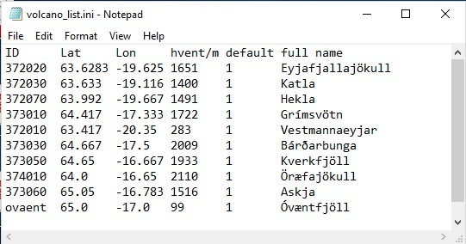

Figure 5. Example of a “volcano_list.ini” file.

The file consists of 6 columns, separated by tabs, one header row and volcano-specific data rows.

**column 1**: “ID” - gives the Smithsonian Institute ID for the eruption site when created with FoxSet.py. It is still possible to change it manually.

**column 2**: “Lat” gives the latitude of the monitored vent in decimal notation

**column 3**: “Lon” gives the longitude of the monitored vent in decimal notation

**column 4**: “hvent/m” gives the altitude of the vent above sea level in meters

**column 5**: “default” value is defined by 1, if the location is one of the FutureVolc eruptive sites, 0 otherwise.

**column 6**: “full name” of the eruption site

Note: If you assign less than 10 volcanoes the system will simply denote the empty slots “n.a.”. The maximum number of volcanoes can be changed in the source code, which has to be re-compiled for the modification to take effect. This applies also for the other parameters which are specified in the following.

#### Generating “Cband.ini”

The file “*Cband.ini*” contains information about the location of C-band radar stations and the according server addresses of their data streams.  
Note that all sensors of this type are treated as the horizontally scanning radar devices used in Iceland.

Up to 6 C-band radar stations can be assigned. **Error! Reference source not found.** illustrates such a file.

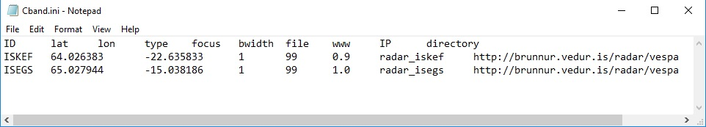

Figure 6. Example of a “Cband.ini” file. Note that it is not necessary to align the data to the headers.

A “*Cband.ini*” file consists of 9 columns, separated by tabs, one header row and up to 6 data rows.

Note: If you assign less than 6 stations to the system empty slots will be denoted “n.a.”

**column 1**: “ID” – specifies the code of the radar station

**column 2**: “lat” gives the latitude of the radar station in decimal notation

**column 3**: “lon” gives the longitude of the radar station in decimal notation

**column 4**: “type” indicates the sensor type – since C-band radar stations are specified by “1” insert always “1” here

**column 5**: “focus” – defines a specific focus on a certain volcano. One should always use “99” for C-band radar stations, since their data are not restricted to a specific volcano.   
(99 serves as indicator for the system that the sensor is not restricted to one single volcano).

**column 6**: “bwidth” – gives the beam width of the radar (in °).

**column 7**: “file” – specifies the name of the file containing streamed data. This file is retrieved from a server and copied on the local working drive, using the same file name. This means, e.g. if the online source is a file named “*radar_iskef.txt*”, the copy of it on the local drive will be named “*radar_iskef.txt*” as well. Make sure that the extension is always “*.txt*”!

**column 8**: “www” – specifies the url of the server which provides the file with plume height data.

If the data is not accessible online via a url, you can specify the IP address (column 8) and working directory (column 9), instead. In that case, column 7 has to be kept empty.

**column 9**: “IP” – specifies the IP address of the ftp server providing the file with plume height data.

**column 10**: “directory” – specifies the directory of the ftp server under which the file with plume height data can be retrieved.

#### Generating “Xband.ini”

The file “*Xband.ini*” contains information about the location of X-band radar stations and the according server addresses of their data streams.  
Note that all sensors of this type are treated as the vertically scanning radar devices (as used in Iceland).

Up to 6 X-band radar stations can be assigned. **Error! Reference source not found.** illustrates an “*Xband.ini*” file.

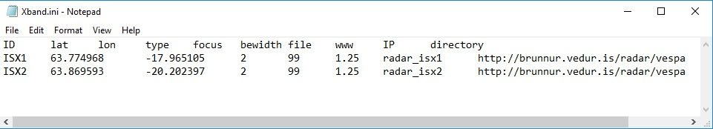

Figure 7. Example of an “Xband.ini” file.

An “*Xband.ini*” file consists of 9 columns, separated by tabs, one header row and up to 6 data rows.

Note: If you assign less than 6 stations to the system empty slots will be denoted “n.a.”

**column 1**: “ID” – specifies the code of the radar station

**column 2**: “lat” gives the latitude of the radar station in decimal notation

**column 3**: “lon” gives the longitude of the radar station in decimal notation

**column 4**: “type” indicates the sensor type – X-band radar stations are specified by “2”

**column 5**: “focus” – defines a specific focus on a certain volcano. One should always use “99” for X-band radar stations, since their data are not restricted to a specific volcano.   
(99 serves as indicator for the system that the sensor is not restricted to one single volcano).

**column 6**: “bwidth” – gives the beam width of the radar (in °).

**column 7**: “file” – specifies the name of the file containing streamed data. This file is retrieved from a server and copied on the local working drive, using the same file name. This means, e.g. if the online source is a file named “*radar_isx1.txt*”, the copy of it on the local drive will be named “*radar_isx1.txt*” as well. Make sure that the extension is always “.txt”!

**column 8**: “www” – specifies the url of the server which provides the file with plume height data.

If the data is not accessible online via a url, you can specify the IP address (column 8) and working directory (column 9), instead. In that case, column 7 has to be kept empty.

**column 9**: “IP” – specifies the IP address of the ftp server providing the file with plume height data.

**column 10**: “directory” – specifies the directory of the ftp server under which the file with plume height data can be retrieved.

##### Generating “Cam.ini”

The file “*Cam.ini*” contains information about the location of plume-tracking webcams and the according server addresses of their data streams.

Up to 6 webcams can be assigned. **Error! Reference source not found.** illustrates a “*Cam.ini*” file.



Figure 8. Example of a “Cam.ini” file.

A “*Cam.ini*” file consists of 9 columns, separated by tabs, one header row and up to 6 data rows.

Note: If you assign less than 6 stations to the system empty slots will be denoted “n.a.”

**column 1**: “ID” – specifies the code of the webcam

**column 2**: “lat” gives the latitude of the webcam in decimal notation

**column 3**: “lon” gives the longitude of the webcam in decimal notation

**column 4**: “type” indicates the sensor type – webcams are specified by “3”

**column 5**: “focus” – defines a specific focus on a certain volcano. In the current version of REFIR, web cams (i.e., sensor type 3) are supposed to be focused on a specific eruption site, only. The number in this column refers to the position of the eruption site within the file “*volcano_list.ini*”, starting from 0. For example, if a webcam is focused on the volcano specified in the first entry within “*volcano_list.ini*”, the value in this column should be “0”. If it is focused on the 2nd volcano listed within that file, the number in column 5 should be “1”, and so on.   
In the example presented in Fig.6, the two webcams are focused on the third entry of the volcano list, which is in the shown case Hekla (see the according “*volcano_list.ini*” file in Fig.3).

**column 6**: “bwidth” – not applicable for cameras, hence can be set to any number.

**column 7**: “file” – specifies the name of the file containing streamed data. This file is retrieved from a server and copied on the local working drive, using the same file name. This means, e.g. if the online source is a file named “*cam1.txt*”, the copy of it on the local drive will be named “*cam1.txt*” as well. Make sure that the extension is always “*.txt*”!

**column 8**: “www” – specifies the url of the server which provides the file with plume height data.

If the data is not accessible online via a url, you can specify the IP address (column 8) and working directory (column 9), instead. In that case, column 7 has to be kept empty.

**column 9**: “IP” – specifies the IP address of the ftp server providing the file with plume height data.

**column 10**: “directory” – specifies the directory of the ftp server under which the file with plume height data can be retrieved.

##### e. Generating “*volc_database.ini*”

The “*volc_database.ini*” file contains 2 header rows, up to 10 rows and 22 columns, representing a matrix, which reflects the vent heights and the relative distances between the volcanos and the sensors.  
Stations which are not assigned are denoted “n.a.”.

The volcano data base provides the program FIX with crucial observatory-specific information. These are required for the subsequent processing performed by FOXI to produce estimates of MER. For example, it is necessary to convert plume height values that may be reported as “above sea level” (a.s.l.) to a common “above vent” (a.v.) value, requiring details of the elevation of the vent. **Error! Reference source not found.** shows a “*volc_database.ini*” file.

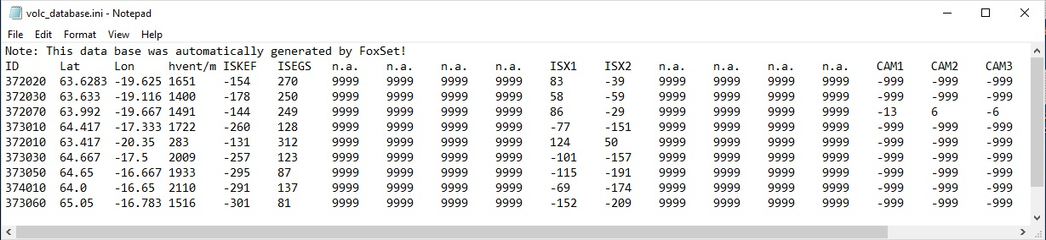

Figure 9. Example of a “volc_database.ini” file

**column 1**: ID of the eruption site

**column 2**: “Lat” gives the latitude of the eruption site in decimal notation

**column 3**: “Lon” gives the longitude of the eruption site in decimal notation

**column 4**: “hvent/m” gives the altitude of the vent above sea level in meters

**column 5** - **column 10:**distance of respective C-band radar station towards the eruption site (in km):

* a positive value indicates that when looking from the monitored vent, the sensor is located in the East (“located in the Eastern sector”)
* a negative value indicates that when looking from the monitored vent, the sensor is located in the West (“located in the Western sector”)
* “9999” indicates an empty slot (i.e., a placeholder if no sensor is assigned)

**column 11** - **column 16:**distance of respective X-band radar station towards the eruption site (in km):

* a positive value indicates that when looking from the monitored vent, the sensor is located in the East (“located in the Eastern sector”)
* a negative value indicates that when looking from the monitored vent, the sensor is located in the West (“located in the Western sector”)
* “9999” indicates an empty slot (i.e., a placeholder if no sensor is assigned)

**column 17** - **column 22:**distance of respective automatic plume-tracking webcams towards the eruption site (in km):

* a positive value indicates that when looking from the monitored vent, the sensor is located in the East (“located in the Eastern sector”)
* a negative value indicates that when looking from the monitored vent, the sensor is located in the West (“located in the Western sector”)
* “9999” indicates an empty slot (i.e., a placeholder if no sensor is assigned)
* “-999” indicates that the eruption site is out of focus

### Option 2 – Using FoxSet.py to generate the “.ini” files semi-automatically.

FoxSet.py assists the operator with generating the necessary “.*ini*” files.

#### Initiating FoxSet

Place a copy of FoxSet.py in the folder “refir_config” and start the program. **Error! Reference source not found.** presents the start screen:



Figure 10. Start screen of the REFIR setup script FoxSet.py

After launching the program, the user is provided with the following options:

[1] Default Icelandic setup   
When this option is selected a “*volcano_list.ini*” file is automatically generated which reflects the volcano setting for Iceland ( listing the 9 most important Icelandic volcanoes and a placeholder, denoted “Óvæntfjöll”, which can easily be modified and adjusted by hand using a simple text editor).

[3] New setup   
When this option is selected the user can enter data of new eruption sites (see “STEP 1: Setting up volcanoes”)

[5] Volcanoes already defined - move on to setup sensors (STEP 2)  
The volcano specification level (STEP 1) is skipped. This option should be selected when the “*volcano_list.ini*” file already exists, but no sensors are defined yet.

[7] Volcanoes and sensors already defined - move on to STEP3  
Select this option, when volcanoes (“*volcano_list.ini*”) and sensors (“*Cband.ini*”, “*Xband.ini*” and/or “*Cam.ini*”) are already defined and you want to compile them to generate the “*volc_database.ini*” file.

[0] Quit without change  
Ends the program without change

#### STEP 1: Setting up volcanoes

If a new setup was selected, the program goes through a number of queries (e.g., see **Error! Reference source not found.**).

FoxSet creates a “*volc_list.ini*” file and adds the entries, according to the specifications given by the user. After the entry is saved, the user is asked if another volcano should be added (select “1” if this is the case).

After the last entry of volcanoes (10 max) the following message is displayed:

List completed!  
Check in file „volcano_list.ini" if all data are correct and modify accordingly!

Pressing any key will bring you to STEP 2.

#### STEP 2: Setting up sensors



Figure 11. FoxSet (STEP2) – Setting up auto-stream sensors

In this step, the user is provided by the following options (see Figure 11):

[1] Default Icelandic setup   
When this option is selected the three files “*Cband.ini*”, “*Xband.ini*” and “*Cam.ini*” are automatically generated containing the information of the current sensor settings for Iceland (2 C-band stations, 2 X-band stations, 3 webcams focused on Hekla).   
Important note: Since the X-band stations in Iceland are mobile, the user is advised to check and –if necessary- modify the coordinates for the two X-band stations!

[3] New setup of sensors   
Select this option to add new sensors (see below, “Sensor type menu”)

[5] Sensors already defined - move on to STEP3  
Select this option, when volcanoes (“*volcano_list.ini*”) and sensors (“*Cband.ini*”, “*Xband.ini*” and/or “*Cam.ini*”) are already defined and you want to compile them to generate the “*volc_database.ini*” file.

[0] Quit without change  
Ends the program without change

#### Sensor type menu

If “[3] New setup of sensors” was selected, a menu appears (see **Error! Reference source not found.**) which offers the user to specify the sensor type to be added.



Figure 12. Adding sensors - sensor type menu

The following options are available:

[1] C-band (horizontally scanning) RADAR  
will create a file “*Cband.ini*” and lead the user through a number of queries in order to generate the according entries within “*Cband.ini*”.

[3] X-band (vertically scanning) RADAR  
will create a file “*Xband.ini*” and lead the user through a number of queries in order to generate the according entries within “*Xband.ini*”.

[5] Auto-tracking web-cameras  
will create a file “*Cam.ini*” and lead the user through a number of queries in order to generate the according entries within “*Cam.ini*”.

[0] Continue  
will skip this step and move on to Step 3 (the generation of a “*volc_database.ini*” file)

#### STEP 3: Compiling the “volc_database.ini” file

This step is run completely automatic. FoxSet reads “*volcano_list.ini*” file together with the three source type “.ini” files and compiles the data to compute a table with distances between eruption sites and sensors. This table is stored as “*volc_database.ini*”.

With the generation of “*volc_database.ini*”, the setup is completed.

**Important Note**: When an eruption is imminent or ongoing, the entries in the “.*ini*” files should be adjusted accordingly. In particular the vent height and the columns of mobile radar stations should be checked. Entries from the volcano data base are read by FIX only in the phase of initialization, when the respective volcano was selected. This means that changes in the data base will only take effect when FIX is terminated and restarted.

## How apply changes or modifications to an existing setup

Each of the entries can be manually modified, when necessary -for example, if one of the radar stations is moved. Care has to be taken that these changes are also overtaken in “*volc_database.ini*”.

With exception for changes in “*volcano_list.ini*”, changes in the “.*ini*” files are immediately adapted by FIX without requiring a reboot.

The following three use-cases shall present a guideline to quickly modify a setup as needed:

### Use case 1: Adding a new sensor to the REFIR system

1. Start FoxSet within the folder “refir_config”
2. In the start menu select [5]: “Volcanoes already defined – move on to setup sensors (STEP2)”
3. In the STEP2 menu, select [3]: “New setup of sensors/ Add new sensor”
4. In the following sensor type menu, select the type of sensor to add
5. Enter the relevant data in the queries that follow
6. Once you have finished, you are asked if you want to add another sensor. Select [2] in case you don’t.
7. After pressing any key to confirm, you are back in the sensor setting menu (“STEP2”). If you are finished with adding sensors, press [0] to continue.
8. The file “*volc_database.ini*” file is then automatically recomputed. All changes are now overtaken by FIX and FOXI.

### Use case 2: Adding a new volcano to the REFIR system

In contrast to newly added sensors, new volcanoes are not adopted by FIX while running.  
Therefore it is recommended to close FIX before changing the settings and restart it when the modification of the setup is finished.  
Furthermore, using FoxSet to add a volcano to “*volcano_list.ini*”, would require a redefinition of the already existing volcanoes. As a work-around the following procedure is advised:

1. Open “*volcano_list.ini*” within the folder “refir_config”
2. Add the new volcano and its data accordingly. Note that only the first 10 entries are considered by the system. If needed replace one of the entries with the new data.
3. Start FoxSet within the folder “refir_config”
4. In the start menu select [7]: “Volcanoes and sensors already defined - move on to STEP3”
5. The file “*volc_database.ini*” file is automatically recomputed and the program closes.
6. If FIX is now started, the new volcano appears in the initial menu and can be selected.

### Use case 3: Changed location of one of the sensors

It is recommended to close FIX before changing the settings and restart it when the modification of the setup is finished. Within the folder “refir_config” open the according sensor type “.*ini*”-file (e.g. in case of an X-band radar station: “*Xband.ini*”)

1. Change latitude and longitude of the sensor in question and save the file.
2. Start FoxSet within the folder “refir_config”
3. In the start menu select [7]: “Volcanoes and sensors already defined - move on to STEP3”
4. The file “*volc_database.ini*” file is automatically recomputed and the program closes. All changes are now overtaken by FIX and FOXI.

# FIX

This chapter presents in detail the functionality of the program FIX (version presented: 19.0), which is the main control interface between the user and the REFIR system. Note that the appearance of the presented windows might slightly differ, depending on which operation system and version of python is used. Additionally, FIX and FOXI can be initialized in parallel by running the script REFIR.py. This is not mandatory, FIX and FOXI can be run separately, depending on the user’s choice. However, it is advised to keep FIX running together with FOXI; by doing so, the user can modify the computation settings via FIX in real-time or, more importantly, add estimates of plume height and/or MER as they become available from other sources. Therefore, running FIX and FOXI in parallel allows the operator to exploit the potential of REFIR in full.

## Initialization –Selection of the operation mode

Make sure that FIX is located in the correct working folder. When initialized, a first widget opens that allows controlling REFIR operation mode (see Figure 13).

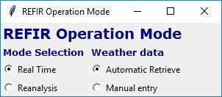

Figure 13. REFIR operation mode selection.

By means of this widget, the user can control if to run REFIR in real time (the default method) or in reanalysis mode and if to use weather data automatically retrieved or manually entered. If the “Automatic Retrieve” option is chosen, weather data are retrieved and elaborated to obtain weather conditions that are needed by FOXI to compute MER by means of the implemented plume models. This option will be discussed in Section 4.4.1.

### Reanalysis mode

If this option is selected, a window opens requesting the user to specify the start day and time and the end day and time of the eruption under analysis (Figure 14).

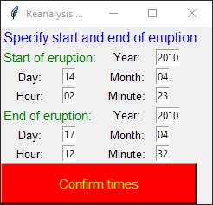

Figure 14. Window to specify start and end of the eruption

In reanalysis mode the execution of FIX and FOXI is very similar to the real-time mode, with the only differences being:

1. Plume height data are not retrieved from the online data streams, but FOXI searches for them in the working folder. This means that the user will need to make the plume height data available in the working folder in the format described in Section 5.4.3 before starting FOXI.
2. FOXI loop runs without the standard waiting time of 5 minutes, which is the case of real-time analyses. The loop time step is 5 minutes like in real-time mode.

In the following we will always refer to the real-time mode, unless otherwise specified.

## Selection of Eruption Site

Subsequently, a window opens requesting the user to select the eruption site (see Figure 15).



Figure 15 Volcano selection widget

A volcano is selected by clicking on it and then closing the window. Once the eruption site is selected, the corresponding data set is imported from the REFIR volcano data base. It is important to remember that after initialization, any update in those settings (e.g. the distances of the plume height sensors and the vent height) requires a restart of FIX to take effect. If an eruption occurs at a site that is not listed, follow the guidelines described in section 3.3.

## The Operation Control Board

After closing the eruption site selection window the following message is displayed:

**** REFIR FIX system is booting ****

The Operation Control Board then opens (see Figure 16). This window is the virtual “command and control centre” for the operator, from which all relevant setting panels can be accessed.

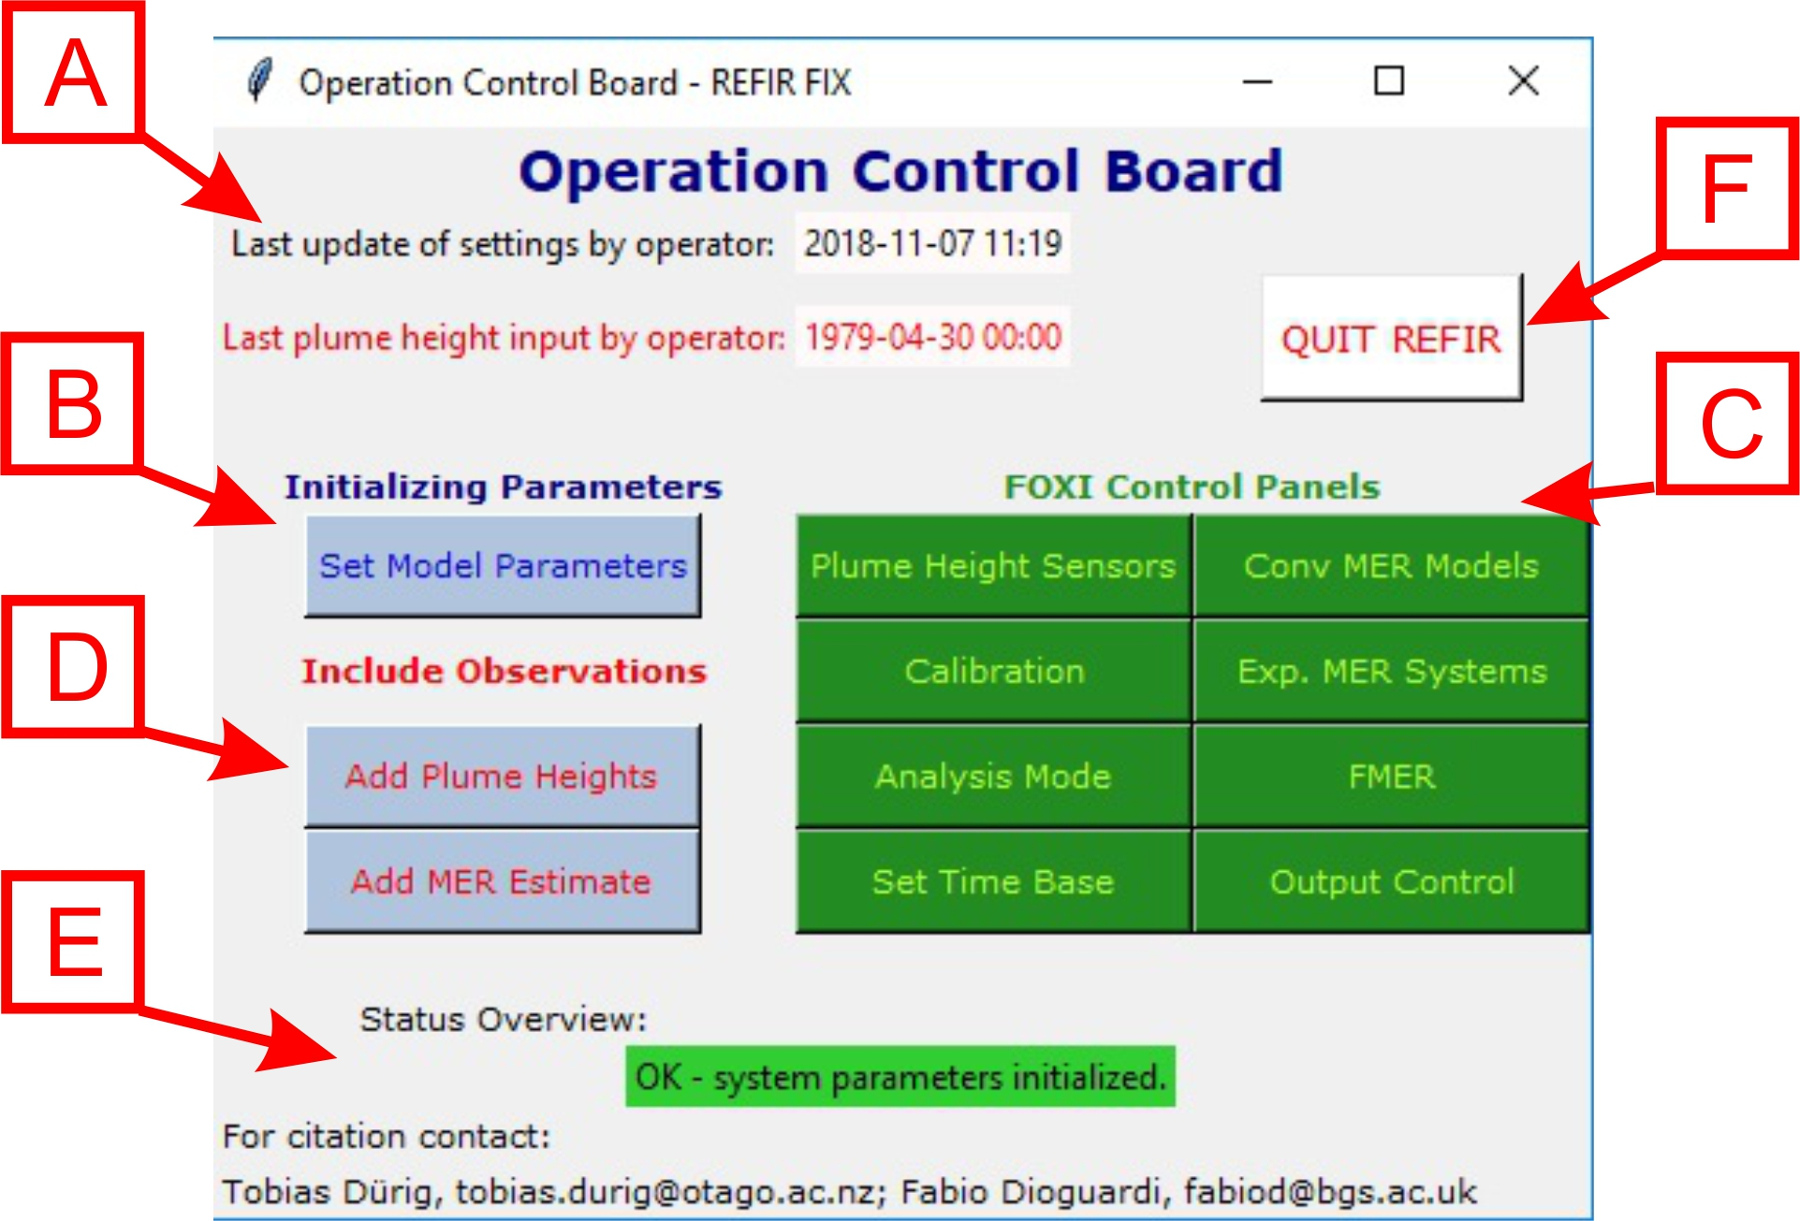

Figure 16. Components of the Operation Control Board

The window consists of five blocks:

* **Time stamps (Field A)**:   
  The upper line displays (in black) date and time of the last setting update. If no update has been made since the first start of FIX (and no fix_config.txt file has been generated yet),   
  “--:--:--“ is displayed.  
  The lower line indicates (in red) time and date of the last manual plume height input. If no input has been made since the first start of FIX, “--:--:--“ is displayed. If parameter settings have been stored but no plume heights manually added, “1979-04-30 00:00:00” occurs on the display.
* **Initializing parameters (Field B)**:  
  This field consists of only one button, albeit a crucial one, which opens a panel for the entry of mandatory model parameters. Without setting these parameters, FOXI cannot be initialized.
* **FOXI control panels (Field C)**:  
  This block comprises eight buttons each providing the operator with control over the data stream by regulating the input and output, as well as over parameters that govern the data processing routines within FOXI.
* **Include Observations (Field D)**:  
  The operator can manually add plume heights and MER estimates via these two buttons.
* **Status overview (Field E)**:

This display informs the operator of the status of the system. When an action by the operator is required, a warning is issued, highlighted in yellow. For example if the system has not yet received a configuration file, and an appropriate warning has been issued, stating:

!!!NOTE: Set initial parameters and activate plume height sensors!!!

* **Quit button (Field F):**

If clicked during the execution of FOXI, this button stops FOXI and FIX, the latter is it has been left running. When FOXI is stopped, all the output files (log files, plots, downloaded and elaborated weather data) are moved from the working folder into a folder called “run_YYYYMMDDHHMM”, where YYYY, MM, DD, HH, MM are the year, month, day, hour and minute of the time instant when FOXI has been initialized.

The following sections describe all submenus that are accessible via the Operation Control Board that can be activated by clicking on the corresponding buttons. Note that when a submenu is opened the Operation Control Board stays visible and active. Hence, several submenus/windows can be opened simultaneously.

## “Set Model Parameters”

After launching FIX in order to prepare a new run of FOXI, it is always recommended to start with the parameter setting process by clicking on the “Set Model Parameters” Button. Indeed, FOXI cannot be run without setting the initial parameters.

The setup menu that pops up shows a list of entries, which are displayed in five groups (see Figure 17).

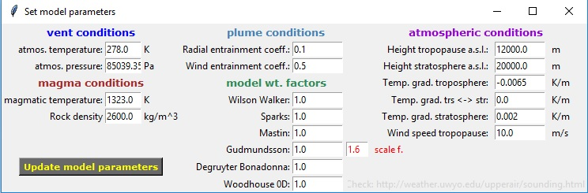

Figure 17. "Set model parameters" menu

**vent conditions**:

* the **atmospheric temperature at the vent** (in K): by default, this is initialized to the last setting.
* the **atmospheric pressure at the vent** (in Pa): by default a value is suggested which is calculated by applying the barometric equation and using the atmospheric standard pressure at sea level along with the vent height.

**magma conditions**:

* the **magmatic temperature at the source** (in K): by default, this is initialized to 1323 K.
* the **rock density of magma at the source** (DRE in kg/m3): by default, this is initialized to 2600kg/m3.

**plume conditions**:

* the **radial entrainment coefficient** (**): by default, this is initialized to 0.1.
* the **wind entrainment coefficient** (**): by default, this is initialized to 0.5.

**model weight factors**:

In this group, the six models used within REFIR are listed:

* **Wilson & Walker**: a theoretical model developed by *Wilson and Walker* (1987)
* **Sparks**: an empirical model introduced by *Sparks et al*. (1997)
* **Mastin**: an empirical model developed by *Mastin et al*. (2009)
* **Gudmundsson**: the adjusted Mastin model introduced by *Gudmundsson et. al*. (2012)
* **Degruyter & Bonadonna**: based on the calibrated theoretical model developed by *Degruyter & Bonadonna* (2012)
* **Woodhouse 0D**: based on the calibrated theoretical model developed by *Woodhouse et al. (2013)*

For background information about the models, we refer the reader to section 5.6.1.

The suite of six models are used together to produce an estimate of MER. Each model gives on output a value of MER based on the observational data. The MER values are combined to produce the REFIR-internal estimate “RMER” by applying a weighted mean. The weight factors in this calculation are specified as the model weight factors for each of the six models (Figure 18). Further details of the calculation are presented in section 5.6.3. We note that the RMER value also contributes to the Final estimate of MER, FMER.

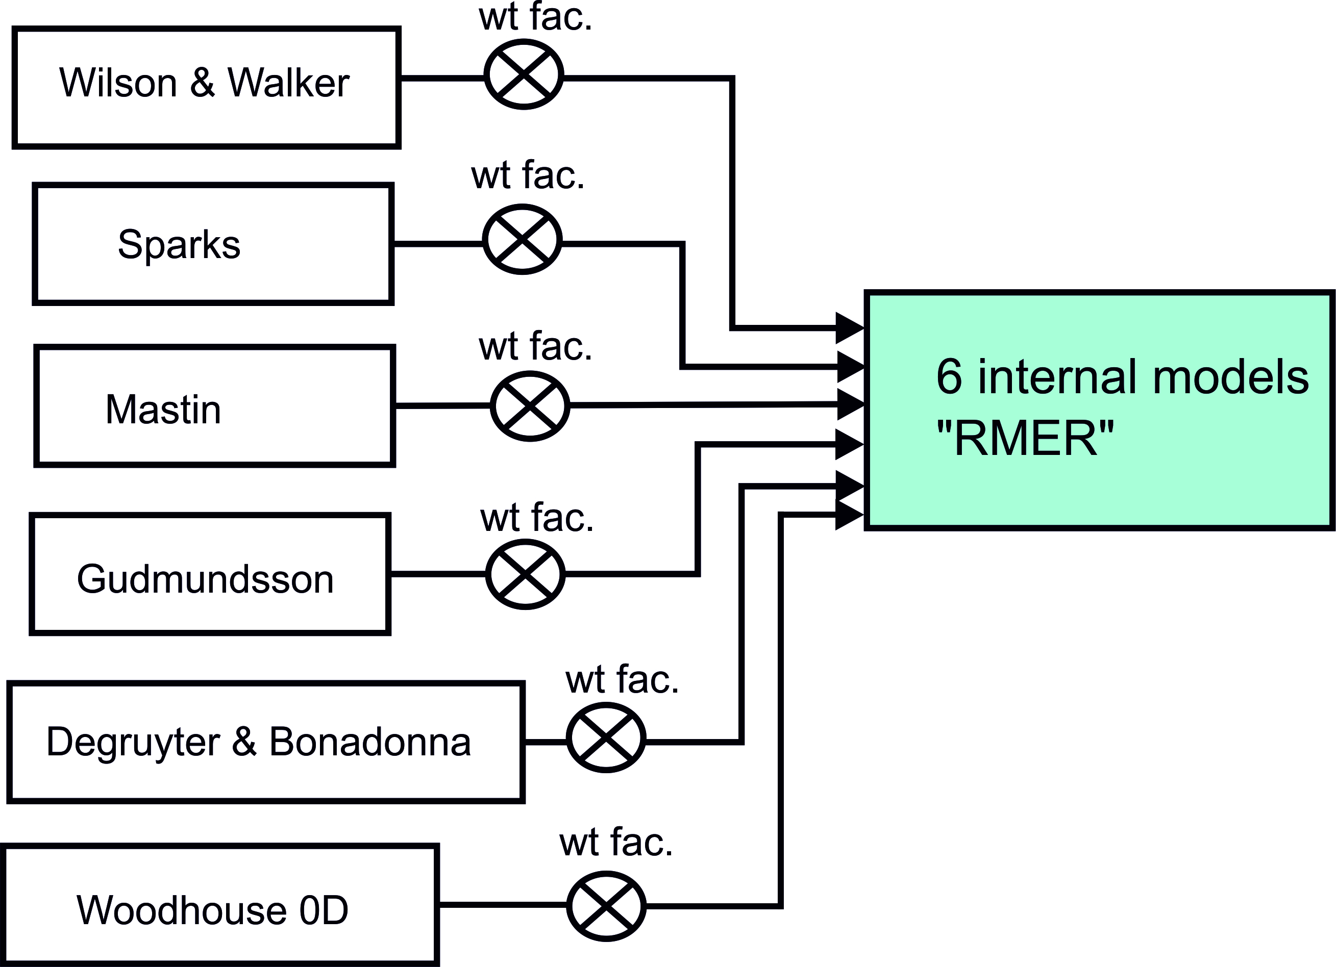

Figure 18. Influence of models on RMER depends on attributed weight factors

If a model is “trusted” and expected to be more accurate than other models, the contribution of this model to the RMER is enhanced by specifying a relatively large weight factor. On the other hand, if a model should be omitted from the computation of RMER and FMER, its contribution can be neglected by assigning to it a weight factor equal to zero.

Note that the selection of optimal weight factors based on experience will significantly increase the accuracy of MER estimates. A brief discussion about the conditions under which each of the models in the suite adopted by REFIR shows the highest precision can be found in section 5.6.2, although this topic remains an important subject for future research. An application example could consist in focusing on the empirical models only by setting the weight factor to 1 for Wilson & Walker, Sparks, Mastin and Gudmundsson and to 0 to Degruyter & Bonadonna and Woodhouse 0D. Or the opposite of this can be done if the operator might want to use wind-blown models only (e.g., for weak plumes).

By default, the last setting is displayed. If no settings have been stored at this stage, (meaning no configuration file exists), the six models are weighted equally with a weight of 1. In this case the weighted mean coincides with the six MERs produced by the six models.

In addition to the weight factors, the model of Gudmundsson requires a **scale factor *kI*** (see section 5.6.1). This parameter can be set in the field to the right of the corresponding weight factor (marked in red). If this parameter has not specified before, FIX sets the Gudmundsson scale factor to a default value of 1.6.

**atmospheric conditions**:

The parameters from this group are only needed for the two wind-dependent plume models: Degruyter & Bonadonna and Woodhouse 0D:. The required parameters are:

* the **height of the tropopause above sea level** (in m): by default, a value of 12000 m is set;
* the **height of the stratosphere above sea level** (in m): by default, this is initialized to a value of 20000 m;
* **temperature gradient within the troposphere** (in K/m): by default, a value of -0.0065 K/m is set
* **temperature gradient between troposphere** **and stratosphere** (in K/m): by default, this is initialized to a value of 0 K/m;
* **temperature gradient within the stratosphere** (in K/m): by default, this is initialized to a value of 0.002 K/m;
* **plume-height-averaged wind speed** (in m/s): a wind speed of 10m/s is set as default.

In the lower right corner of the window a URL of a webpage is displayed, which provides all relevant atmospheric information.

The settings are saved by clicking on the “Update Model Parameters” button located at the left bottom of the window. FIX confirms the update by the returning:

*** settings updated! ***

If the window is closed without having clicked the update button any change in the entries will be discarded.

**Important Note**:

Changes are only saved if the “Update Model Parameters” button has been clicked!

### Automatically-retrieved weather data

When this option is chosen via the widget in Figure 13, FIX ignores the atmospheric conditions manually specified by the user in the menu of Figure 17 and calculates them from forecasts or reanalysis archives. This is done by a set of Python scripts stored in the folder “weather”:

* retrieve_data.py: downloads the data;
* read.py: reads the gridded files, extracts the relevant data (geopotential height, temperature and wind speed) over the eruption location and saves these in a profile file;
* calc_wt_par.py: reads the profile files and calculate the parameters that are needed for the calculation of MER with the models of Degruyter and Bonadonna (2012) and Woodhouse et al. (2013).

The sources of weather data depend on the selected REFIR operation mode; if the reanalysis mode is used, the archive from which weather data are retrieved depends on the time interval of the eruption.

Specifically:

* Real-time mode. NOAA GFS forecasts are downloaded. In particular, the 0.25 degree 1-hourly database is used (<http://www.nco.ncep.noaa.gov/pmb/products/gfs/#GFS>).
* Reanalysis mode. In this case, archives of past GFS weather forecasts or ECMWF ERA-Interim reanalyses are used, based on the availability, which in turn depends on the date of the considered eruption. retrieve_data.py searches for data in this sequence:
  + GFS forecasts (<http://www.nco.ncep.noaa.gov/pmb/products/gfs/#GFS>), 0.25 degree, 1-hourly database.
  + GFS forecasts (<https://nomads.ncdc.noaa.gov/data/gfs4>), 0.5 degree, 3-hourly database.
  + ERA-Interim (<https://www.ecmwf.int/en/forecasts/datasets/archive-datasets/reanalysis-datasets/era-interim>), 0.75 degree, 6-hourly database.

In real-time mode, FIX downloads weather data valid for the current hour by invoking retrieve_data.py; only one time step of the GFS forecasts is initially retrieved. When FOXI is running, it always checks whether the processed weather data files (see below) valid at runtime are available in the working folder; if not, FOXI invokes retrieve_data.py again for downloading the GFS forecast file valid at that specific time and processes them with the other two scripts.

In reanalysis mode, FIX downloads all weather data for the whole eruption period specified by the user (Figure 14) and process them all at once.

Both in real-time and reanalysis mode, the weather package (in particular, read.py) extracts the vertical profile of weather data needed by REFIR (geopotential height, pressure, temperature, wind speed) at the volcano location by interpolation. This creates a gridded file named “profile_*start-time*_to_*stop-time*.txt”, where *start-time* and *stop-time* define the weather data validity interval. From this files, vertical profiles at each time step of the weather data are saved in separate files named “profile_*YYYYMMDD*.txt”; these files are still in grib format. These are then converted in the format that is finally used for calculating the weather parameters; the resulting files are named “profile_data_*YYYYMMDD*.txt” and a screenshot is shown below in Figure 19:

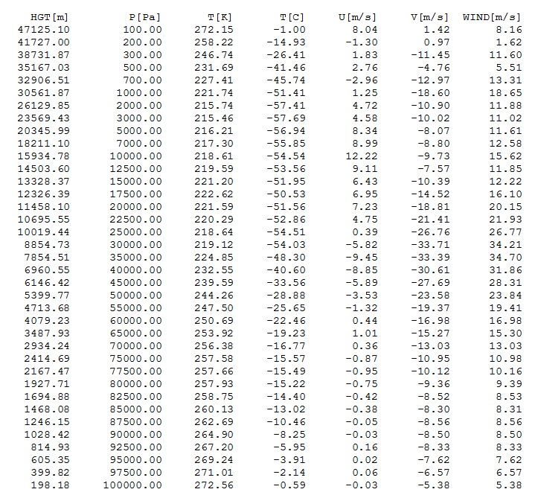

Figure 19. Screenshot of a profile file. HGT[m] is the geopotential height; P[Pa] is the atmospheric pressure; T[K] and T[C] are the temperature in K and C, respectively; U[m/s] and V[m/s] are the two horizontal component of the wind vector; WIND[m/s] is the resulting wind speed.

Using the data stored in these files, the script calc_wt_par.py calculate the weather parameters needed by FOXI and, specifically, the wind-affected plume models (Degruyter and Bonadonna, 2012; Woodhouse et al. 2013); namely, atmospheric pressure and temperature at the vent location; plume height averaged buoyancy frequency and wind speed; the *Ws* parameter of Woodhouse et al. (2013). These are stored in separate files named “weather_parameters_*YYYYMMDD*.txt” (Figure 20).

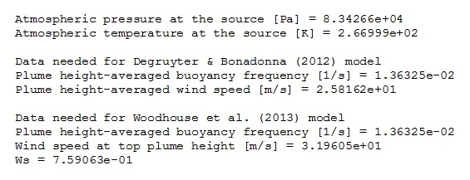

Figure 20. Screenshot of a weather parameters file.

Note that the plume-height averaged quantities (buoyancy frequency and wind speed) and the wind speed at top plume height can be calculated only when plume height is assessed; hence, the weather parameters are calculated by FOXI before MER is calculated.

Once REFIR is stopped, all the downloaded and processed weather data are stored in a folder, whose name depends on the operation mode. If REFIR is run in real-time, the folder name is “raw_forecast_weather_data_*YYYYMMDD*”; in reanalysis mode it is “raw_reanalysis_weather_data_*YYYYMMDD*”. In both cases, *YYYYMMDD* refers to the starting date of the eruption.

## “Plume Height Sensors”

This important menu serves as a control centre for all the plume height data sources that feed the FOXI program with information. A screenshot of this window is shown in Figure 21.

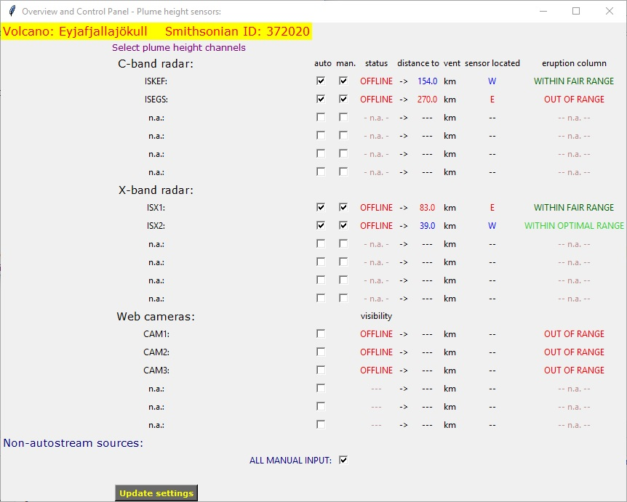

Figure 21. Plume height sensor control panel

On the left top corner, the volcano name and the Smithsonian ID code for the selected eruption site is displayed. These identifiers are specified in the file “*volcano_list.ini*”.

The data sources are subdivided into four groups:

**C-band radar**:

with up to six C-band radar stations. In the example given here two C-band radar sensors are assigned:

* ISKEF: C-band radar station at Keflavík airport
* ISEGS: C-band radar station at Egilstaðir

**X-band radar**:

with up to six X-band radar stations. In the example given here two X-band radar sensors are assigned:

* ISX1: mobile X-band radar station ISX1
* ISX2: mobile X-band radar station ISX2

**web cameras**:

with up to six automatic plume height tracking webcams. In the example given here three web cams are assigned:

* CAM1: automatic plume height tracking webcam in Búrfell
* CAM2: automatic plume height tracking webcam in Rauðaskál
* CAM3: automatic plume height tracking webcam in Mjóaskarð

**Non-autostream sources**:

Data from “non-autostream sources” comprise all data that have not been streamed automatically, but were manually added by the operator.

The sensors presented here are specific for the Icelandic volcanoes, as REFIR has been originally designed for Iceland.

However, by using a different set of “.*ini*” files, REFIR can be easily adjusted to meet the requirements of other observatories and/or eruptions sites.

Note that the name of the classes does not preclude the use of other types of sensors within REFIR. Any kind of sensor capable of automatically providing plume height data streams (e.g. infrared cameras, DOAS or LiDAR) can be incorporated into the system, by assigning them to the one of the three classes to which it fits best. For example, a VHF lightning detection system deployed at a volcano would best be incorporated into REFIR within the “Web Cameras” class, whereas a mobile LiDAR would be better suited to the “X-band radar” class. In practice the classification of the instrument is not critical to the algorithm used in REFIR, although assessing uncertainties and drawing inferences from the observations are assisted by assigning instruments to an appropriate class.

Hereafter we will always refer to the Icelandic (FutureVolc) case as example, when dealing with monitoring stations, quality of the data, range of visibility.

### Controlling the plume height data channels

REFIR is designed so that the operator has maximum control over all plume height input data, which ensures the quality of results can be optimized. Problems that occur when encountering misleading data from a malfunctioning sensor can be avoided by simply switching off the corresponding data channel. The high degree of flexibility is reflected by the large number of (dis)connectible data channels, which are illustrated schematically in Figure 22.

Data from the (in this example: four) radar sources can be communicated in two ways: by “auto-stream” channels (marked in red within Figure 22) and by “non-auto-stream” channels, e.g. when plume height data recorded by radar has been communicated by phone and then manually added to the system.

(Note that the term “channels” is used here in the sense of functionality. Physically, the manually added plume height data are all imported from a single file as described in section 5.4.1)

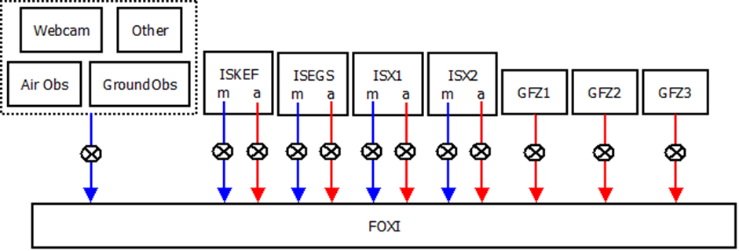

Figure 22. Plume height data channels which can be controlled by the operator (with crossed circles illustrating switches). Red arrows symbolize auto-stream channels (“a”), while manually added data (“m”) are fed via channels marked in blue. This example refers to the Icelandic FutureVolc setting.

In the plume height control panel (Figure 21) the “switches” for each channel are displayed as checkboxes. If a box is unchecked, the channel is disconnected. By default all assigned channels are checked, if no other setting have been saved before the menu is opened.

The first column of checkboxes on the left of the screen (titled “auto.”) represent the switches for the auto-stream data channels. The input flow of manually added data is controlled by the checkboxes in the second column (titled “man.”).

If the checkbox next to ALL MANUAL INPUT is unchecked, the manually added (non-auto-stream) data will not be considered for plume height processing within FOXI.

The right side of the plume height control window gives an overview of the current sensor status, distance and location of the sensors, and expected data quality, which helps the operator to select the optimal input channel settings.

### Overview panel for sensor status and ash plume detectability

The plume height control panel displays an overview of the sensor status and plume detectability in a panel on the right of the screen (Figure 21). The first column from the right, labelled “**eruption column**”, shows information about the principal detectability of the eruption column for each sensor, which provides a qualitative indication of the data quality that can be expected from that source. FIX bases this prediction on the distance between the respective sensor and the vent, which is displayed in the column “**distance to vent**”. The column “**sensor located**” indicates if the sensor is located easterly (marked by a red “E”) or westerly (marked by a blue “W”) from the vent.

Note that the distances have been imported from the *volc_database.ini* file after FIX has been initialized. If a mobile radar station has been relocated, the corresponding entry has to be modified within the data base, and FIX has to be terminated and restarted. (An analogous operation is required if other volcanoes need to be included in the database, see section 3.3.)

**C-band radar** and **X-band radar**:

The expected quality attributed to data from each of the radar instruments is quantified by assigning a quality factor following the decision routine presented in Table 4.

Table 4: The allocation of quality factors to the data from radar sensors is assessed using the distance of the instrument from the vent.

|  |  |  |  |
| --- | --- | --- | --- |
| radar type | distance (km) | displayed text | quality factor |
| C-band | <120 | WITHIN OPTIMAL RANGE | 3 |
| <200 | WITHIN FAIR RANGE | 2 |
| <255 | WITHIN LIMITED RANGE | 1 |
| >255 | OUT OF RANGE | 0 |
| X-band | <60 | WITHIN OPTIMAL RANGE | 3 |
| <120 | WITHIN FAIR RANGE | 2 |
| <180 | WITHIN LIMITED RANGE | 1 |
| >180 | OUT OF RANGE | 0 |

We note that, if a radar station is considered to be out of range, a quality factor of 0 will be assigned to any data coming from it. These data will then be discarded, even if the corresponding data channels are switched on.

The fourth column from the right, titled “**status**” informs the operator if the source is online and available or is not providing data (displaying “ONLINE” or “OFFLINE”, respectively).

**Web cameras**:

The web cameras are mounted at a fixed position and are directed to observe a specific volcano. In case of the cameras CAM1 – CAM3 in the FutureVolc setting, on Hekla. This implies that all other eruption sites would be out of range. Therefore, only one of two possible statements can be displayed:

* WITHIN RANGE
* OUT OF RANGE

In addition to the online status of the web cameras the current visibility conditions are also presented. This information is automatically provided by the cameras along with the plume heights (see Appendix D) and can be found in the third column from the right on the plume height control panel (Figure 21), labelled “**visibility**”. Plume height information obtained from the web cameras are assigned a quality factor which is linked to the visibility, as shown in Table 5.

Table 5: Visibility conditions and quality factors for data from FutureVolc cameras

|  |  |  |
| --- | --- | --- |
|  | displayed text | quality factor |
| web cameras | CLEAR VIEW | 4 |
| FAIR VISIBILITY | 3 |
| RESTRICTED VISIBILITY | 2 |
| VERY LOW VISIBILITY | 1 |
| OUT OF RANGE | 0 |
| OFFLINE |  |

Note that, if no data file is provided by these web cameras, FIX displays “OFFLINE”.

The plume height sensor settings are saved by clicking on the button “Update settings” located at the left bottom of the window. FIX confirms the update by returning a message:

*** settings updated! ***

If the window is closed without having clicked on the update button any change in the entries will be discarded.

**Important Note**:

Changes are only saved if confirmed by clicking on the “Update Settings” button!

## “Calibration”

FIX offers the possibility to apply a linear correction to the auto-stream plume height data provided by the radar stations. This re-calibration of plume heights could become necessary if e.g. data from a radar sensor shows a systematic offset.

After opening the “calibration” menu (see Figure 23) by clicking on the “Calibration” button within the “FOXI control panels” section of the Operation Control Board, the operator can specify the **offset *A*** (in km) and the calibration factor **“cal.f.” *B*** for each of the radar sensors. Radar sensor channels which are not assigned are marked by “n.a”.



Figure 23. Radar calibration window

FOXI considers these calibration parameters when importing the plume heights of the corresponding sources via an auto-stream channel by applying

|  |  |  |
| --- | --- | --- |
|  | $$h_{cal}=A+Bh$$ | (1) |

where *H* and *h* are the corrected and the original plume height, respectively. If the calibration parameters *A* and *B* have not been assigned, the default values are initialized to 0 km and 1, respectively. Note that the manual input channels are not affected by these calibrations.

The calibration parameter settings are saved by clicking on the “Confirm” button located at the bottom of the menu. FIX confirms the update by returning a list of the updated parameters. For example:

ISKEF offset (A): 0.5

ISKEF cal.factor (B): 1.0

ISEGS offset (A): 0.0

ISEGS cal.factor (B): 1.0

ISX1 offset (A): 0.0

ISX1 cal.factor (B): 1.0

ISX2 offset (A): 0.0

ISX2 cal.factor (B): 1.0

*** settings updated! ***

If the window is closed without having clicked the “Confirm” button, any change in the entries will be discarded.

**Important Note**: Changes are only saved when having clicked the “Confirm” button!

## “Analysis Mode”

In the analysis mode, the operator is provided with additional information on plume height data streams and model predictions. When FOXI is run in the analysis mode, eight output files are generated in addition to the standard output, listing MER results for all individual models and all selectable time bases. In addition to that, two extra plots are generated which provide plume height source stats (for details see section 5.6.4).

This mode can be activated by opening the “Analysis Mode” menu (see Figure 24), selecting “ON” and clicking on the “Confirm” button. FIX returns the message

*** settings updated! ***

If the window is closed without having clicked on the update button any change in the entries will be discarded.



Figure 24. Analysis mode menu

The additional output provided in thus mode can help the operator to find the optimal settings for model weight factors and time base. However, it might increase the need of memory, which could potentially become an issue in long term runs.

Hence, by default the analysis mode is deactivated.

**Important Note**:

Changes are only saved when having clicked on the “Confirm” button!

## “Set Time Base”

The time base is a crucial parameter for FOXI. It specifies the time frame within which plume height and external MER estimates are considered for the computation for RMER and FMER. The corresponding menu is presented in Figure 25, which is opened by clicking on “Set Time Base” in the FOXI operation control box (Figure 16).

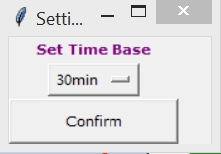

Figure 25. Menu for setting the time base

The window consists only of a confirmation button and a drop down menu, which offers five time base settings:

* **15min**
* **30min**
* **1h**
* **6h**
* **Auto30**

In addition to the four fixed time values (15 min, 30 min, 1 h and 6 h), a variable time base is available through the option “**Auto30**”. With this setting, in each run FOXI compares the average plume heights based on a 30 minute time base with those based on the last 15 minutes. If the difference between these two values does not exceed a certain threshold (being 1 km in FOXI 19.0), the program continues with a time base set to 30 minutes. Otherwise it switches to 15 minutes, which allows FOXI to monitor the change in mass flux with a higher temporal resolution (see also section 5.5.4).

It is a task for the operator to find the best time base, since this will significantly affect MER estimates calculated by FOXI. Using a short time base means that changes in the mass flux of the monitored plume will be detected with a high temporal resolution, provided that enough input data are available. However, if this is not the case (for example if the input data rate is too low) a short time base could cause missing data in the input, which would affect the accuracies of the RMER and FMER estimates. The “Auto30” option is an attempt to reconcile the aim of high temporal resolution for MER estimate with the possibility of not acquiring new observational data if the time base for computation is too rapid.

If the time base has not been specified, “**Auto30**” is selected by default.

The time base settings are saved by clicking the “**Confirm**” button. FIX confirms the update by returning the message

*** settings updated! ***

If the window is closed without having clicked on the confirmation button any change in the entries will be discarded.

**Important Note**: Changes are only saved when having clicked on the “Confirm” button!

## “Add Plume Heights”

To manually add plume height data, the operator has to click on the corresponding button on the left centre of the Operation Control Board (Figure 16); Figure 26 illustrates the window that is opened.

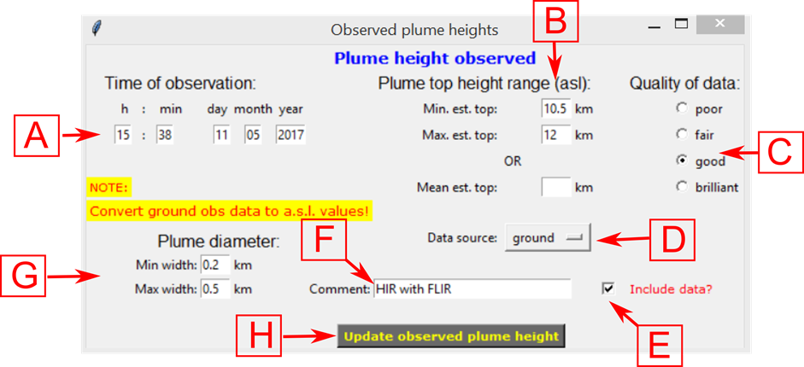

Figure 26. Interface that allows the operator to manually add information on observed plume heights (see text)

In the following the features of this window are briefly described:

* **Time of observation** (field A in Figure 26): specifies the time of the observation of the plume height data that is to be added. By default, this field suggests the current system time.
* **Plume top height range (a.s.l.)** (B): The operator can *either* specify the range of variation of the observed plume top heights by inserting the minimum and maximum heights into the field **Min. est. top** and **Max. est. top**, *or* specify the **Mean est. height**. Note that the latter field is treated with priority, meaning that if all three fields are filled, the minimum and maximum values are not considered. Instead, lower and upper boundaries are assigned automatically by FIX (see below).

**Important Note**: When entering plume heights from ground observations, make sure that the data you add is converted to the a.s.l. (above sea level) height standard!

* **Quality of data** (C): In this field, the quality of the added data set can be characterized by the user. The four quality grades represent the quality factors that are automatically assigned to the data from auto-stream sources (see e.g. in Table 5; “poor” corresponds to a quality factor of 1, “fair” to 2, “good” to 3 and “brilliant” to 4). The quality factor that is input via this window will only be considered for non-autostream sources (i.e., “aircraft”, “ground” and “other”). By default, a quality factor of 4 (“brilliant”) is assigned. If one of the (up to twelve) radar stations has been specified as source, the quality factor of the according auto-stream channel is automatically assigned to the newly added plume height data set.
* **Data source** (D): A drop down menu (see Figure 27) allows the user to specify the source of the data set to be added. Note that in the shown example “ISKEF”, “ISEGS”, “ISX1” and “ISX2” represent the “manual data channels” of the radar sensors in Figure 21, which can be individually switched on and off (see section 4.5.1). By default, this menu is set to “ground”.

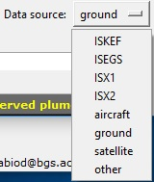

Figure 27. Selectable data sources in the “Add plume height” window. This example shows the menu for the Icelandic FutureVolc setting

* **Include data?** (E): If this checkbox is unchecked, the data set to be added will not be considered by FOXI. By default the checkbox is checked.
* **Comments** (F): Comments filled in here will be attributed to the data set.
* **Plume diameter** (G): minimum and maximum estimates for the width of the plume at the top. The width of the plume is needed to convert plume top heights to centreline plume heights (assuming a cylindrical symmetry).
* **Update observed plume height** (H): Press this button to add data set.

If only a mean height value is added, FIX automatically attributes a range of uncertainty, depending on the characteristics of the source and distance *d* to the vent. Following Arason (2015) and considering the sensor-specific radar beam width *bw*, the following equation is used to compute the uncertainties of plume heights detected by radar sensors:

$∆h=\frac{1}{2}∙d∙\tan\left(\frac{bw∙π}{180}\right)$ (2)

Table 6: Uncertainties assigned to mean plume heights.

|  |  |
| --- | --- |
| **Data source** | **assigned error (m)** |
| C-band radar | *according to eq. (2*) |
| X-band radar |
| aircraft | 1000* |
| ground | 1500* |
| satellite | 1000* |
| other | 1500* |

* Note that the error range of these data sources can be manually specified by the operator.

All manually added data sets are saved in the file *fix_OBSin.txt*, a simple text file which can be easily modified if necessary (for details, see section 5.4.1).

The settings are saved by clicking on the “Update observed plume height” button (H). FIX confirms the update by the returning the message

***observed data stored!***

*** settings updated! ***

If the window is closed without having clicked the update button any change in the entries will be discarded.

**Important Note**: Plume heights are only added if the “Update observed plume height” button has been clicked!

## “Conv MER Models”

In addition to the five REFIR-internal plume height models, FOXI is also able to import MER estimates from the model of wind-affected volcanic plumes, **PlumeRise**, provided by and executed externally by partners of University of Bristol. In reference to its developers, *Woodhouse et al.* (2013), this model is also referred to by the label “**Woodhouse**”.

Together, the REFIR-internal and Woodhouse models are denoted “**conventional models**”. Their outputs are merged by calculating the weighted average using factors which have to be specified by the operator (see Figure 28).

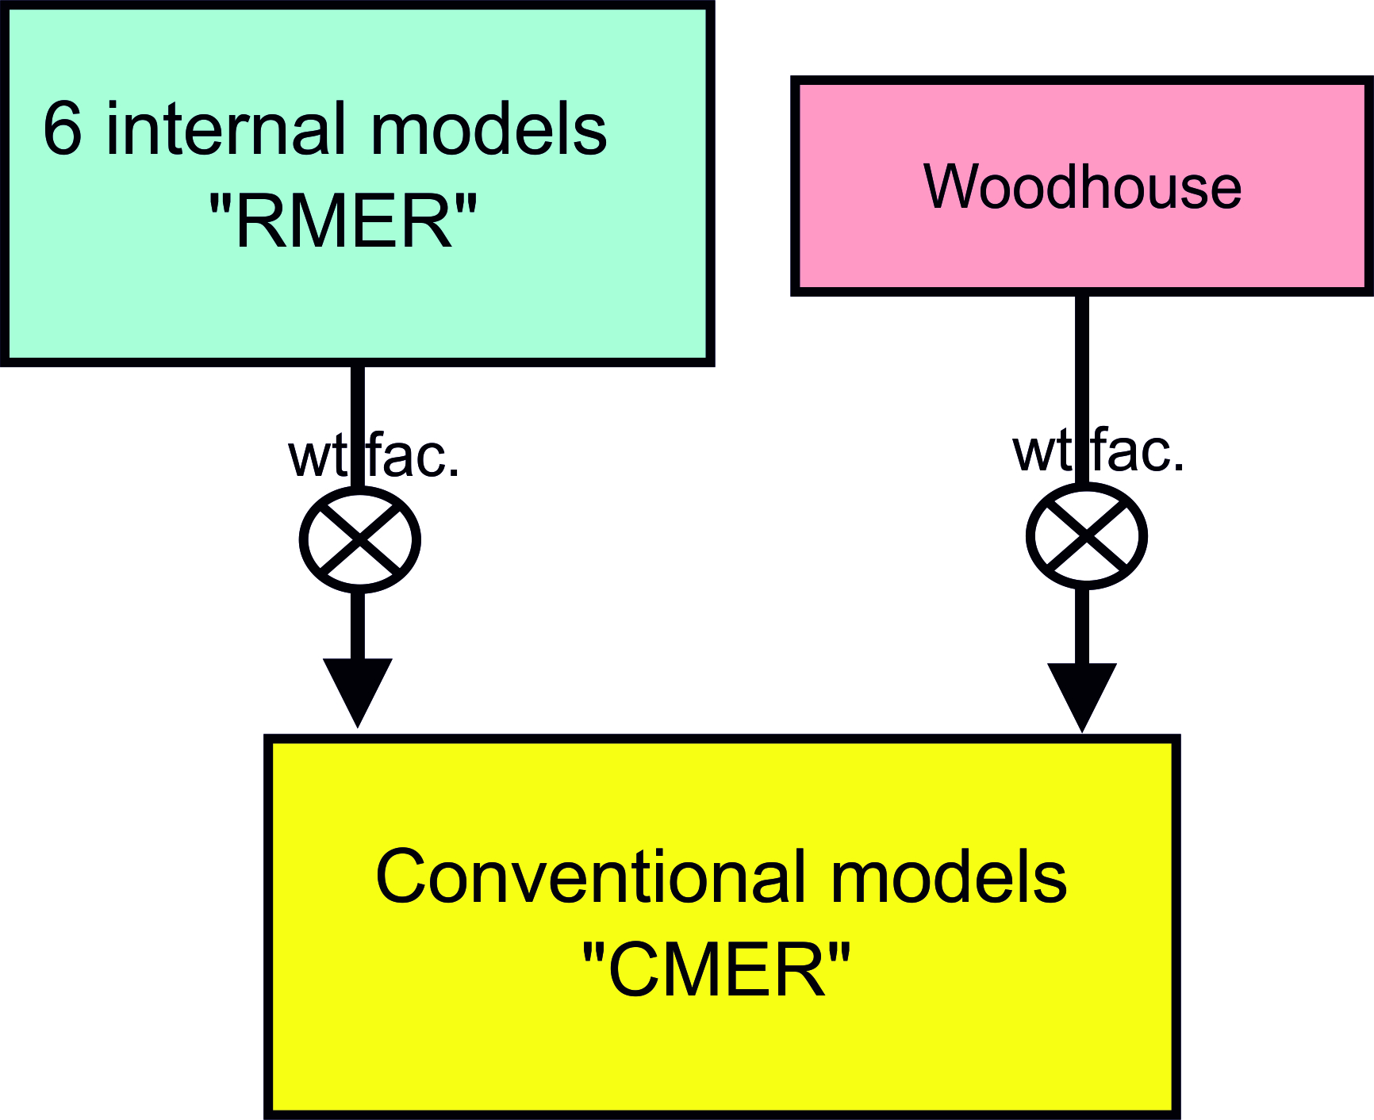

Figure 28. Computation of MER based on conventional models

The corresponding menu (see Figure 29) can be opened by clicking on “**Conv MER Models**” at the right centre of the Operation Control Board.

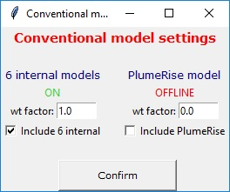

Figure 29. Menu for conventional MER model settings

Under a status information display, the weight factor for the **6 internal models** are specified on the left entry field, while that for the **PlumeRise** model is located on the right side.

A check box allows the operator to switch each of them on and off.

The settings are saved by clicking on the “Confirm” button. FIX then returns the message

*** settings updated! ***

If the window is closed without having clicked the button any change in the entries will be discarded.

**Important Note**: Weight factors are only stored if the “Confirm” button has been clicked!

## “Exp. MER Systems”

FOXI includes a feature to import MER estimates provided by four independent sensors. Since they are all in an experimental stage, their MER estimates are hereby denoted “experimental”. The influence of individual experimental sensors can be regulated by assigning a weight factor (denoted *fi* in eq. (19), see section 5.8.1) as illustrated in Figure 30.



Figure 30. Quantification of the “exp. MER” by experimental systems and considering weight factors.

Experimental MER settings can be edited by clicking on “Exp MER Systems” in the Operation Control Board. The corresponding menu is shown in Figure 31.

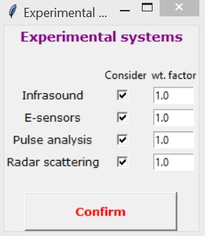

Figure 31. Menu for experimental MER systems

The checkboxes represent switches. If unchecked, the data from the corresponding sensor will not be considered by FOXI. Note that by default all sensors are switched off.

The settings are saved by clicking on the “Confirm” button. FIX then returns the message

*** settings updated! ***

If the window is closed without having clicked the button any change in the entries will be discarded.

**Important Note**: Weight factors are only stored if the “Confirm” button has been clicked!

## “FMER”

FOXI is designed to merge the mass flux estimates by conventional models (CMER), MER estimates by the experimental sensors and those from other sources (which have been fed by manual input, see section 4.13) in order to provide a constrained “final best MER estimate”, denoted FMER. The operator has full control over the influence that each of these three groups of MER sources will have on the FMER (see Figure 32) by selecting appropriate weight factors.

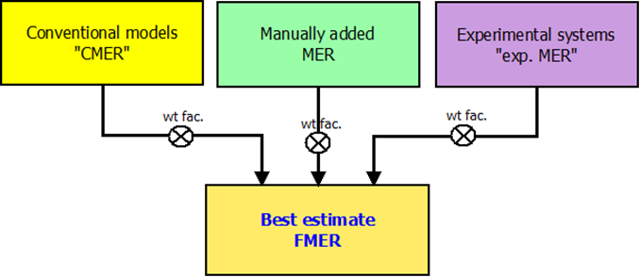

Figure 32. Flow chart illustrating how the influence of each MER source group on the final estimate FMER is regulated via weight factors.

These weight factors are specified within the FMER settings menu (see Figure 33), which is opened by clicking the “FMER” button on the operation control board (Figure 16).

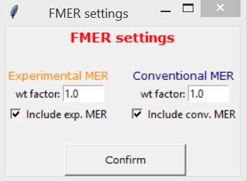

Figure 33. FMER settings menu

Under the entry fields for the weight factors (**wt factor**) of each group of MER estimates, checkboxes allow the operator to decide if these estimates should be included in the calculation of the FMER. (Note that inserting a weight factor value of zero has the same effect as unchecking the checkbox under the entry.)

Weight factors for the manually added MER are not assigned in this window. Instead those values are individually specified by the operator via the “Add MER Estimate” window (see section 4.13).

Note that by default the experimental MER is switched off.

The settings are saved by clicking on the “Confirm” button. FIX then returns the message

*** settings updated! ***

If the window is closed without having clicked the “Confirm” button any change in the entries will be discarded.

**Important Note**: Weight factors are only stored if the “Confirm” button has been clicked!

## “Add MER Estimate”

To manually add MER estimates, one has to click on the “Add MER Estimate” button, located at the lower left of the Operation Control Board (Figure 16). A menu is then opened which is presented in Figure 34.

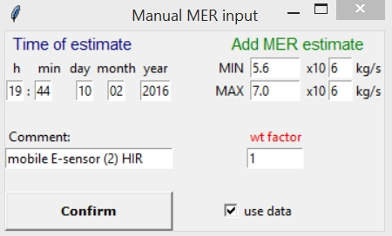

Figure 34. Menu for manual MER input

At the upper left, the **time of the estimate** is specified. By default the system time is displayed.

The lower (**MIN**) and upper (**MAX**) boundaries of the estimated MER is specified on the upper right side of the panel. The right entry fields represent exponents. (In the example shown in Figure 34, the mass flux has been estimated to be between 5.6•106 and 7.0•106 kg s-1.)

The **weight factor** for this data set is inserted below. (Note that this is zero by default and has to be adjusted, if the data set should be included.) Comments can be added in the corresponding entry field on the left side of the panel. At the bottom, a checkbox labelled “**use data**” is activated by default. If this data set should be ignored by FOXI, this box should be unchecked.

MER input is saved by clicking on the “Confirm” button. FIX then returns the imported MER values and returns the message

*** settings updated! ***

All manually added MER data are saved in the file “*fix_MERin.txt*” and can be easily modified, if necessary (see 5.8.2 for the format).

If the window is closed without having clicked the “Confirm” button any change in the entries will be discarded.

**Important Note**: Weight factors are only stored if the “Confirm” button has been clicked!

## “Output Control” and REFIR maps

The output settings menu (see Figure 35) is opened by clicking on “Output Control” button located at the lower right of the Operation Control Board (Figure 16).

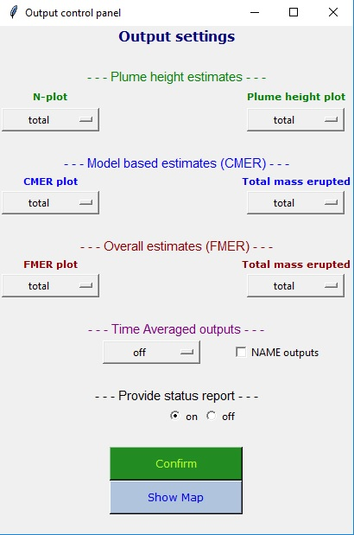

Figure 35. The output control menu

The panel is divided into eight rows, marked by different colours that represent the three data levels illustrated in Figure 1. Note however that here the “blue” group also includes **PlumeRise** (meaning that CMER is considered for the output control instead of RMER).

Up to six plots generated by FOXI can be controlled by this window (see Table 3 in section 2.5, lines 27-32). The selection of the plots is controlled by drop down menus, which also provide additional settings as follows:

* **off**: plot is omitted.
* **total**: plot over the total time axis of the eruption (Note that the beginning of the eruption is specified by the operator, when initializing FOXI.)
* **last 12h**: plot over the last 12 hours (145 data points per curve)
* **last 6h**: plot over the last 6 hours (73 data points per curve)
* **last 1h**: plot over the last hour (13 data points per curve)
* **last 15min**: plot over the last 15 minutes (4 data points per curve). (This setting can be applied when a change in the general settings has been made and previous data has to be post-processed.)

By default, all plots are set to “total”. In addition to the plot settings, the status report can be switched on and off by the operator (with the default setting being “on”).

Additionally, the operator can save time-averaged results of FMER and plume height by clicking on the menu below “Time Averaged outputs” and selecting the time window (15 minutes, 30 minutes, 1 hour, 3 hours, 6 hours). If one of these time windows are chosen, the output are time-averaged over that time interval and saved in the files “_tavg_FMER.txt” and “_tavg_PLH.txt”. Finally, the operator can activate the production of files that store the average, maximum and minimum solution of the eruption source parameters calculated by REFIR in a format that can be used by NAME, the UK Met Office ash dispersion model (Jones et al., 2007). The files are named “_NAME_sources_avg.txt”, “_NAME_sources_max.txt”, “_NAME_sources_min.txt”.

All changes are taken over when the “Confirm” button is clicked.

If the window is closed without having clicked the “Confirm” button any change in the entries will be discarded.

By clicking on “Show Map”, FIX generates two maps, which show the locations of all eruption sites and sensors listed in the according “.*ini*” files. The maps are saved in both “.png” and “.svg” format under the file names “map1” and “map2”. While “map1” gives an overview over all potential areas of monitoring (see Figure 36), “map2” shows the selected eruption site in close view (see Figure 37).



Figure 36. Example of a REFIR overview map generated by FIX

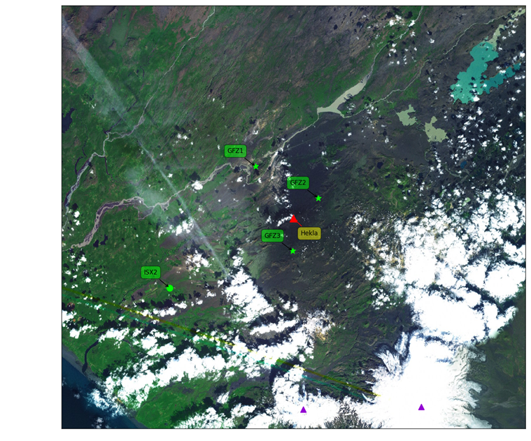

Figure 37. Example of a REFIR close-up map generated by FIX

The following list gives the legend of the REFIR maps:

* **Eruption sites registered by REFIR** are marked by purple triangles
* **The selected eruption site** which is currently monitoredis marked by a red triangle and a label showing its name.
* **C-band radar stations** are marked by circles with a label indicating its ID
* **X-band radar stations** are marked by squares with a label indicating its ID
* **Automatic plume tracking webcams** are marked by stars

The colours of the sensors indicate if they are switched on (“green”) or off (“orange”). (It is to note that this colour indicator exclusively indicates the checkbox status within the plume height sensor control panel (Figure 21). It does, e.g., not reflect if a sensor is out of range. Hence a sensor which is shown as “switched on” in a map, does not necessarily stream data or is considered by FOXI.)

# Functionality of FOXI

FOXI is the core of the REFIR system, working completely autonomous after being initialized, featuring a repetition rate of 5 minutes. This chapter describes the functionality of the current version of FOXI (FOXI 19.0). The processing steps and the data flow within FOXI 19.0 are illustrated in Figure 38. A detailed flow chart can be found in Appendix B.

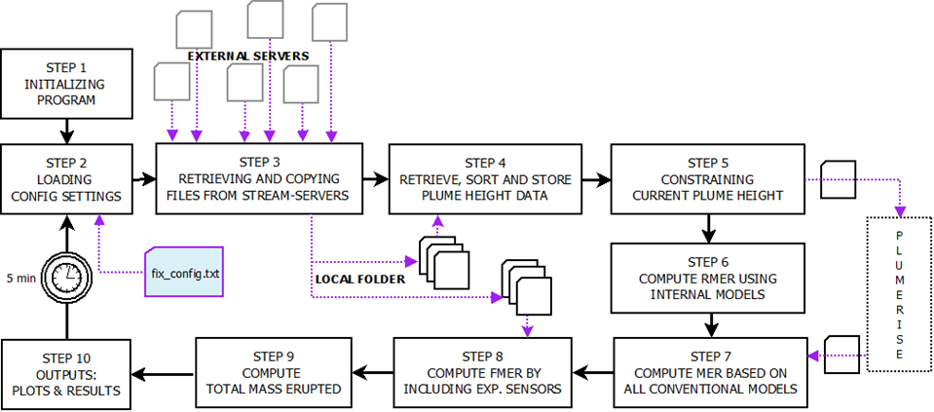

Figure 38. Flow chart illustrating the main data processing steps of FOXI. After being initialized, the program iterates a loop (step 2 – step 10) every 5 minutes.

The following sections detail each of the procedures indicated in Figure 38.

## Step 1: Initializing the Program

After starting FOXI, a window which requests the input data is displayed to the operator (see Figure 39). The following settings are required.

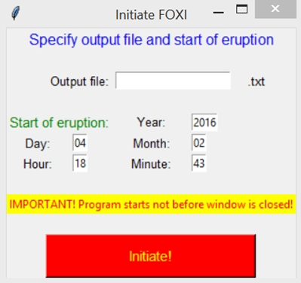

Figure 39. Start window of FOXI

“Output file”: In this entry field, the operator specifies the name of the output file. This identifier will be inherited in all output files. For example, if the output file for the event is chosen to be “katla16” the plot for the FMER will be saved under the name “*katla16_FMER_plot.png*” (see Table 2).

Note that if a file name is selected that was already used before within the same working folder, FOXI will **not** overwrite the files, but will append new output data to the existing ones. This feature allows the operator to continue interrupted operations (e.g. if FOXI is unwillingly aborted) without losing already processed information.

If no output name is selected, “*default_fox*” is assigned by default.

**Important Note**: Check the working directory before initializing FOXI. Make sure that you do not use an identical name to a previous event, unless you want to continue to monitor it.

**“Start of eruption”**: year, day, month, hour and minute of the start of eruption have to be specified. By default, the fields display the current time and date. Since this data defines the origin of time axis, it is strongly recommended that the same start time and date are used for identical events. This applies particularly for cases when resuming the monitoring after an interruption of FOXI runs. Note that any entry in these fields will be neglected when running in reanalysis mode, since the start (and the end) of the eruption will be recorded via the FIX menu shown in Figure 13.

**“Initiate!”**: When pressing this button, the parameters are adopted from the entry fields. The program returns the message

time since eruption: 34min

Configuration completed!

Waiting for Initiation

with the first line showing elapsed time (in minutes) since the onset of the eruption.

It is essential to note that after pressing the “Initiate!” button, the program still holds until the window is closed.

**Important Note**: After initialization, FOXI is ready to run, but still on hold.

To launch the monitoring procedures you have to **close** the start window!

After closing the window, FOXI enters the loop and proceeds to step 2.

## Step 2: Loading the Configuration Settings

All relevant system parameters are read from the file “*fix_config.txt*”. All changes in the settings communicated by the operator via FIX will be adopted in this step. A list of these parameters is presented in Appendix A. After the successful data transfer, the program returns the message

***** step 2 successful *****

## Step 3: Retrieving and Copying Files from Auto-Stream servers

In this step FOXI transfers the streaming data by copying files from their respective servers into the working folder. The IP (or URL) of these external servers, the directories and name of the source files are specified in the sensor-specific “.*ini*” files and can be easily adjusted to any monitoring network.

The following sequence of stops is performed for each streamed file:

1. FOXI checks if the data input channel in question is switched on by operator. If it is not, the following steps are skipped and a sensor-specific message is returned. For example,  
    ISKEF: automatic data stream switched OFF
2. FOXI attempts to connect with the streaming server and returns a confirmation if successful. For example,

>>> ISKEF >>> connected!  
Otherwise, a sensor-specific warning message is displayed and the next step skipped. An example for such a warning is

!! WARNING: ISKEF streaming site offline!

1. FOXI retrieves a data file and saves it on in the local working directory. Files from the run before are overwritten in this step. If successful, a confirmation message is displayed:

OK - file transferred!  
Otherwise, a warning message is returned, e.g.

!! WARNING: No source file found for ISKEF!

Note that, if a server is not available by FOXI, then step ii might consume considerable time (in the trials up to ~20 s) before the warning message is returned and the next file is requested. It is therefore recommended to switch off all “unnecessary” data input channels, i.e. to switch off auto-stream channels from servers which are known to be offline.

## Step 4: Retrieve, Sort and Store Plume Height Data

In this step, plume height data are imported by subroutines which check, retrieve, sort and store the data sets from the locally stored plume height source files. These procedures are abbreviated “CRSS” (see also flow chart in Appendix B) and are conducted in two different variants, depending on the source type.

### Plume Height Data from Non-automatic Stream Sources

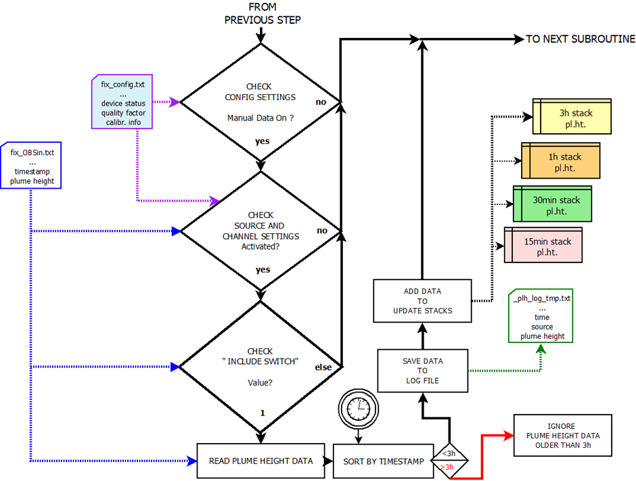

Figure 40. CRSS processing steps for non-auto stream plume height data.

The first data file to be processed is the file *fix_OBSin.txt*, in which all plume height data that have been manually added by the operator are stored (i.e. non-automatically streamed data, also denoted “data from non-auto stream sources”).

The steps within the CRSS subroutine for non-automatic stream data are illustrated in Figure 40. At first it is checked if the option for processing manually added data has been switched on in the configuration settings. If this is not the case, the program skips the complete data retrieval procedure for all non-auto stream data and returns the message

All non-auto stream data switched OFF!

Otherwise, it continues by importing the first data set (which is the first line of the file).

The imported data set contains the following information (starting from the first column to the left):

* date and time of observed plume height
* <include> flag indicating if this data set should be included;
* source (an ID number, according to Table 7 in section 5.4.4);
* minimum height estimate of plume top (if it had not been put in manually, this value has been calculated by subtracting the uncertainty from the average height)
* average height estimate of plume top (if it had not been put in manually, this value has been calculated by computing the average of minimum and maximum estimates of the plume top height)
* maximum height estimate of plume top (if it had not put in manually, this value has been calculated by adding the uncertainty from the average height)
* uncertainty of plume height (which has been assigned by FIX, see section 4.9)
* quality factor (which has been assigned by FIX according to the source, see Table 4 and Table 5 in section 4.5.2)
* a flag indicating if the plume height values have been computed on the basis of one (“1”) or two (“2”) entries
* a placeholder (in the current version always assigned to “9”)
* minimum width of the plume top
* maximum width of the plume top
* timestamp of manual entry
* additional comments (i.e., the entry from the “Comment” field of the plume height input window, see Figure 26 “F”).

In the next step the program checks the source-specific channel settings, specified in the configuration parameters. A data set is only processed further if the “manual input channel” to which the checked data set is associated with is switched on (see section 4.5). Otherwise, this data set is discarded and the next data set is retrieved. This is also the case for data sets that have been individually masked out by the operator (see section 4.9). Only manually added plume height data with an <include> value of 1 are passed on for further processing.

In the subsequent step, the time stamp of the data set is compared to the current system time and the “age” of the data set is calculated. The data set is discarded if it is older than 180 minutes. Otherwise, its content is written into a plume height log file (named *<outputname>_plh_log_tmp.txt*). In addition, the data set is stored in data repositories (in FOXI denoted “stacks”), depending on its age. Four potential stacks are available:

* 15 minutes stack: contains only plume height data not older than 15 minutes
* 30 minutes stack: contains only plume height data not older than 30 minutes
* 60 minutes stack: contains only plume height data not older than 60 minutes
* 180 minutes stack: contains only plume height data not older than 3 hours

For example, plume height data which was observed 20 minutes ago would be found in three stacks; those for 30, 60 and 180 minutes data.

A data set stored in a stack consists of the following information: age (in minutes), minimum plume height, average plume height, maximum plume height, quality factor, source, flag (here identical to <include>).

After adding the data to the stacks, a new CRSS procedure is started for the next data set retrieved from the source file *fix_OBSin.txt*. When the last data set of this file is processed, the program starts to process data from automatic stream sources.

### Plume Height Data from Automatic Stream Sources

Significant parts of the CRSS subroutines for auto-stream plume height data (see Figure 41) are identical to those for the manually added plume height data (see Figure 40).

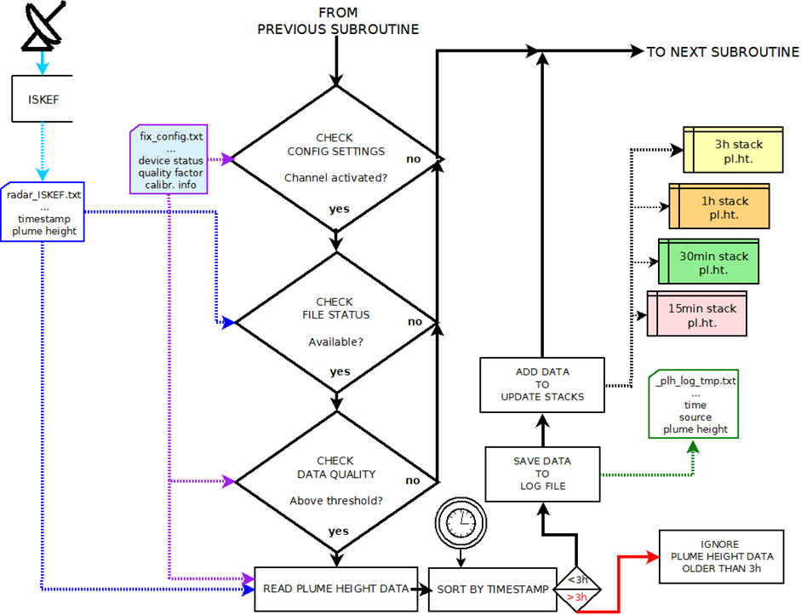

Figure 41. CRSS processing steps for automatic stream plume height data.

The only difference occurs within the first four steps: after a source-specific channel check, the availability of the file is verified. The major difference to the procedure applied to data from non-auto-stream sources, however, is an additional data quality check conducted in the following step. It is checked if the quality factor attributed to the source via the configuration settings (imported from *fix.config.txt*) is above a threshold value. In the current version of FOXI this threshold is zero. Data sets that “fails” this quality test are discarded.

(FIX assigns e.g. a quality factor of 0 to data sets from a radar station that is considered to be out of range for detecting the plume over the vent. In this case no data will be considered by FOXI, even if the respective channel for this radar sensor is switched on and some data is streaming.)

In the case of C- or X-band radar-stream data, the data import procedure is also linked to a special function, which adjusts the plume heights according to the source-specific calibration factors specified by the operator via FIX. This adjustment is performed according to eq. (1) (see section 4.6).

The remaining steps of this procedure (sorting and storing the data sets according to the time stamps) are identical to those described for data from non-automatic sources (see section 5.4.1) and the same data stacks are used, as described above. For C- or X-band radar-stream data, source specific uncertainties are computed according to eq. (2), while the webcams provide the range of error by themselves.

Although the data import functions for C-band radar, X-band radar and the FutureVolc cameras vary in detail (which allows FOXI to read different file formats), schematically, the same CRSS subroutines are applied to all data from automatic stream sources.

The chronological order for the data files that are CRSS processed is as follows:

1. data from the (up to 6) C-band radar stations
2. data from the (up to 6) X-band radar stations
3. data from the (up to 6) webcams.

For example, with the Icelandic “Futurevolc” configuration the processing order would be:

1. *radar_ISKEF.txt*: data from the C-band radar station Keflavík (ISKEF)
2. *radar_ISEGS.txt*: data from the C-band radar station Egilstaðir (ISEGS)
3. *radar_ISX1.txt*: data from the mobile X-band radar station ISX1
4. *radar_ISX2.txt*: data from the mobile X-band radar station ISX2
5. *cam1.txt*: data from the automatic webcam CAM1
6. *cam2.txt*: data from the automatic webcam CAM2
7. *cam3.txt*: data from the automatic webcam CAM3.

### Format of plume height data from radar and cameras

FOXI can interpret plume height data from radar and auto-tracking webcams in a specific format. However, each observatory and/or civil protection agencies has its own format that might significantly differ from others and change over time. Additionally, the way the data are transferred might be significantly different. Since it is unpractical to create a tool/script capable of interpreting all the formats from all the observatories and civil protection agencies worldwide, the most realistic and feasible option is to define a FOXI-specific format for the streamed data (radar and webcams). It is then the operator’s duty to make these data readable by FOXI, for example by creating an ad-hoc script for downloading the data in the working folder and convert them to the FOXI format. The script radar_converter.py provided in the package is a working example designed for using the radar data currently streamed by the Icelandic Met Office for the Futurevolc configuration (<http://brunnur.vedur.is/radar/vespa/>).

For radar data, the FOXI-specific format is shown in Figure 42. Note that the height is in km above sea level. For auto-tracking webcams, the FOXI-specific format is shown in Figure 43. In the latter, the data are tab-separated. Column with “99” derives from the column “bwidth” in the Cam.ini file (see Fig. 8); it is not applicable for cameras, hence it is ignored. Column with “2” is the “focus” in the Cam.ini file, hence the volcano in the list to which the camera is pointed. The second to last column is the plume height (in km above sea level) and the last column is the uncertainty (in km).

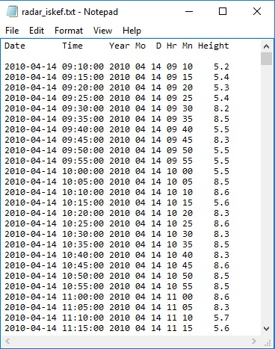

Figure 42. Example of a radar data file usable by FOXI

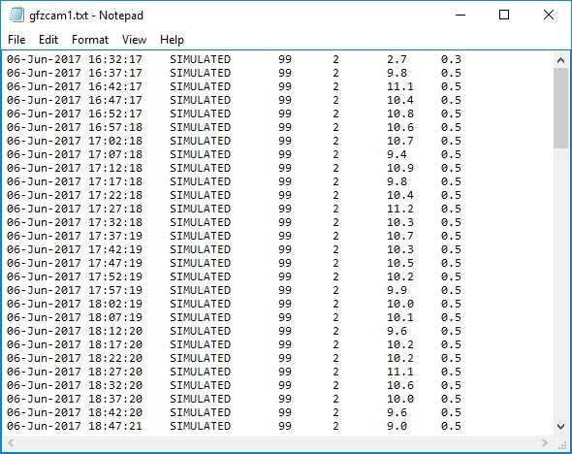

Figure 43. Example of an auto-tracking webcam data file usable by FOXI

### The Output Files *\*_plh_log_tmp.txt* and *\*_plh_log.txt*

As detailed above, for each run, all imported plume height data that are considered for further processing (i,e, stored in at least one of the data stacks) are logged in a text file with the ending *“_plh_log_tmp”*. This file is retained for quality control and allows the operator to keep track of every single plume height input that is processed by FOXI.

Every line in *\*_plh_log_tmp.txt* represents a data set with the following information:

* column 1: date and time of plume height record
* column 2: minimum plume height
* column 3: average plume height
* column 4: maximum plume height
* column 5: quality factor (0: insufficient; 1: poor; 2: fair; 3: good; 4: brilliant)
* column 6: source ID (explanation, see Table 8)
* column 7: <include> (1 if not changed, can be used to “flag” data set)

Note that a data set is logged with every new run, whenever it is considered as suitable input and as long as its time stamp is within the 180 min time frame. This implies the log file can contain re-occurring data sets, which reflects in detail the flow of data input, but might make it difficult for getting a quick overview. If the operator might only want to be updated on new incoming input, this information is more conveniently found in the file *<outputname>_plh_log.txt*. This file is generatedat the end of step 4 by importing and removing all duplicates from *<outputname>_plh_log_tmp.txt.* Hence, the entries have the same format.

Each plume height source is assigned to a specific source ID, presented in Table 7.

Table 7: Identification codes for plume height sources

|  |  |  |
| --- | --- | --- |
| **Source ID** | **Input Type** | **Source** |
| 11 | auto-stream | C-band radar 1 |
| 101 | manual |
| 12 | auto-stream | C-band radar 2 |
| 102 | manual |
| 13 | auto-stream | C-band radar 3 |
| 103 | manual |
| 14 | auto-stream | C-band radar 4 |
| 104 | manual |
| 15 | auto-stream | C-band radar 5 |
| 105 | manual |
| 16 | auto-stream | C-band radar 6 |
| 106 | manual |
| 21 | auto-stream | X-band radar 1 |
| 201 | manual |
| 22 | auto-stream | X-band radar 2 |
| 202 | manual |
| 23 | auto-stream | X-band radar 3 |
| 203 | manual |
| 24 | auto-stream | X-band radar 4 |
| 204 | manual |
| 25 | auto-stream | X-band radar 5 |
| 205 | manual |
| 26 | auto-stream | X-band radar 6 |
| 206 | manual |
| 31 | auto-stream | automatic webcam 1 |
| 32 | auto-stream | automatic webcam 2 |
| 33 | auto-stream | automatic webcam 3 |
| 34 | auto-stream | automatic webcam 4 |
| 35 | auto-stream | automatic webcam 5 |
| 36 | auto-stream | automatic webcam 6 |
| 700 | manual | aircraft observation |
| 800 | manual | ground observation |
| 900 | manual | other source |

## Step 5: Constraining the Current Plume Height

Within this step, the four stacks are processed sequentially, resulting in best estimates for plume heights for the past 15, 30, 60 or 180 minutes. In addition to the best estimates of average plume heights, the minimum and maximum boundaries are constrained.

In the first step of processing the plume height data, the number of data sets *N* within each stack is determined and a summary is provided. An example summary is shown below.

number of plume height data considered by system:

within last 180 min: 27

within last 60 min: 12

within last 30 min: 5

within last 15 min: 2

This information provides the operator with a useful indication of the optimal time base for FOXI. (The larger the number of data, the more reliable the resulting best estimate. On the other hand, the shorter the time base, the higher the temporal resolution of changes in plume heights and MER.)

The subsequent processing depends on the data size *N*.

### Plume Height Constraining Procedures

If the stack analyzed is empty (*N* = 0), the following message is returned:

No plume height data - no calculation possible!

If only one data set is available (*N* = 1), the best estimate for the range of plume heights cannot be further constrained. It is then simply defined by the average, minimum and maximum values of the only available data set.

The plume height range constraining procedures applicable for *N* > 1 are illustrated in Figure 44.

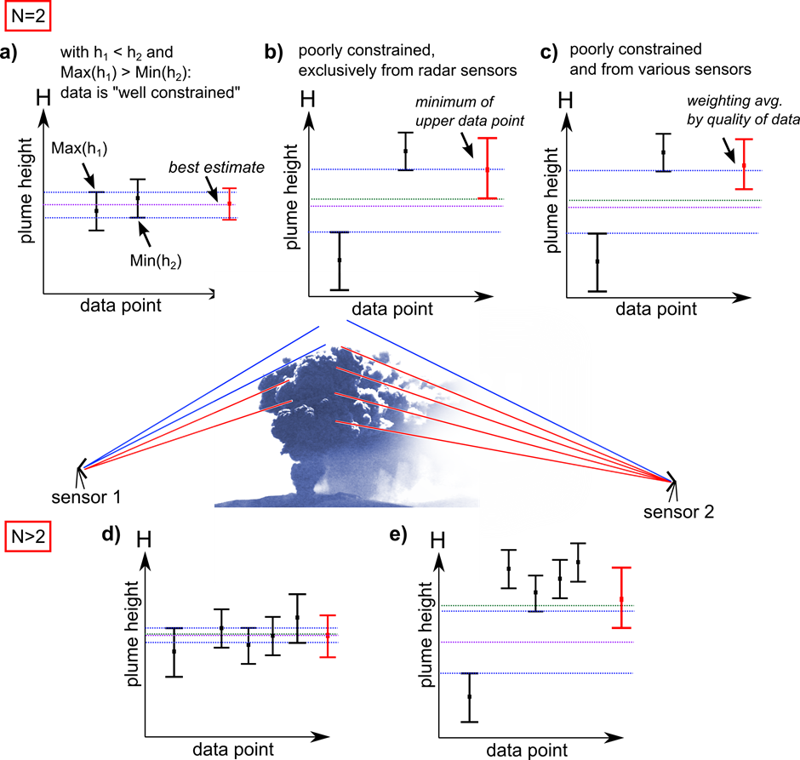

Figure 44. Procedures for constraining and finding best estimate for plume heights (see text).

If the analysed stack contains two data sets (*N* = 2), FOXI distinguishes between three cases that are presented in the upper half of Figure 44:

Figure 44a shows two data sets that constrain the plume height well, since the minimum of the upper range of heights is above the maximum of the lower range of heights. If this condition is fulfilled, the average *havg* is taken as best estimate. The range [*hmin, hmax* ] is determined by the combined error s, according to:

$\begin{matrix}h_{max} \\ h_{min}\end{matrix}=h_{avg}±s$ (3)

with:

$s=\sqrt{0.5}\sqrt{{{∆h}_{1}}^{2}{{∆h}_{2}}^{2}}$ (4)

where *Δh1* and *Δh2* represent the uncertainties (here defined as the range of the data in the data sets 1 and 2, respectively).

If the maximum of the lower height is below the average height, FOXI considers the data set as not well constrained and decides how to proceed on the basis of their source origin.

* In the case that both data points originate from radar sensors (see Figure 44b), it can be assumed that what seems to be contradicting plume height information might in fact be resulting from a gap in the radar coverage, as a consequence of the step-wise radar scanning. In this case, the top of the plume height can be expected to be very close to the minimum boundary of the uncertainty range attributed to the upper plume height value. This is therefore defined as the best estimate with a range of uncertainty calculated by eq. (3) and (4).
* Otherwise (see also **Error! Reference source not found.** 44c), the best estimate is quantified by calculating the weighted average and using the according quality factors as weight factors. For example, let us assume the two data sets originate from a remote C-band radar station located 220km from the vent (quality factor: 1) and from an automatic web cam that observes the plume in perfect visibility conditions (quality factor: 4). The best estimate would then be defined by ${\left(1∙h_{c}+4∙h_{GFZ}\right)}/5$ where *hC* and *hGFZ* represents the average plume heights provided by the C-band radar and the camera. Also here, the range of uncertainties is determined by eq. (3) and (4).

If the analysed stack contains more than two data sets (N > 2), only two cases are distinguished:

* If the maximum of the lowest range of heights is above the plume height average and the minimum of the highest range of data sets is below the plume height average (see Figure 44d), the mean value of all average plume heights is assumed to be the best estimate of the average plume height. Its range is given by eq. (3), using for *s* the standard deviation calculated by the individual uncertainties.
* Otherwise (for example if there is an outlier, see **Error! Reference source not found.** 44e), the quality-weighted average is calculated, as described above. The range of uncertainty is defined by the quality-weighted average values of the individual minimum and maximum values.

As a result of these procedures to constrain the plume height, the plume height data contained in the stacks is condensed to 12 key values: minimum, average and maximum best estimate for plume heights each for a time base of 15, 30, 60 and 180 minutes.

### The Files *\*_hbe_15.txt,* *\*_hbe_30.txt, *_hbe_60.txt, *_hbe_180.txt* and *\*_QUO_LOG.txt*

Along with the plume height constraining procedure, the resulting key values are exported to text files, which are marked by the name ending “*_hbe_*” and a number indicating the respective time base (standing for 15, 30, 60 or 180 minutes).

Figure 45 presents an excerpt of such a file with time base 60:

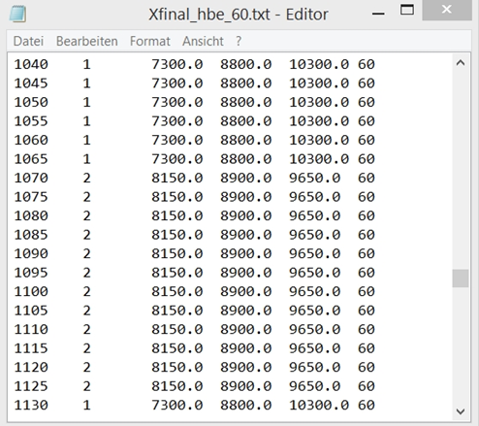

Figure 45. “_hbe_60” file, recorded during the FutureVolc Exercise 2 (2016), Day 2.

Each line represents a data set of one run, with the following entries:

* Column 1: time since onset of eruption (in minutes);
* Column 2: *N*, i.e. number of plume height data processed;
* Column 3: minimum best estimate for plume height (in m);
* Column 4: average best estimate for plume height (in m);
* Column 5: maximum best estimate for plume height (in m);
* Column 6: time base (in min);

These data are the key input parameters for the system-internal models. Therefore, the information provided by these files can help the operator to trace the causes of unexpected or unusual behaviour, for example sudden changes within MER calculation. Moreover, it is easy to identify data gaps and to find an optimal time base setting in order to avoid them. (This aspect is also particularly important for post-processing operations.)

In addition to the four “*_hbe_*” files, also a file named “*\*_QUO_LOG.txt”* is generated which lists just three entries per run:

* Column 1: time since onset of eruption (in minutes)
* Column 2: plume height constraining process code (“PHCP code”)
* Column 3: selected time base during run (in min)

The PHCP code (see Table 8) informs the operator which of the plume height constraining procedures described above has been applied for the data set of the selected time base.

Table 8: Meaning of the PHCP code in the \**_QUO_LOG.txt* file.

|  |  |  |
| --- | --- | --- |
| **PHCP code** | ***N*** | **processed as** |
| **0** | 0 | - |
| **1** | 1 | single data set |
| **2** | 2 | well constrained data |
| **21** | 2 | not well constrained data, both data from horizontally stepping radar |
| **22** | 2 | not well constrained data, not all from horizontally stepping radar |
| **31** | >2 | well constrained data |
| **32** | >2 | not well constrained data |

### The Output File “*Foxi_hbe.txt*”

An additional file, denoted “*Foxi_hbe.txt*”, is generated and exported to an online accessible server. It contains the following data:

* Column 1: time stamp;
* Column 2: time since eruption (in minutes);
* Column 3: volcano identification number (see Table 4);
* Column 4: vent height (in m);
* Column 5: lower boundary of best plume height estimate;
* Column 6: average best plume height estimate;
* Column 7: upper boundary of best plume height estimate;

This data is intended to be imported by a PlumeRise/Foxi interface located and operated by University of Bristol. This system uses the plume height data to determine a best MER estimate on the base of curves which are computed by the numerical model PlumeRise (*Woodhouse et al.*, 2013). The resulting MER values are then exported via a text file named “*PlumeRise_out.txt*”.

Table 4 in section 4.5.2 lists the ID numbers for volcanos as communicated via *Foxi_hbe.txt*.

### The “Auto30” Setting

If the “Auto30” setting has been selected as time base, FOXI compares the average value of the best plume height estimates *havg* calculated on a 30 minutes time base with that based on 15 minutes. If no significant change in plume height has occurred, FOXI uses the larger time base.

If however, the difference between both average values exceeds a certain threshold (currently a threshold value of 1 km is used), FOXI automatically selects a time base of 15 minutes in order to monitor the mass flux changes with high temporal resolution. In that case the operator is informed by a message such as

change in plume height is: 1.1km

NOTE: automatically switched to time base mode 15MIN!

## Step 6: Computing Interim Mass Flux (RMER)

### FOXI-Internal Plume Models

Within FOXI, six 0D single equation plume models are implemented, which are either based on the Morton buoyant plume theory (*Morton et al*., 1956) or empirical correlations between observed plume heights and measured volumes tephra deposits formed of past eruptions (*Sparks et al*., 1997; *Mastin et al*., 2009).

- **“Wilson Walker”:** a theoretical model by *Wilson and Walker* (1987) which estimates the

mass flux *Q* by

$Q_{Wilson Walker}={\left(h/c\right)}^{4}$ (5)

where *h* denotes the plume height (in m) and *c* is a constant which is calibrated to be

236m(s/kg)1/4.

- **“Sparks”**: an empirical model by *Sparks et al*. (1997) which approximates Q by

$Q_{Sparks}={ρ∙\left(h/c\right)}^{3.86}$ (6)

where *ρ* is the DRE of the magma erupted and forming the plume,

and *c* is calibrated to be 1670m(s/m3)1/3.86.

- **“Mastin”**: An empirical model by *Mastin et al*. (2009) which estimates the mass flux

by

$Q_{Mastin}={ρ∙\left(h/c\right)}^{4.15}$ (7)

with *ρ* being 2500 kg/m3 and *c* calibrated to be 2000m(s/m3)1/4.15.

- **“Gudmundsson”**: an empirical model by *Gudmundsson et. al*. (2012) that makes it

possible to adjust the Mastin model to the mapped fallout. In practice this was

done for the 2010 Eyjafjallajökull eruption. In contrast to the first three models,

this model requires both the average and maximum plume heights, denoted by *havg* and *hmax* respectively, and provides a MER estimate as

$Q_{Gudmundsson}={ρ∙a∙k_{I}∙\left(\left(h_{avg}+h_{max}\right)/c\right)}^{4.15}$ (8)

where *c* is the constant from Mastin, 2000m(s/m3)1/4.15, *a* represents a

dimensionless constant which is calibrated to be 0.0564. *kI* is a scaling factor which

was found to be 2.15 for the first (phreatomagmatic) stage (14 – 16 April) of the Eyjafjallajökull 2010 eruption. For the subsequent magmatic eruption phases *kI* dropped to 1.58 for 17 April and 1.59 for 18 April – 22 May (see *Gudmundsson et al*. 2012).

- **Degruyter & Bonadonna”**: this approach is based on an algebraic relationship that is calibrated applying a numerical model by *Degruyter and Bonadonna* (2012), which is based on a combination of the models of *Morton et al*. (1954) and *Hewett* et al. (1971) and is designed for wind-affected bent-over plumes It links atmospheric parameters with plume centreline height *H* and the derived mass eruption rate *Q*, using

$Q_{DegruyterBonadonna}=π\frac{ρ_{a0}}{g'}\left(\frac{2^{5/2}α^{2}{\overline{N}}^{3}}{z_{1}^{4}}H^{4}+\frac{β^{2}{\overline{N}}^{2}\overline{v}}{6}H^{3}\right)$ (9)

where $\overline{N}$ is the average buoyancy frequency and $\overline{v}$ the average wind velocity across the plume height, and where *ρa0* is a reference density for the surrounding atmosphere, *g’* is measured in m/s2 and defined as $g∙\left(\left(c_{0}θ_{0}-c_{a0}θ_{a0}\right)/c_{a0}θ_{a0}\right)$ with g being the gravitational acceleration, *c0* and *θ0* being the source specific heat capacity and temperature and *ca0* and *θ a0* being the heat capacity and temperature of the surrounding atmosphere, *α* and *β* are the radial and the wind entrainment coefficients, and *z1* is the maximum non-dimensional height determined by numerical integration of the non-dimensional governing equations described in *Morton et al*. (1954) (for details see *Degruyter and Bonadonna* 2012). Note the different symbol used for the plume height in this equation, *H*: this is the plume centreline height, which might differ from the top plume height *h* in case of wind-blown plumes.

- **“Woodhouse 0D”**: based on the numerical solution of their integral 1D plume model, Woodhouse et al. (2013) derived an equation linking the rise about the vent *H* in a crossflow and the rise of the equivalent plume in a quiescent environment *H0*:

|  |  |  |
| --- | --- | --- |
|  |  | (10) |

where $W_{s}$ is a dimensionless parameter measuring the strength of the wind field from the ground to a reference height *H1*:

|  |  |  |
| --- | --- | --- |
|  |  | (11) |

in which *V1* is the wind speed at the reference height. In FOXI, the reference height is chosen to be the plume height measured from the sea level.

By using the same 1D integral model, the authors found an approximation of *h0* for a plume rising in a quiescent atmosphere and confined within the troposphere:

|  |  |  |
| --- | --- | --- |
|  | $$H_{0}=0.318Q^{0.253}$$ | (12) |

By combining eq. 10 and 12 and replacing $W_{s}$ with $\tilde{W_{s}}=1.44W_{s}$, which comes from fitting to numerical solution of the dry volcanic plume with constant wind shear in a Standard Atmosphere, Woodhouse et al. developed a new equation linking *h* to the mass flow rate at the source *QWood0D*, which has been implemented in FOXI:

|  |  |  |
| --- | --- | --- |
|  | $$H=0.318Q_{Wood0D}^{0.253}\frac{1+1.373\tilde{W_{s}}}{1+4.266\tilde{W_{s}}+0.3527{\tilde{W_{s}}}^{2}}$$ | (13) |

### Situational Accuracy of Models

Importantly, *H* in eqs. (9), (10), (13) describes the height of the centreline of the plume which, in the case of a wind-distorted plume, is not identical to the top of the plume height (see Figure 46).



Figure 46. Difference between plume top and centreline plume heights. With the width of the plume in the umbrella region and the top heights known, FOXI is able to compute the according centreline heights assuming a cylindrical plume symmetry.

It is a matter of debate which of the heights is detected by the radar systems: the height level of the highest ash concentration (being the centreline), or the actual top level of the plume. Studies on the plumes of the 2004 Grímsvötn eruption (*Oddsson et al*., 2012) and on the 2010 Eyjafjallajökull eruption (*Gudmundsson et al*. 2015), which compared photos taken from the ground and aircrafts with radar signals at the same time, suggest that radar sensors capture the top rather than the centreline of the plume.

This implies that if a best estimate for the plume height is obtained and used as input parameter for all 6 models listed above, Degruyter & Bonadonna and Woodhouse 0D models would be expected to provide an overestimate in the case of weak or medium eruptions under strong wind conditions (resulting in “bent-over” plumes). In order to avoid this potential source of error, FOXI converts top plume height values into centreline heights if plume width data is available.

First, FOXI checks if observed plume width data is available. The observed plume width can be provided by the operator using the control panel shown in Figure 26 (see section 4.9).

If this data has not been provided, FOXI uses estimated plume width data modelled by PlumeRise and communicated via the text file ”*PlumeRise_out.txt*” (see section 5.7).

If also this data is not retrievable (e.g., because the **PlumeRise** model has been switched off, see section 4.10), a conversion from plume top heights to plume centreline is not possible. In this case, Degruyter & Bonadonna and Woodhouse 0D model are solved by using *h* instead of *H*. Even if this introduces an error, it has been decided to keep using the models even when plume width data are not available since it can be demonstrated that the error introduced by this approximation is much smaller than that caused by the uncertainty in some of the model parameters, particularly the wind entrainment coefficient *β* (eq. 9).

Following the approachof *Degruyter & Bonadonna* (2012), FOXI computes the ratio of the two terms in parentheses of eq. 9:

$Π=6\frac{2^{5/2}}{z_{1}^{4}}\frac{\overline{N}\check{H}}{\overline{ν}}{\left(\frac{α}{β}\right)}^{2}$ (14)

where $\check{H}$ equals *h* or *H* depending on the plume-width availability as explained above. Specifically:

* If Π is larger than a threshold value (denoted PI_THRESH in FOXI), the plume is considered to be vertically rising. In this case FOXI simply assumes the centreline height *H* to be identical to the plume top height *h* and computes the model of Degruyter and Bonadonna accordingly with using *h*.
* If Π is smaller than PI_THRESH, the monitored ash column is considered to be a wind dominated bent-over plume. The centreline heights *H* are then estimated by subtracting half of the plume width from the plume top heights *h*.

By default, PI_THRESH is set to be 5. This value can be easily changed in the FOXI source code in the “settings” section at the beginning of the script. It has to be noted that the exact value of PI_THRESH is probably location dependent, and has to be calibrated for the specific eruption site.

Focusing on the other 0D models, in the situation of bent-over plume Wilson Walker, which does not consider wind effects, might underestimate the current MER. Mastin and Sparks models are basically both based on the same data set of recorded eruptions, representing the range of uncertainties within the historical data set used. In general the predictions of Mastin are always lower than those of Sparks and are therefore expected to provide an underestimate of MER for such bent-over plumes. The Gudmundsson model, on the other hand, was calibrated to the Eyjafjallajökull 2010 plume, which represents a very good example of such a “bent-over” eruption scenario.

Appendix E provides an example of situation-dependent weight factor settings.

It is important to note that the points discussed above are just basic considerations reflecting only a small part of the complex interdependencies between MER and plume heights. Future studies on MER, by analysing historic and future volcanic events and comparing the observed plume heights with the mapped deposited tephra (as done for Eyjafjallajökull 2010 by *Gudmundsson et al*. 2015) will aid the understanding of which model should be trusted under specific boundary conditions. Furthermore, studies on entrainment rates, in particular on the wind entrainment rate ** will help to further improve the accuracy of Degruyter & Bonadonna and of eventual other wind affected 0D or 1D models that might be implemented within REFIR in the future.

### Statistical Characterization of Model Outputs - Computing RMER

Based on the individual MER estimates, resulting from the models, a number of key values are computed, by using the lower and upper boundary *hmin*, *hmax* as well as the average *havg* of the best plume height estimates as input parameter. The key figures are:

* ***Qabs.min*** (also denoted ***abs. min***): minimum of all MER model results (except for Gudmundsson) fed by minimum plume heights *hmin*. This value can be seen as the lowest extreme of all possible MERs.
* ***Qabs.max*** (also denoted ***abs. max***): maximum of all MER model results fed by maximum plume heights *hmax* including Gudmundsson (which is fed by *hmax* and *havg* according to eq. (8))*.* This value can be seen as the highest extreme of all possible MERs.
* ***Qavg*** (also denoted ***avg***)average of all MER model results fed by *havg* including Gudmundsson (which is fed by *hmax* and *havg* according to eq. (8)). It is identical to the weighted average, if for all models weight factors 1 are selected, hence

$Q_{avg}=1/5∙\sum_{i}{Q_{i}\left(h_{avg}\right)}$ (15)

* ***Qwavg*** (also denoted ***weighted avg***): weighted average of all MER model results fed by *havg* using the model-specific weight factors *wi* defined by the operator. *Qwavg*is given by

$Q_{wavg}=\left(1/\sum_{i}{w_{i}}\right)∙\sum_{i}{\left(w_{i}{∙Q}_{i}\left(h_{avg}\right)\right)}$ (16)

* ***Qmaxhmin***: maximum of all MER (except for Gudmundsson) models fed by *hmin*.
* ***Qmaxnowihmin***: minimum value of the maximum of the three “non-wind-affected” models Wilson Walker, Sparks and Mastin, fed by *hmin*, and the minimum of these models fed by *havg*.
* ***Qlower*** (also denoted ***lower boundary of best MER estimate***): defined by the minimum of the four values given by *Qmaxhmin, Qmaxnowihmin* and by the wind-affected model mod. Degruyter & Bonadonna and Woodhouse 0D, fed by *havg*.
* ***Qupper*** (also denoted ***upper boundary of best MER estimate***): weighted average of all MER models fed by *hmax*, calculated as

$Q_{upper}=\left(1/\sum_{i}{w_{i}}\right)∙\sum_{i}{\left(w_{i}{∙Q}_{i}\left(h_{max}\right)\right)}$ (17)

* ***QRMER*** (also denoted **RMER**): the best MER estimate based on REFIR-internal models is computed within FOXI by

$Q_{RMER}={\left(Q_{upper}+Q_{wavg}+Q_{lower}\right)}/3$ (18)

Although FOXI computes these key values for all four time bases, only the results for the time base selected is used for the further mass flux processing. However, it is possible to export all results by activating the analysis mode (see also section 4.7).

### The Analysis Mode

This mode allows the operator to study the results of all FOXI internal models for all time bases, which can help to optimize the settings.

If the analysis mode is switched on by the operator (see section 4.7), eight files are generated with the names ending “*_allmer_<timebase>.txt*” and “*_statmer_<timebase>.txt*”, where <timebase> specifies if the file contains the information for the time base (see Table 3).

The format of “*_allmer_”* files is:

* Column 1: time since eruption;
* Column 2: number of considered plume height data sets *N;*
* Column 3: best plume height estimate applied *havg* ;
* Column 4: model ID (see Table 10);
* Column 5: minimum MER estimated by model *Qmodel(hmin);*
* Column 6: average MER estimated by model *Qmodel(havg);*
* Column 7: maximum MER estimated by model *Qmodel(hmax);*
* Column 8: time base.

Table 10: model IDs within the “*_allmer_*” files

|  |  |
| --- | --- |
| **model ID** | **model name** |
| 0 | Gudmundsson |
| 1 | Wilson Walker |
| 2 | Sparks |
| 3 | Mastin |
| 4 | Degruyter & Bonadonna |

The recorded data within the “*_statmer_”* files are:

* Column 1: time since eruption;
* Column 2: number of considered plume height data sets *N;*
* Column 3: abs. min;
* Column 4: *Qmaxhmin;*
* Column 5: weighted average *Qwavg;*
* Column 6: upper boundary of best MER estimate *Qupper;*
* Column 7: abs. max;
* Column 8: *QGudmundsson;*
* Column 9: *QDegruyter Bonadonna;*
* Column 10: RMER (*QRMER*);
* Column 11: avg (*Qavg*);
* Column 12: *Qmaxnowihmin;*
* Column 13: time base.

In addition to these eight text files, two plots are generated which provide statistical information on the plume-height source specific data situation (for a detailed plot description, see section 5.10.4):

* **Source statistics plot (SRC Stat plot)**,saved with the ending string “*_SRC_stat*”.
* **Total Data Source plot (SRCtotal Stat plot)**, stored with the ending string “*_SRCtotal_stat*”.

If the analysis mode is activated, FOXI informs the user by returning the message

WARNING:

ALL individual MER values are logged "in _allmer_" files!!

Source Stats Plots are activated

This warning is to avoid unintended generation of potential large files (which might become a relevant memory issue in long-term runs).

## Step 7: Compute MER Based on All Conventional Models

As described in section 5.5.3, a range of MER estimates based on regularly updated curves computed by **PlumeRise** (Woodhouse et al., 2013) is imported by FOXI via a text file named “*PlumeRise_out.txt*”, provided that **PlumeRise** has been activated by the operator (via FIX) and that the file is available online. Otherwise step 7 is skipped.

The file *PlumeRise_out.txt* contains:

* Column 1: time stamp;
* Column 2: minimum MER estimate;
* Column 3: average MER estimate;
* Column 4: maximum MER estimate.

After importing MER data, MER key values described in section 5.6.3 are re-computed.

The only parameter which is not affected in this step is ***Qmaxnowihmin*** since this value only considers Wilson Walker, Mastin and Sparks.

The other MER key values are recalculated from this step on considering also the PlumeRise estimates:

* ***Qabs.min***: the absolute minimum of all estimates
* ***Qabs.max***: the absolute maximum of all estimates
* ***Qmaxhmin***: maximum of conv. MER (except for **Gudmundsson**) models fed by *hmin*.
* ***Qlower***: the minimum of the four values given by *Qmaxhmin, Qmaxnowihmin* and by the two wind-affected models **Degruyter & Bonadonna** and **PlumeRise**, both fed by *havg*.
* ***Qavg***: average of all mean MER estimates, now using the relationship:

$Q_{avg}=1/6∙\sum_{i}{Q_{i}\left(h_{avg}\right)}$ (19)

Note that some of the equations used for re-computing MER key values are significantly modified. As indicated by Figure 28 in section 4.10, the “conventional MER” is calculated on the basis of a weighted average using weight factors *w1* and *w2* specified by the operator.

* ***Qconv_wavg*** is defined by:

$Q_{conv_wavg}={\left({w_{1}∙Q}_{wavg}+{w_{2}∙Q}_{wood}\left(h_{avg}\right)\right)}/{\left(w_{1}+w_{2}\right)}$ (20)

with *Qwood* being the current **PlumeRise** estimate.

* ***Qconv_upper*** is within step 7 determined by

$Q_{conv_upper}={\left({w_{1}∙Q}_{upper}+{w_{2}∙Q}_{wood}\left(h_{max}\right)\right)}/{\left(w_{1}+w_{2}\right)}$ (21)

With these parameters, the REFIR-internal MER estimate is extended to the conventional model based “**CMER”**

* ***QCMER*** (also denoted “**conv. MER”** or **CMER**), defined by:

$Q_{CMER}={\left(Q_{conv_upper}+Q_{conv_wavg}+Q_{lower}\right)}/3$ (22)

The best MER estimate at this stage is therefore represented by ***QCMER*** with its boundaries being constrained by ***Qlower*** and ***Qconv_upper***.

## Step 8: Compute FMER by Including Experimental Sensors

### Processing Data from Experimental MER Sensors

All four implemented sensor-based MER estimation systems are at an experimental stage. Therefore the procedures within step 8 are subject to future refinement. In the current version of FOXI (19.0), only a very basic routine for data processing is provided.

First, the files are imported from the appropriate web servers and stored locally in the working directory, provided that the sensors have been activated by the operator via FIX (see also section 4.11).

The names of the files are *esens_out.txt*, *isound_out.txt, mwave_out.txt* and *pulse_out.txt* (see also Table 1).

Currently FOXI expects the following format:

* column 1: timestamp of estimate;
* column 2: minimum MER estimate *Qmin,I;*
* column 3: maximum MER estimate *Qmax,I;*
* column 4: flag variable (indicating if data set should be trusted or not).

FOXI then imports these data from the local files and checks if the time stamp is within the currently set time frame (being defined by the time base). If this is the case, the mean values *Qavg,i* for each data set *i* is calculated.

After this, FOXI computes the weighted average based on the user-defined weight factors *fi* by applying

$Q_{exp_wavg}=\left(1/\sum_{i}{f_{i}}\right)∙\sum_{i}{\left(f_{i}{∙Q}_{avg,i}\right)}$ (23)

The same equation is applied to the minimum and maximum estimates *Qmin,i* and *Qmax,i*, resulting in *Qexp_min* and *Qexp_max* which define the uncertainty range of the “experimental MER” (“exp. MER” in Figure 30, see section 4.11).

### Importing Manually Added MER Estimates

If applicable, manually added MER estimates (see section 4.13) are imported from the file *fix_MERin.txt*, which has the following format:

* column 1: time since eruption (in minutes);
* column 2: <include> (flag indicating if data set should be included or not);
* column 3: weight factor *ai;*
* column 4: minimum MER estimate, *Qman_min,I;*
* column 5: maximum MER estimate, *Qman_max,I;*
* column 6: free slot (currently “7”);
* column 7: free slot (currently “7”);
* column 8: free slot (currently “7”);
* column 9: free slot (currently “7”);
* column 10: comment;

FOXI only considers data sets with <include> variables being equal to 1 and which are within the time frame that is defined by the time base selected.

For these data sets, the mean values *Qman_avg,i* are determined.Then the lower and the upper boundaries (*Qman_min* and *Qman_max*) as well as the average best MER estimate for manually added mass fluxes *Qman_wavg* are computed by calculating the weighted averages:

$Q_{man_min}=\left(1/\sum_{i}{a_{i}}\right)∙\sum_{i}{\left(a_{i}{∙Q}_{man_min,i}\right)}$ (24)

$Q_{man_wavg}=\left(1/\sum_{i}{a_{i}}\right)∙\sum_{i}{\left(a_{i}{∙Q}_{man_avg,i}\right)}$ (25)

$Q_{man_max}=\left(1/\sum_{i}{a_{i}}\right)∙\sum_{i}{\left(a_{i}{∙Q}_{man_max,i}\right)}$ (26)

In addition, the average weight factor *aman* for the manually added mass flux estimates is calculated.

### Computing the FMER

In the next step the “final” best MER estimate (**FMER**) is computed by FOXI.

As indicated by Figure 32 in section 4.12, the FMER is also based on a weighted average. While the weight factors for the conventional and the experimental MER sources *a_conv* and *a_exp* can be specifically assigned by the operator (see section 4.12), the weight factor *aman* for manually added MER data is automatically calculated (see above).

The following final best MER estimate key values are then computed:

* ***Qf_abs. min***: Lowest assumable MER calculated as the minimum of *Qabs.min,* *Qman_min* and *Qexp_min*.
* ***Qf_abs. max***:

Highest assumable MER calculated as the maximum of *Qabs.max,* *Qman_max* and *Qexp_max*.

* ***QFMER_min***:  
  the lower boundary of the range of best MER estimates (FMER) suggested by FOXI. This value is calculated as

$Q_{FMER_min}=\frac{{a_{conv}∙Q}_{lower}+{a_{exp}∙Q}_{exp⁡_min}+{a_{man}∙Q}_{man⁡_min}}{a_{conv}+a_{exp}+a_{man}}$ (27)

* ***QFMER_max***:  
  the upper boundary of FMER suggested by FOXI, calculated as

$Q_{FMER_max}=\frac{{a_{conv}∙Q}_{conv_upper}+{a_{exp}∙Q}_{exp⁡_max}+{a_{man}∙Q}_{man⁡_max}}{a_{conv}+a_{exp}+a_{man}}$ (28)

* ***QFMER***:  
  the weighted-average best MER estimate (FMER) suggested by FOXI, calculated as

$Q_{FMER}=\frac{{a_{conv}∙Q}_{CMER}+{a_{exp}∙Q}_{exp⁡_wavg}+{a_{man}∙Q}_{man⁡_wavg}}{a_{conv}+a_{exp}+a_{man}}$ (29)

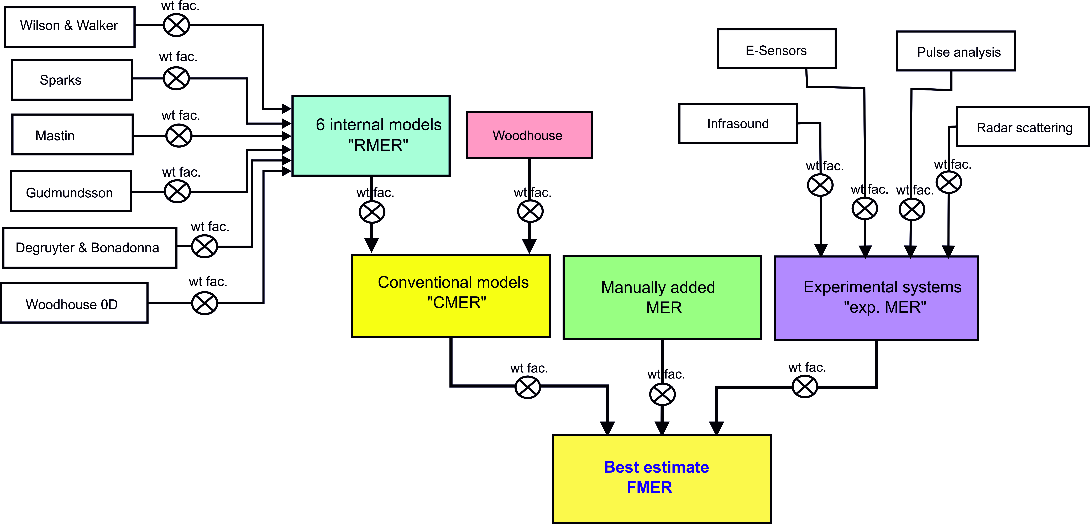

Figure 47. Overview over the computation of the best MER estimate (FMER) by FOXI. This figure summarizes the strategy underlying the computation of the FMER. Note that there are three different levels through which the weight factors influence the final estimate. The highest impact have the weight factors assigned by the FMER setting and, importantly, when manually adding MER data.

### Saving Results to *\*_mer_LOG.txt* and *\*_mer_NOW.txt*

A complete list of input parameters and MER results (including all key values listed in this chapter) are exported to a file with the ending *\*_mer_LOG.txt* (see Appendix F).

Additionally, a (much smaller) file is generated, denoted *<outputname>_mer_NOW.txt*. As the name suggests, this file is constantly overwritten and logs only the latest MER key values described in the sections above.

It contains:

* column 1: time since eruption (in minutes);
* column 2: *N*, number of data sets considered;
* column 3: *Qabs.min*
* column 4: *Qmaxhmin*
* column 5: *Qwavg*
* column 6: *Qconv_upper*
* column 7: *Qabs.max*
* column 8: *QGudmundsson*
* column 9: *QDegruyter Bonadonna*
* column 10: *QCMER*
* column 11: *Qavg*
* column 12: *Qlower*
* column 13: *Qmaxnowihmin*
* column 14: *Qf_abs.min*
* column 15: *Qf_abs.max*
* column 16: *QFMER_min*
* column 17: *QFMER*
* column 18: *QFMER_max*
* column 19: time base

### The output files “*_FMER.txt*” and “*_PLH.txt*”.

These files stores the time series of the minimum, average and maximum final estimates of MER and plume height (PLH). These files have been designed to easily access the time series of the final REFIR results. In particular, “*_FMER.txt*” is structured in this way:

* Column 1: Time UTC
* Column 2: Minutes since t0. This is the cumulative time in minutes since the beginning of the eruption or simulation.
* Column 3: FMER min. Minimum estimate of FMER (kg s-1)
* Column 4: FMER avg. Average estimate of FMER (kg s-1)
* Column 5: FMER min. Minimum estimate of FMER (kg s-1)

“*_PLH.txt*” has a compatible structure:

* Column 1: Time UTC
* Column 2: Minutes since t0. This is the cumulative time in minutes since the beginning of the eruption or simulation.
* Column 3: PLH min. Minimum estimate of plume height above sea level (m)
* Column 4: FMER avg. Average estimate of plume height above sea level (m)
* Column 5: FMER min. Minimum estimate of plume height above sea level (m)

### Other optional output files.

Time-averaged version of the files described in Section 5.8.5 are generated when requested by the operator via the “Output settings” menu (see Section 4.14) by clicking on the “Time Averaged outputs” tab and selecting the desired averaging time interval. Available options are 15 minutes, 30 minutes, 1 hour, 3 hours and 6 hours. When activated, this option creates the files “*_tavg_FMER.txt*” and “*_tavg_PLH.txt*”. Their structure is identical to *_FMER.txt* and *_PLH.txt*, but results are time-averaged and appended every each time interval. An example is shown in Figure 48.

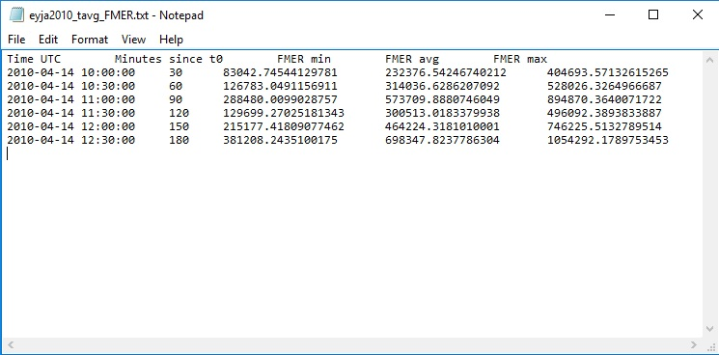

Figure 48. Example of a time-averaged output file

Time-averaged time series can be useful for many applications, in particular for inputting eruption source parameters of integral plume models or ash dispersion simulations. For further supporting the latter, by means of the same menu, the user can activate the creation of additional files that can be used by NAME (Jones, 2007), the UK Met Office ash dispersion model. These are comma separated files that contains the time-averaged series of both FMER and plume height; separate files are generated for each solution (*_NAME_sources_avg.txt*, *_NAME_sources_max.txt*, *_NAME_sources_min.txt*). The format is compatible with the NAME file that describes time varying source conditions; specifically:

* Column 1: Name. Name of the Source; each time step define a different cycle. The source name is “Source n”, where n is the sequential number.
* Column 2: Z. Height of the plume centroid above sea level (m)
* Column 3: dZ. Plume height above the vent (m)
* Column 4: Source strength. Name of the emitted species, which by default for FOXI is “VOLCANIC_ASH” and FMER in g hr-1
* Column 5: Start time. Start time of the current time interval (UTC).
* Column 6: Stop time. Stop time of the current time interval (UTC).

A screenshot of one of these files is shown in Figure 49.

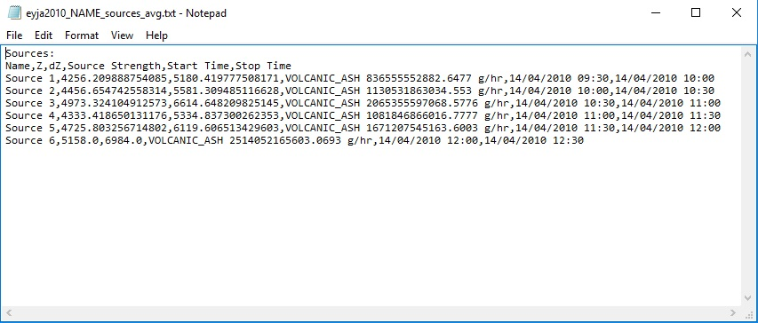

Figure 49. Example of a time-averaged output file specific for NAME.

## Step 9: Compute Total Mass Erupted

When entering this stage, FOXI computes the total mass erupted based on its previous CMER and FMER estimates, as well as on the absolute minimum and maximum assumable mass fluxes. This is done by importing the corresponding values *Q(t)* from the *\*_mer_LOG.txt* file, and integrating it over time since the start of the eruption *te*:

$M_{i}=\int_{0}^{te}{Q\left(t\right)dt}$ (30)

This equation is applied to the following mass fluxes:

on the CMER data level:

* ***Qabs.min*** resulting in ***MC_abs.min***
* ***Qabs.max*** resulting in ***MC_abs.max***
* ***Qmaxhmin*** resulting in ***MC_maxhmin***
* ***Qconv_wavg*** resulting in ***MC_wavg***
* ***QCMER*** resulting in ***MCMER***
* ***Qconv_upper*** resulting in ***MCMER_max***
* ***QGudmundsson*** resulting in ***MGudmunds***
* ***QDegruyter Bonadonna*** resulting in ***MDegr_Bona***
* ***QWood0D*** resulting in ***MWood0D***
* ***Qlower*** resulting in ***MCMER_min***

on the FMER data level:

* ***Qf_abs. min*** resulting in ***Mabs.min***:

minimum assumable mass erupted

* ***Qf_abs. max*** resulting in ***Mabs.max***:

maximum assumable mass erupted

* ***QFMER_min*** resulting in ***MFMER_min***:  
  the lower boundary of best estimate for total mass erupted suggested by FOXI
* ***QFMER*** resulting in ***MFMER***:  
  the best estimate for total mass erupted suggested by FOXI
* ***QFMER_max*** resulting in ***MFMER_max***:  
  the upper boundary of best estimate for total mass erupted suggested by FOXI

The results are written into the file *<outputname>__mass_LOG.txt*, which adopts the order of the values that is listed above.

## Step 10: Outputs - Plots and Results

Technically, many of the output files (plots and text files) described in this section are in fact generated during previous steps by FOXI. Step 10 represents just a finalizing phase in which the output data can be transferred on an openly accessible file server and hence made online available. (This is the case for the FutureVolc-specific version REFIR 19.0FV run by University of Iceland and the Icelandic Met Office).

However, for better clarity all plots generated by FOXI, are presented all together in this section.

### The “*.log*” file

When starting the program, FOXI creates a “*.log*” file, located in a subfolder named “foxi_log”. (If this folder doesn’t exist, it is automatically generated by the script). The name of the log file includes the date and time of program initiation according to the following format: “***refir_****yyyymmdd****_****HHMM****.log***”.

The “.log” file of a FOXI run started at 15:00 on 15 May 2017 would hence be labelled “*refir_20170515_1500.log*”.

A log file allows to track the processes performed by FOXI during each run. It records all messages displayed on screen, all relevant input parameters, along with all intermediate and final results. Each entry contains the date and time of creation along with a marker of the processing level, following in broad outline the “step” structure of this manual (see Figure 38). In the example given in Figure 50, “Level05” indicates that the depicted entries refer to the procedures computed during step 5 (described in section 5.5).

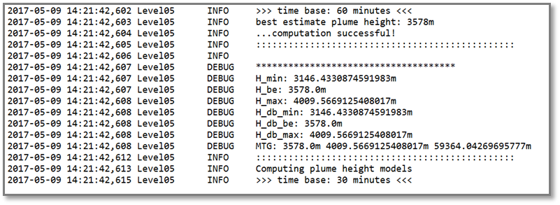

Figure 50. Excerpt of a typical ".log" file. "Level05" indicates that the depicted entries were generated during the computations conducted within step 5.

The entries in an additional column inform the user about the type of each entry:

* DEBUG: these entries give extra information which might be relevant for debugging (e.g. intermediate results). They were not displayed on the screen.
* INFO: these entries contain useful information for the operator, displayed on the screen.
* WARNING: these entries contain warnings reported to the operator.
* ERROR: these entries report an error, for example when a configuration file is missing.
* CRITICAL: these entries inform the user about a potential critical error, such as inconsistent plume height data.

### The Status Report

If this feature is switched on (see section 4.14), a status report will be issued, which is saved under *<outputfile>_STATUS_REPORT.txt*. At each iteration of the processing loop, the file is replaced. (See Appendix G, which shows the status report at the very end of the FutureVolc Exercise 2 in January 2016).

The report is an ASCII text file which gives a concise overview of the current MER situation. It is written in a way that allows it to be printed to page, uploaded and accessed on a webpage (or e.g. a blog), or send by e-mail, without the need of lengthy explanations.

The key values listed in the report are:

**“>>> Plume Height Stats (a.v.) <<<”:**

* **“time frame”** => corresponds to the **time base** used in FOXI
* **“tracked data N”** => corresponds to the number of considered data for the run ***N*** in FOXI
* **“minimum pl.h.”** => corresponds to the minimum best plume height estimate ***hmin***
* **“best e. pl.h.”** => corresponds to the average best plume height estimate ***havg***
* **“maximum pl.h.”** => corresponds to the maximum best plume height estimate ***hmax***

**“>>> Mass Eruption Rate Stats <<<”:**

* **“minimum MER”** => corresponds to the minimum assumable MER ***Qf_abs.min***
* **“wt. average MER”** => corresponds to MER ***QCMER***
* **“maximum MER”** => corresponds to the maximum assumable MER ***Qf_abs.max***

**“>>> Best Estimate of Current MER <<<”:**

* **“lower boundary”** => corresponds to the minimum assumable MER ***QFMER_min***
* **“best est. MER”** => corresponds to MER ***QFMER***
* **“upper boundary”** => corresponds to the maximum assumable MER ***QFMER_max***

**“>>> Computed Total Erupted Mass <<<”:**

* **“lower boundary”** => corresponds to the minimum assumable MER ***MFMER_min***
* **“best est. MER”** => corresponds to MER ***MFMER***
* **“upper boundary”** => corresponds to the maximum assumable MER ***MFMER_max***

### Plume Height Plots

Three types of plume height plots are provided, each of them in both, “.*png*” and “.*svg*” format:

* **Best Plume Height Estimate (“PH plots”):**

These plots show the temporal development of the estimated average, maximum and minimum plume height above sea level (“a.s.l.”) in meters, as a result of the plume height constraining procedures described in section 5.5. An example of such a plot is depicted in Figure 51.

The PH plots illustrate the evolution of the main input parameter for the eruption source parameter models used within FOXI. They are stored with the ending string “_PH_plot”.

PH plots can be controlled by the operator, using the “Output Control” menu within FIX (see Figure 52).

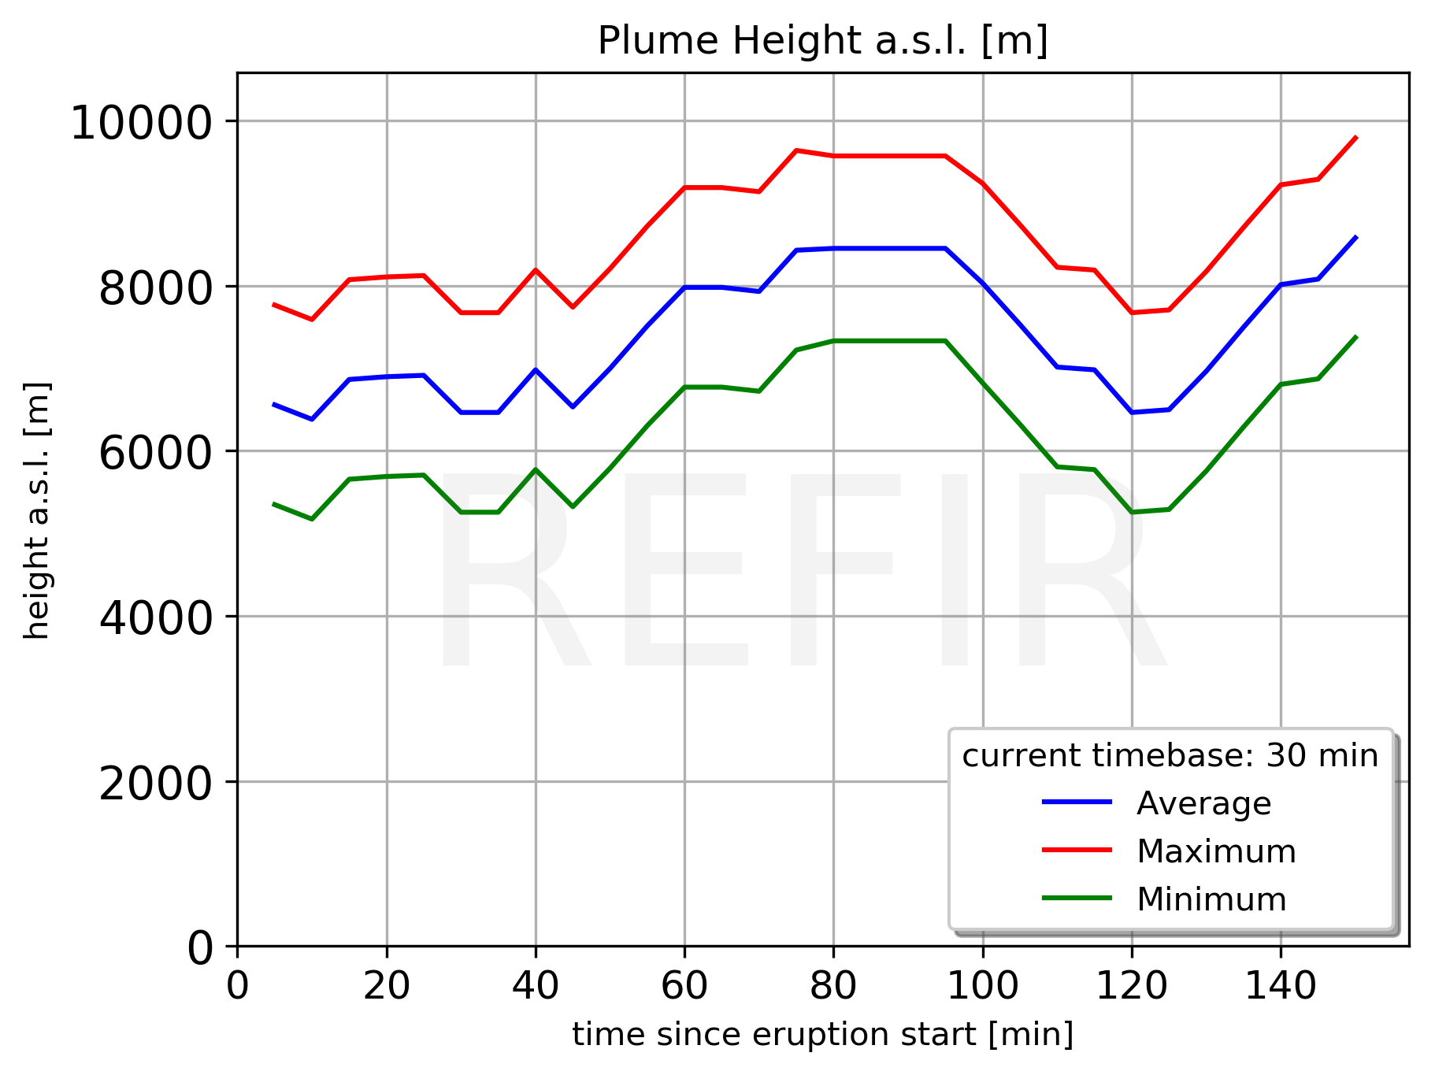

Figure 51. Plot presenting the estimated plume height, based on the results from the FOXI plume height constraining procedures described in section 5.5.

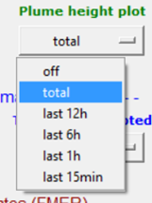

Figure 52. PH plot control menu. The operator can specify the time axis of the PH plots via the output control menu provided by FIX (see section 4.14).

* **Plume Heights by Sources and Sectors (“APH plots”):**

These plots shows the temporal development of plume heights separated by individual data sources. Each sensor is characterized by a different colour. Plume heights from data sources that are located to the East of the vent (“Eastern sector”) are marked by dashed lines, those originating from sensors in the Western sector are marked by straight lines. It is to note that these values are heights in meters above the vent (“a.v.”). The APH plots help the operator to e.g. quickly spot deficiently working sensors or source-specific systematic offsets. They are stored with the ending string “*_APH_plot*”.

An example of such a plot is given in Figure 53. Note that in this case the time axis has been reversed. This type of display might be useful for operational purposes (see also PHSec plots).

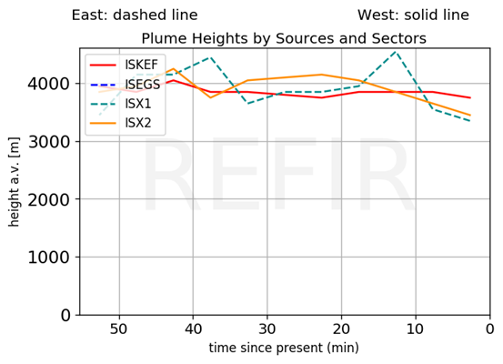

Figure 53. APH plot showing plume heights above vent, separated by sensors. In the depicted example, three sensors (ISKEF, ISX1 and ISX2) did provide data. The radar station ISEGS, located 270 km to the East of the simulated vent of Eyjafjallajökull, has been switched off.

* **Plume Heights by Sectors (“PHSec plot”):**

These plots show the individual plume heights provided by each of the sensors, separated by their location. Plume heights obtained by different sensors are characterized by different colours. Plume heights from data sources that are located to the East of the vent (“Eastern sector”) are marked by dashed lines, those obtained by sensors to the west of the vent are marked by straight lines. All values are heights in meters above the vent (“a.v.”). Note that the values closest to the right represent the most recent plume heights obtained. The PHSec plots allow the operator to identify and quantify potential wind distortion of the monitored plume. They are stored with the ending string “*_PHSec_plot*”.

An example of such a plot is given in Figure 54. Like in Figure 53, the time axes are displayed in reverse order. This option can be activated by changing the value of the parameter “time_axis” in the settings section of FOXI from 1 to 0. (Note: This setting affects only APH and PHSec plots.)

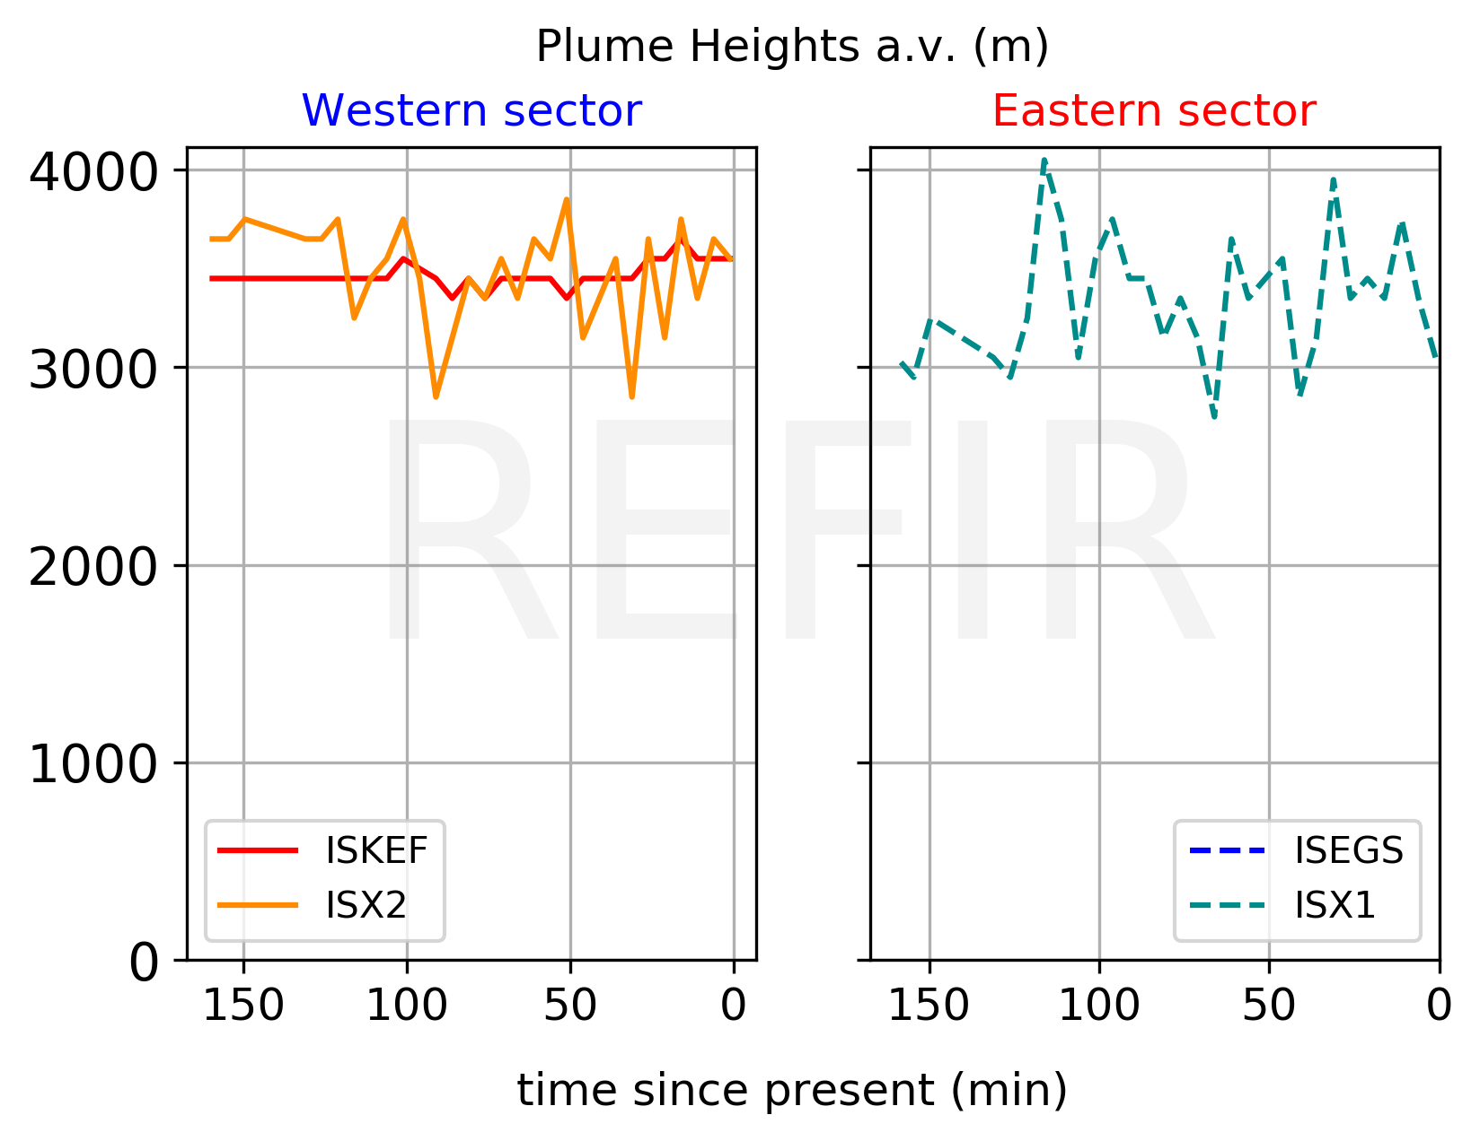

Figure 54. PHSec plot showing plume heights above vent, separated by the location of the sensors. In this example ISKEF and ISX2 were located to the West of the vent, while ISX1 was situated to the East (ISEGS was switched off). The fact that the plume heights show no significant difference between the two sectors, indicate that the plume is currently not considerably affected by wind distortion.

### Plots showing Source Stats

These types of plots provide the user with information about the current data situation. This helps the operator when making decisions on crucial system settings, such as on which time base to be used, or which sensor to be trusted.

* **N plots:**

These plots visualize the number of plume height data sets considered for MER calculation in each run (see Figure 55). These graphs are useful to identify data gaps and evaluate the quality of the current CMER estimates. The plots are stored with the ending string “*_N_plot*” and can be controlled by the operator, using the “Output Control” menu within FIX (see Figure 56).

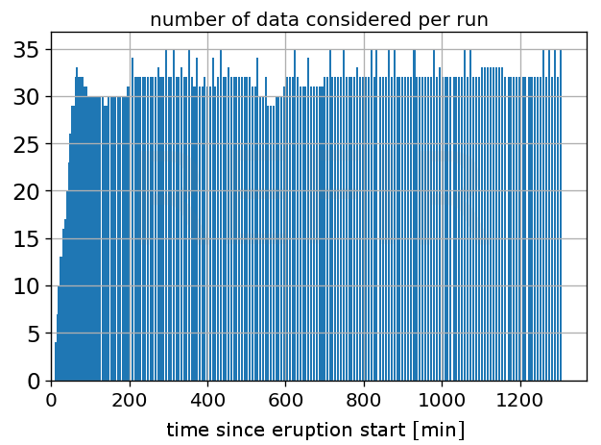

Figure 55. Example for an N plot. This plot was generated during a simulation with using a time base of 60 minutes. With approx. 30 data points per run the depicted situation is very favorable, so that the operator might even consider using a shorter time base to increase the temporal resolution of the mass eruption rate estimates.

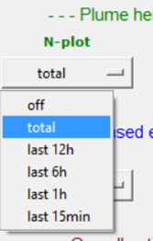

Figure 56. PH plot control menu. The operator can specify the time axis of the PH plots via the output control menu provided by FIX (see section 4.14).

* **Source statistics plots (SRC Stat plots):**

These plots are only generated when the analysis mode is switched on (see section 4.7) and show the operator which source provided the most recent data (see Figure 57). All potential data channels are listed. Blue bars refer to auto-stream data channels, while the manually added data is marked in green colour. The ages of the source-specific data sets are classified into 6 groups. The length of a bar indicates how close the provided data is to the present moment. A bar which reaches the “30 min” level, e.g., indicates that a data set obtained by this source is not older than 30 minutes.

SRC Stat plots allow the operator to achieve a quick overview over the current data situation, and they are stored with the ending string “*_SRC_stat*”.

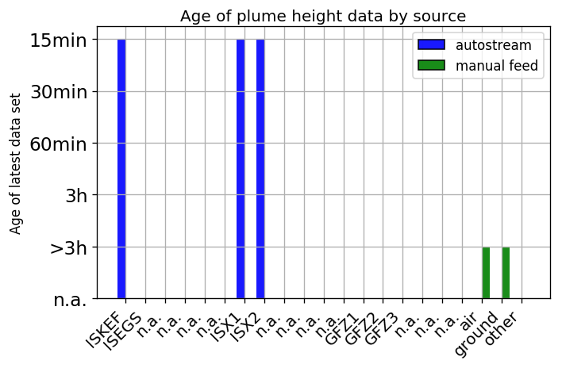

Figure 57. Example for a SRC Stat plot. In the depicted case, the current computations of FOXI are based on auto-stream data obtained by ISKEF, ISX1 and ISX2, all of them younger than 15 minutes. Manually added data by air and ground observations is older than 3 hours, thus outdated and hence not considered by the system.

* **Total Data Source plots (SRCtotal Stat plots):**

These plots are only generated when the analysis mode is switched on (see section 4.7) and visualize the total number of data obtained, separated by each data channel (see). All potential data channels are listed. Blue bars refer to auto-stream data channels, while the manually added data is marked in green colour.

SRCtotal Stat plots informs the operator on the reliability of the used sensors. They are stored with the ending string “*_SRCtotal_stat*”.

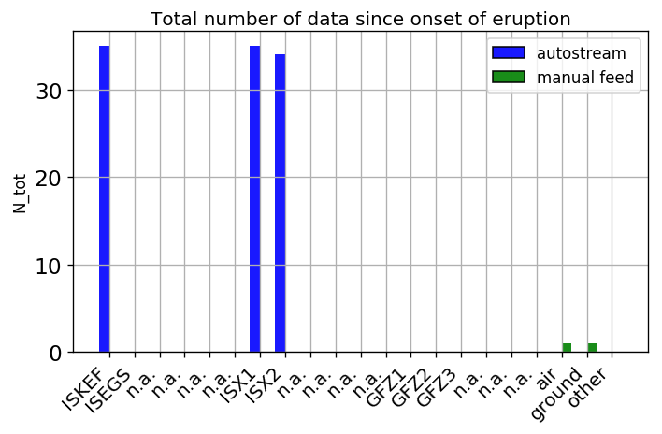

Figure 58. Example for a SRCtotal Stat plot. In the depicted case the three auto-stream sources have provided most of the data. The data contribution of air and ground observations was marginal.

### Mass Eruption Rate Plots

Based on the FOXI results, two types of MER plots are produced by importing the data from the two logfiles *\*_mer_LOG.txt* and *\*_mass_LOG.txt*.

* **CMER plots**:

These graphs show the temporal evolution of CMER estimates based on conventional models   
(see Figure 59).

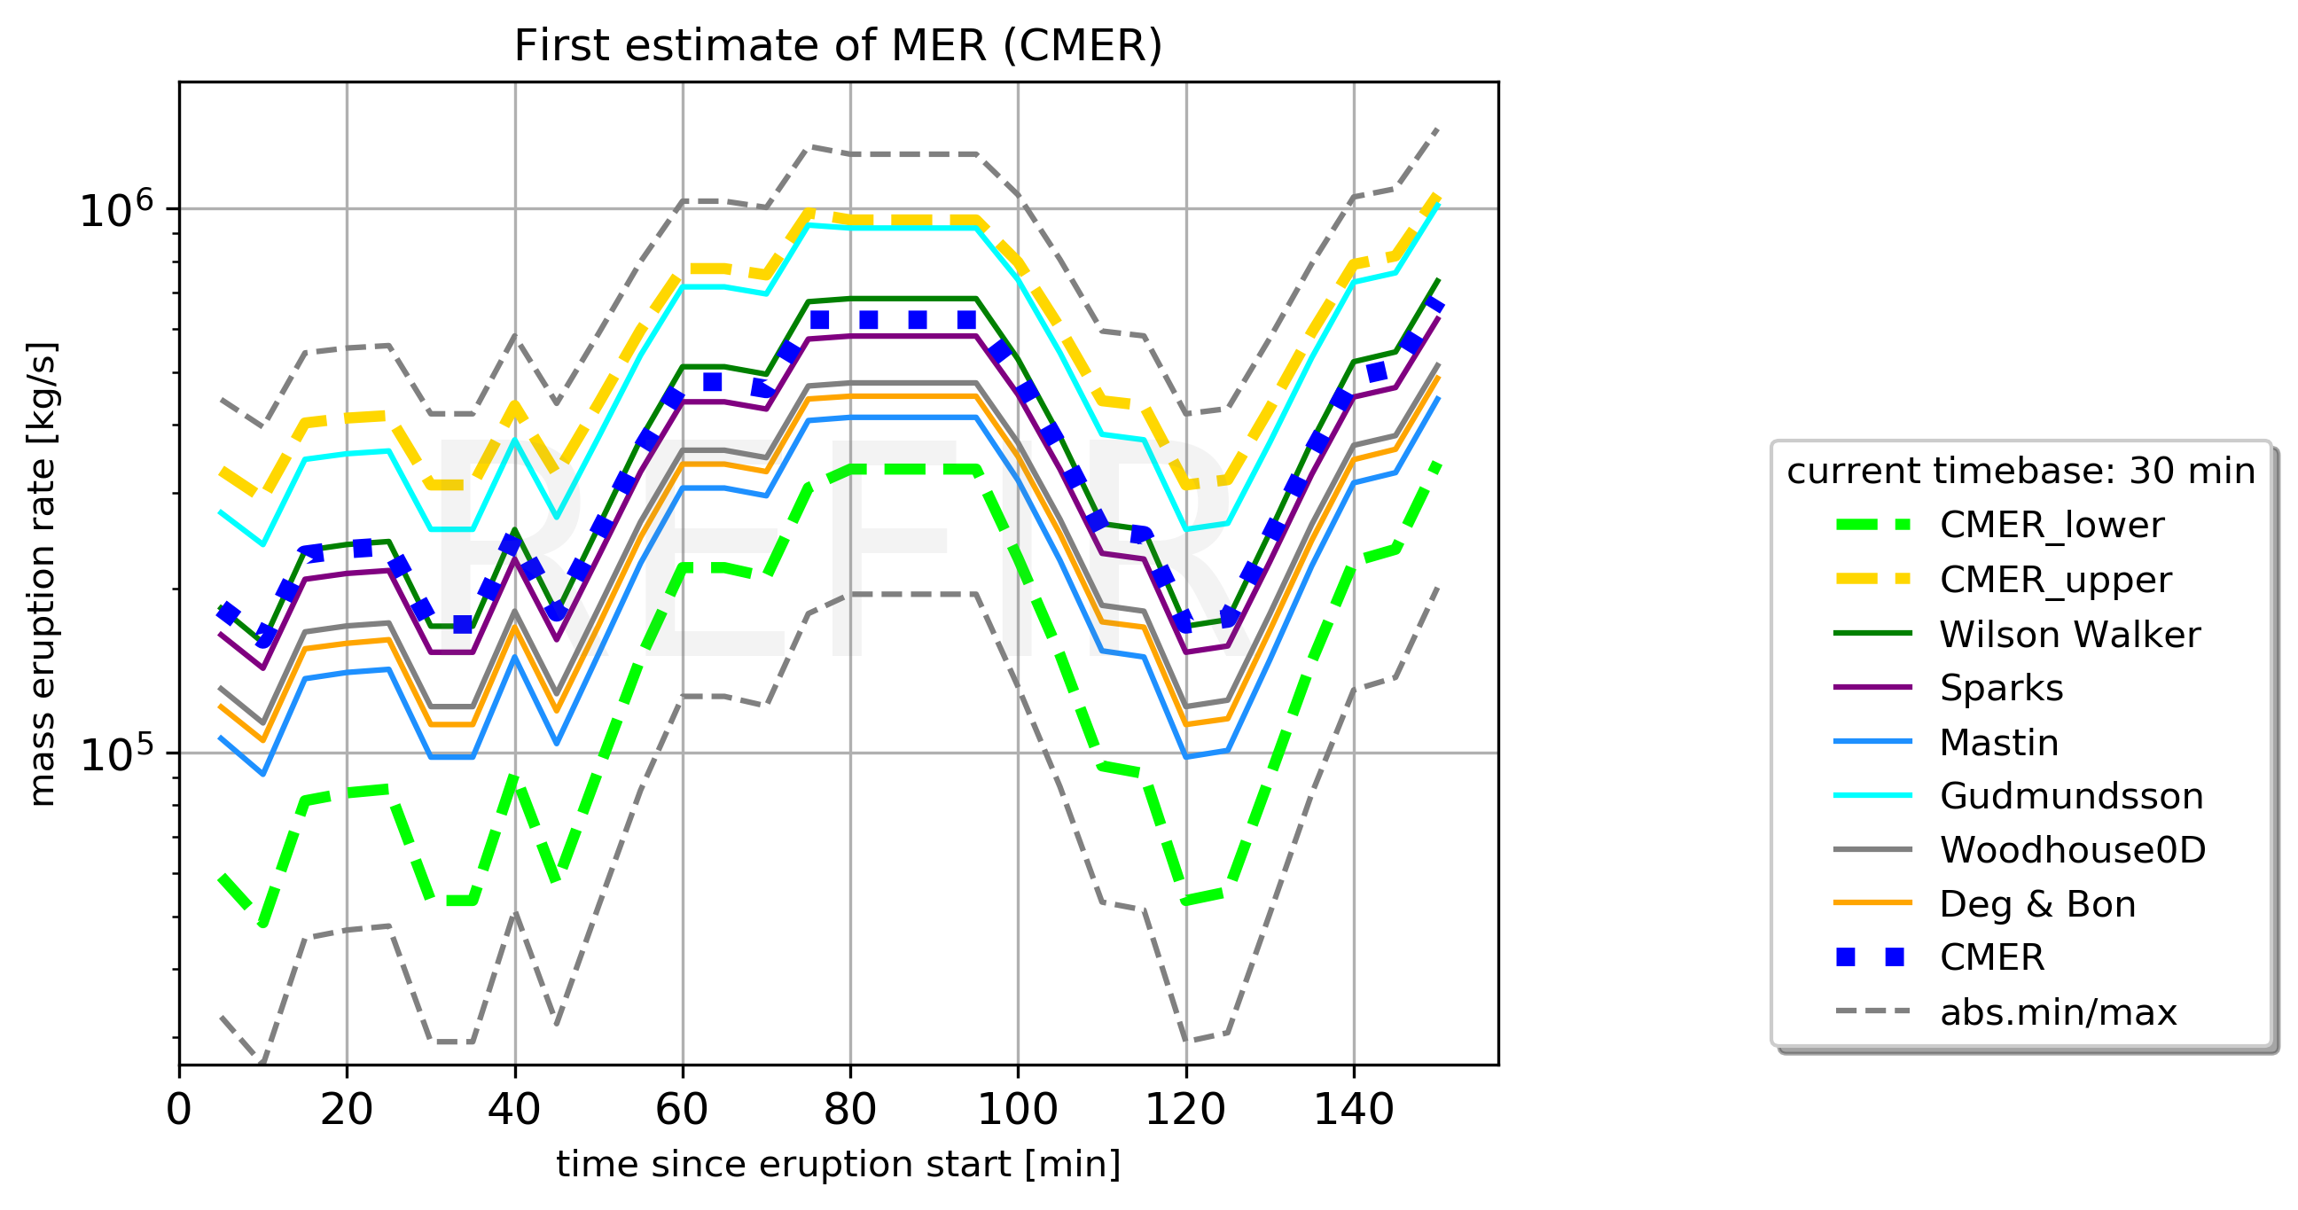

Figure 59. Example for a CMER plot.

Next to the individual MER curves for all considered conventional models, the following conventional MER estimates (see section 5.7) are plotted:

***Qabs.min***: grey dashed line

***Qlower***: green dashed line

***QCMER***: blue dashed line

***Qconv_upper***: yellow dashed line

***Qabs.max***: grey dashed line

The CMER plots are stored with the ending string “*_CMER_plot*” and can be controlled via FIX (see section 4.14 and Figure 60).



Figure 60: CMER plot control menu. The operator can specify the time axis of the CMER plots via the output control menu provided by FIX (see section 4.14).

* **FMER plots**:

These plots show the results for FMER, i.e. the best estimate of the mass eruption rate based on FOXI routines (see Figure 61).

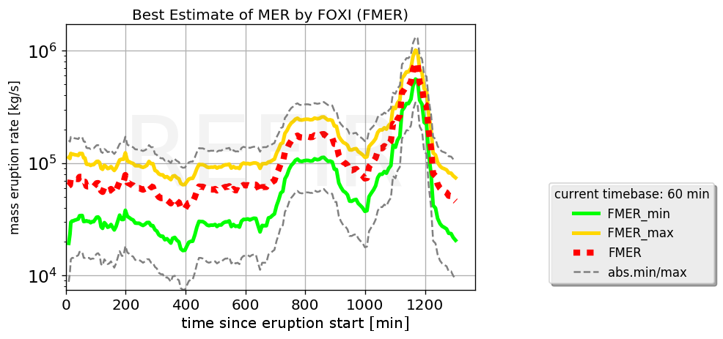

Figure 61: Example for an FMER plot. This graph shows the FMER results of a simulation on the basis of the radar data achieved during the Eyjafjallajökull eruption on May 5, 2010.

The curves in these plots represent the temporal development of (see section 5.8.3):

***Qf_abs. min***: grey dashed line

***QFMER_min***: green straight line

***QFMER***: red dashed line

***QFMER_max***: yellow straight line

***Qf_abs. max***: grey dashed line

The FMER plots are stored with the ending string “*_FMER_plot*” and can be controlled via FIX (see section 4.14 and Figure 62).



Figure 62: FMER plot control menu. The operator can specify the time axis of the FMER plots via the output control menu provided by FIX (see section 4.14).

### Total Erupted Mass Plots

Two types of plots showing the erupted mass integrated over time are generated by FOXI, by importing the data from the two logfiles *\*_mer_LOG.txt* and *\*_mass_LOG.txt*.

* **Plots showing first estimate of total erupted mass (“Cmass plots”)**:

These graphs show the temporal evolution of the total erupted mass, based on CMER estimates   
(see Figure 63).

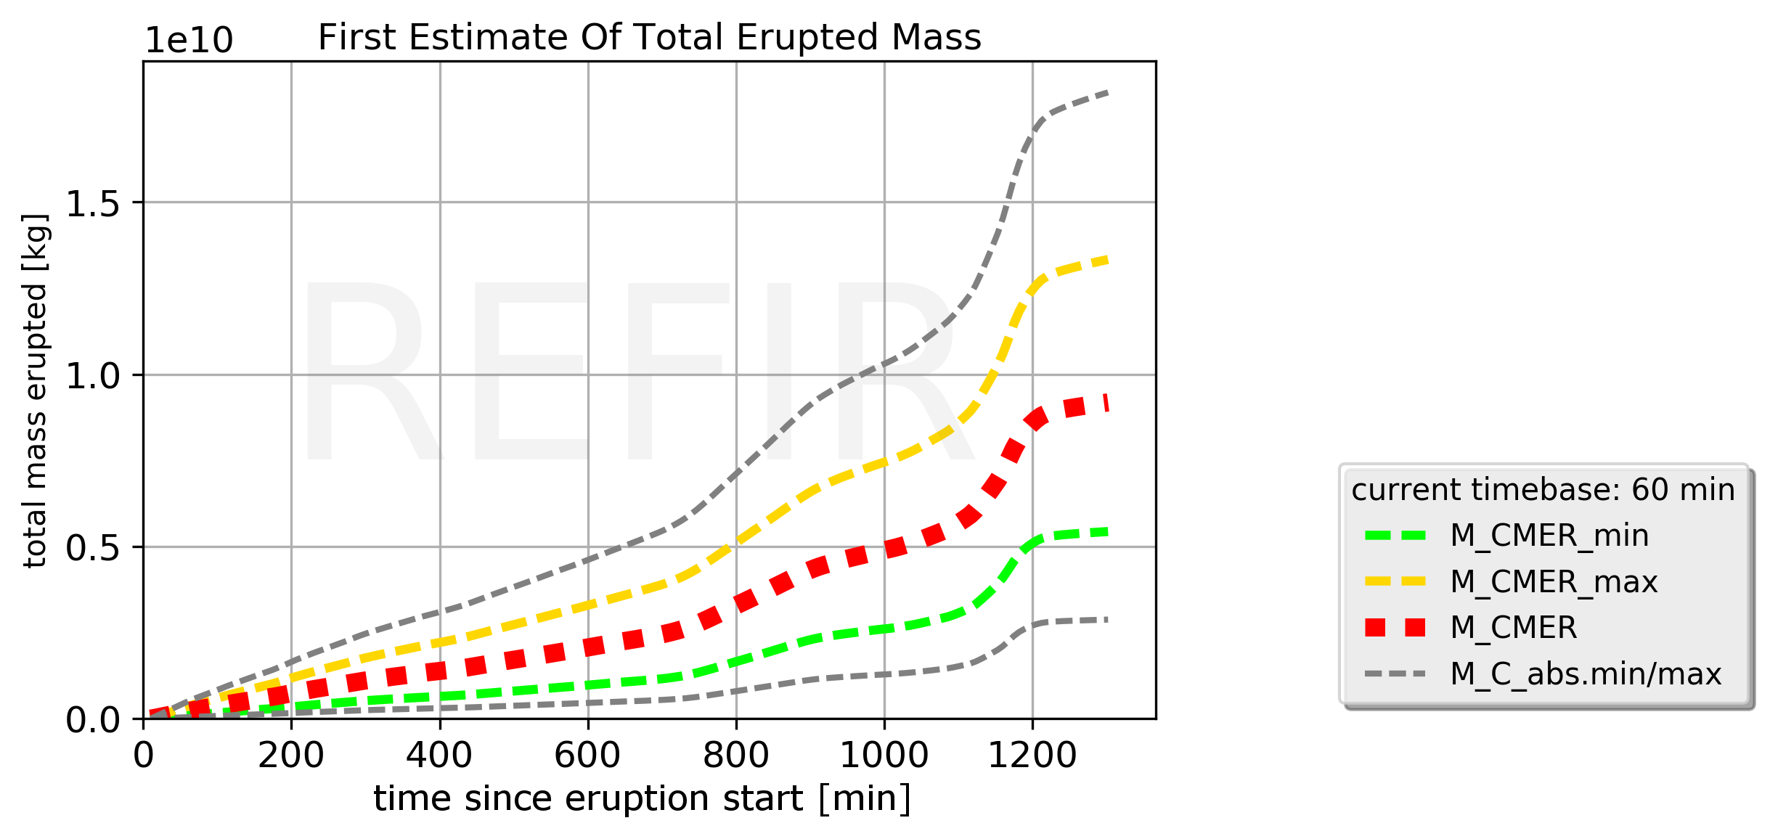

Figure 63. Example for a “Cmass plot”, which shows the first estimate of the total erupted mass, based on the computed CMER values. The depicted graph is a result of a simulation on the basis of the radar data achieved during the Eyjafjallajökull eruption on May 5, 2010.

The curves in these plots represent the temporal development of (see section 5.9):

***MC_abs.min***: grey dashed line

***MCMER_min***: green dashed line

***MCMER***: red dashed line

***MCMER_max***: yellow dashed line

***MC_abs.max***: grey dashed line

The FMER plots are stored with the ending string “*_Cmass_plot*” and can be controlled via FIX (see section 4.14 and Figure 64).



Figure 64: Cmass plot control menu. The operator can specify the time axis of this type of plot via the output control menu provided by FIX (see section 4.14).

* **Plots showing best estimate of total erupted mass (“Fmass plots”)**:

These graphs show the temporal evolution of the total erupted mass, based on FMER estimates   
(see Figure 65).

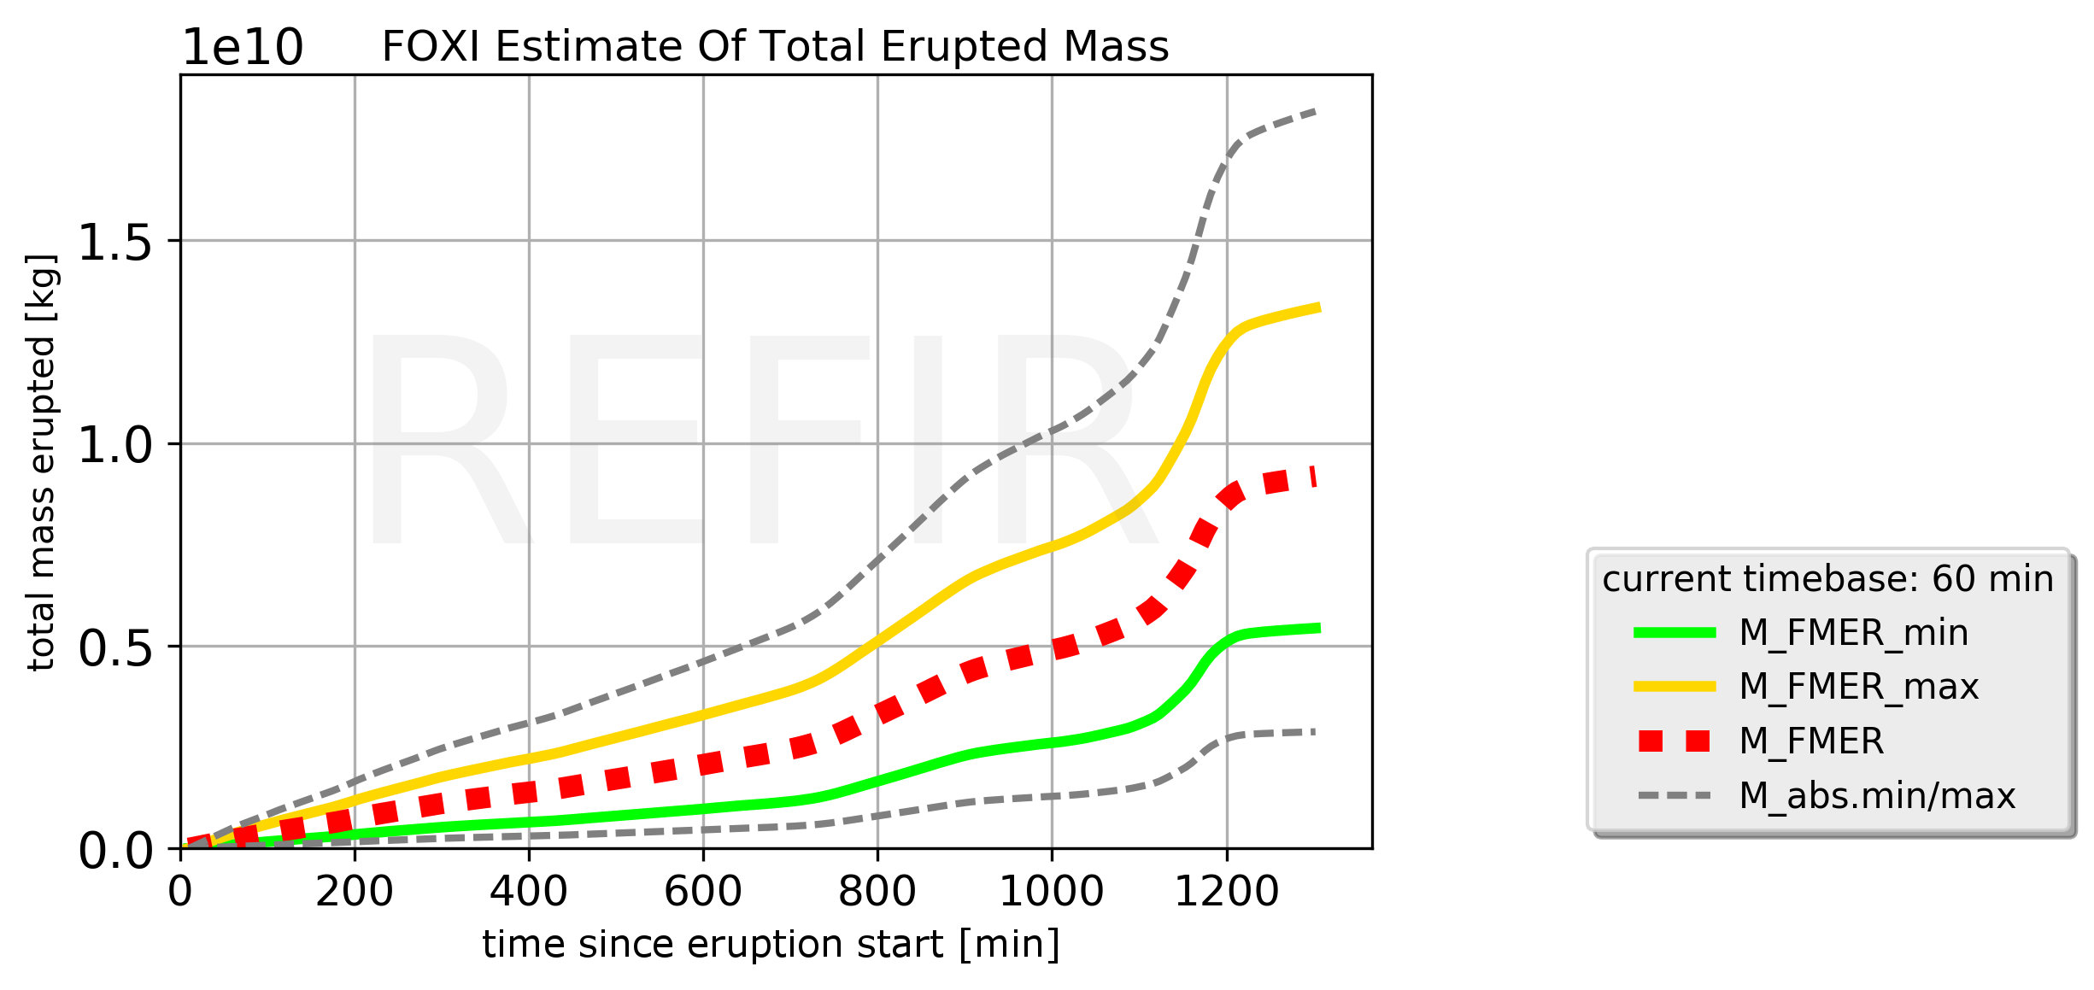

Figure 65. Example for an “Fmass plot”, which shows the best estimate of the total erupted mass, based on the computed FMER values. The depicted graph is a result of a simulation on the basis of the radar data achieved during the Eyjafjallajökull eruption on May 5, 2010.

The curves in these plots represent the temporal development of (see section 5.9):

***Mabs.min***: grey dashed line

***MFMER_min***: green straight line

***MFMER***: red dashed line

***MFMER_max***: yellow straight line

***Mabs.max***: grey dashed line

The FMER plots are stored with the ending string “*_Fmass_plot*” and can be controlled via FIX (see section 4.14 and Figure 66).



Figure 66. Fmass plot control menu. The operator can specify the time axis of this type of plot via the output control menu provided by FIX (see section 4.14).

### The status records

Next to the plots and the summarizing status report, FOXI also generates a set of records which detail the current values of all relevant REFIR parameters, including the intermediate and final results.

These text files are marked by the ending string “*_status*” and a running number, as described in the following.

* “***_status1.txt***”: PLUME HEIGHT STATUS  
  lists all plume height relevant key numbers
* “***_status2.txt***”: ERUPTION SOURCE PARAMETER STATUS 1

provides a summary of the computed MER, according to the following scheme:

==========================================

>>> Overall Mass Eruption Rate Stats <<<

------------------------------------------

abs. min MER: ***Qf_abs. min***

average MER: ***Qavg***

abs. max MER: ***Qf_abs. max***

>>> Best Estimate of Current MER <<<

==========================================

lower boundary: ***QFMER_min***

*************

best est. MER: ***QFMER***

*************

upper boundary: ***QFMER_max***

==========================================

* “***_status3.txt***”: ERUPTION SOURCE PARAMETER STATUS 2

provides a summary of the computed mass erupted, according to the following scheme:

=========================================================

>>> Computed Total Erupted Mass <<< (Approx. Erupted Volume**)

---------------------------------------------------------------

lower boundary*: ***MFMER_min*** (***VFMER_min***)

best estimate m*: ***MFMER*** (***VFMER***)

upper boundary*: ***MFMER_max*** (***VFMER_max***)

-----------------------------------------------------------------------------

(**assuming bulk dens: 1000 kg/m^3)

===========================================================

with *V* being the erupted volume, according to the relation *V* = *M*/(1000 kg/m3)

* “***_status4.txt***”: REFIR MODEL PARAMETERS 1

lists the relevant input parameters for the REFIR models, (e.g. current atmospheric data)

* “***_status5.txt***”: REFIR MODEL PARAMETERS 2

lists the current quality factors of all auto-stream sources

* “***_status6.txt***”: REFIR MODEL PARAMETERS 3

lists the current plume height uncertainties (in km) assigned to the auto-stream sources.

(A value of 99.0 is assigned to sensors which are deactivated, out of range or not available.)

* “***_status7.txt***”: REFIR MODEL PARAMETERS 4

provides a list of the current sensor locations.

(A value of 1.0 indicates that the sensor is located to the East of the vent; -1.0 indicates that it is located in the Western sector. A zero indicates an empty slot, meaning that this sensor has not been assigned.)

* “***_status8.txt***”: REFIR MODEL PARAMETERS 5

provides a list of the current auto-stream sensor settings.

(A value of 1 indicates that the sensor is switched on; sensors that are switched off are marked by 0; empty slots are characterized by -1.)

* “***_status9.txt***”: REFIR MODEL PARAMETERS 6

provides a list of the current manual input channel settings.

(A value of 1 indicates that the manual channel is switched on; channels that are switched off are marked by 0; empty slots are characterized by -1.)

* “***_status10.txt***”: REFIR MODEL PARAMETERS 7

provides a list of the currently assigned radar sensor calibration factors

* “***_status11.txt***”: REFIR MODEL PARAMETERS 8

provides a list of the current model settings, including the model weight factors (“wtf”).

* “***_status12.txt***”: REFIR MODEL PARAMETERS 9

lists the output settings and the current value of plume width used to compute the centreline plume heights

## Resting and Closing the Loop

If the output files have been successfully exported, FOXI returns a message such as

Total mass erupted computed - plots provided.

.........status report updated!

***** step 8 successful *****

:::::::::::::::::::::::::::::::::::::::::::::::::

Level08: INFO ***** steps 8 successful *****

Level09: INFO .........status report updated!

Level09: INFO ***** step 9 successful *****

Level10: INFO :::::::::::::::::::::::::::::::::::::::::::::::::

Level10: INFO SYSTEM UPDATE:

Level10: INFO

run No. 36 successful

Level10: INFO ALL CLEAR!

Level10: INFO .......................

Level10: INFO .......................

Level10: INFO waiting for new run....

Then the program pauses while a countdown is activated. (Note that in the current FOXI version this time adjusted in a way that it is roughly 5 minutes. The processing times for the program, however, differ. For example, if it attempts to retrieve data from an online source that is currently unavailable this might cause a slight delay.)

The operator is informed every 30 seconds about the countdown time left by a message such as

...next run in 270 seconds

.....

...next run in 240 seconds

.....

The last ten seconds of the countdown are displayed and acoustically accompanied a beep. This procedure is to keep the operator updated about how much time he has to apply changes, for example to modify the plume height file fix_OBSin.txt and/or to make changes via FIX, before the new run is started.

After the countdown is complete, the program closes the loop and returns to Step 2.

# FoxScreen

FoxScreen is a tool developed to bundle all important output files for displaying them on a single screen. Its purpose is to provide the operator with all relevant information at one glance.

To use it, place the script *FoxScreen.py* in the active working folder (i.e., the folder in which also FIX and FOXI are located) and run it.

Once started, the program first asks for the name of the data set (i.e., the identifier the operator assigned to the run when FOXI was initiated). Thereafter, a window opens, displaying a montage of six separated monitors (see Figure 67).



Figure 67: Overview window provided by FoxScreen. This window allows the operator to browse quickly to all relevant output data generated by FIX and FOXI.

* **REFIR Map** (field “A” in Figure 67):

This display shows the location of all monitored volcanoes and available sensors in an overview map. By clicking on “Switch Map View”, a different map is displayed, showing a close-up of the monitored eruption site. The maps are only displayed if they have been generated before by means of FIX (see section 4.14). Otherwise this field stays empty. Changes in the map files are adopted immediately.

* **Plume height monitor** (field “B” in Figure 67):

This screen provides information on the monitored plume heights. By clicking on “Switch Plumeheight View”, the user can cycle through the three types of plume height plots provided by FOXI: **PH plot**, **APH plot** and **PHSec plot** (for detailed description see section 5.10.3).

The display is regularly updated, so that changed plot files are immediately displayed.

* **Source stats monitor** (field “C” in Figure 67):

This screen provides information on the current input data situation. By clicking on “Switch Source Stats”, the user can cycle through the three types of source stats plots provided by FOXI: **N plot,** **SRC Stat plot** and **SRCtotal Stat plot** (for detailed description see section 5.10.4).

Changed plot files are immediately displayed.

* **Mass eruption rate monitor** (field “D” in Figure ):

This screen displays the MER plots provided by FOXI. By clicking on “Switch MER Plots”, the user can switch between the two types of mass eruption rate plots: **CMER plot** and **FMER plot** (for detailed description see section 5.10.5).

The display is regularly updated and any changes in the plot files are immediately adopted.

* **Erupted mass monitor** (field “E” in Figure 67):

This screen shows the resulting total erupted mass plots estimated by FOXI. By clicking on “Switch Erupted Mass Plots”, the user can switch between two types of plots: **Cmass plot** and **Fmass plot** (for detailed description see section 5.10.6).

The display is regularly updated and any changes in the plot files are immediately adopted.

* **REFIR status monitor** (field “F” in Figure 67):

This screen displays the various status records provided by FOXI.

* By clicking on “REFIR Results”, the user can cycle through plume height status and the computed eruption source parameters. The according screens simply display the content of the text files “***_status1.txt***”, “***_status2.txt***” and “***_status3.txt***”, generated by FOXI.
* By clicking on “REFIR Parameters”, the user can cycle through the various REFIR model parameters stored within the FOXI generated text files “***_status4.txt***”, “***_status5.txt***” … “***_status12.txt***”.

A description of the displayed parameters and results is provided in section 5.10.7.

Also this display is regularly updated, so that any changes in the status files are immediately adopted.

# References

Arason, Th. <http://brunnur.vedur.is/pub/arason/radar/calc> (2015); retrieved 06/06/2017

Büttner, R., Zimanowski, B. & Röder, H. Short-time electrical effects during volcanic eruption: Experiments and field measurements. *J. Geophys. Res*. 105, 2819 (2000). DOI:10.1029/1999JB900370

Degruyter, W. & Bonadonna C. Improving on mass flow rate estimates of volcanic eruptions. *Geophys. Res. Lett*. 39, L16308 (2012). DOI: 10.1029/2012GL052566

Devenish, B.J. Estimating the total mass emitted by the eruption of Eyjafjallajökull in

2010 using plume-rise models. *J. Volcanol. Geotherm. Res.*, in press (2016). DOI: 10.1016/j.jvolgeores.2016.01.005

Donnadieu, F., Freville, P., Hervier, C., Coltelli, M., Prestifilippo, Valade, S., Rivet, S. & Caucault, P. Near-source Doppler radar monitoring of tephra plumes at Etna. *J. Volcanol. Geotherm. Res.*, in press (2016). DOI:10.1016/j.jvolgeores.2016.01.009

Dürig, T.,Gudmundsson, M. T., Karmann, S., Zimanowski, B., Dellino, P., Rietze, M. & Büttner, R*.* Mass eruption rates in pulsating eruptions estimated from video analysis of the gas thrust–buoyancy transition – a case study of the 2010 eruption of Eyjafjallajökull, Iceland. *Earth Planet Sp.* **67**, 180 (2015). DOI:10.1186/s40623-015-0351-7

Gouhier, M., Guillin, A., Azzaoui, N., Eychenne, J.& Valade, S. Source mass eruption rate retrieved from satellite-based data using statistical modelling. *Geophys. Res. Abs.* 17, EGU2015-10222-1 (2015).

Gouhier, M., Harris, A.J.L., Calvari, S., Labazuy, P., Guéhenneux, Y., Donnadieu, F. & Valade S. Lava discharge during Etna's January 2011 fire fountain tracked using MSG-SEVIRI. Bull. Volcanol. 74, 787-793 (2012). DOI:10.1007/s00445-011-0572-y

Gudmundsson, M.T., Thordarson, T., Höskuldsson, Á., Larsen G., Björnsson, H., Prata, A.J., Oddsson, B., Magnússon, E., Högnadóttir, T., Pedersen, G.N., Hayward, C.L., Stevenson, J.A., Jónsdóttir, I. Ash generation and distribution from the April-May 2010 eruption of Eyjafjallajökull, Iceland. *Sci. Rep*. 2, 572 (2012). DOI:10.1038/srep00572

Gudmundsson, M.T., Högnadóttir, T., Dürig, T., Höskuldsson, Á., Björnsson, H., Oddsson, B., Ágústsdóttir, T. Field laboratory, aircraft observations and radars. *Futurevolc Report* D7.2 (2015).

Hewett, T.A., Fay, J.A. & Hoult, D.P. Laboratory experiments of smokestack plumes in a stable atmosphere. *Atmospheric Environment* 5, 767–789 (1971).

Jones, A. R., Thomson, D. J., Hort, M., Devenish, B. The U.K. Met Office's next-generation atmospheric dispersion model, NAME III. In Borrego C. and Norman A.-L. (Eds) Air Pollution Modeling and its Application XVII (Proceedings of the 27th NATO/CCMS International Technical Meeting on Air Pollution Modelling and its Application), Springer, pp. 580-589, 2007.

Kylling, A., Marzano, F., Montopoli, M., Cimini, D., Beckett, F., Sigurðadóttir, G.M., von Löwis, S. Synthesis of eruptive products. *Futurevolc Report* D8.6 (2016).

Marzano F.S., Picciotti, E., Vulpiani, G. & Montopoli, M. Inside Volcanic clouds: Remote Sensing of Ash Plumes Using Microwave Weather Radars. *Bulletin Am. Met. Soc*. 94, 1567-1586 (2013). DOI:10.1175/BAMS-D-11-00160.1

Mastin, L.G., Guffanti, M., Servranckx, R., Webley, P., Barsotti, S., Dean, K., Durant, A., Ewert, J.W., Neri, A., Rose, W.I., Schneider, D., Siebert, L., Stunder, B., Swanson, G., Tupper, A., Volentik, M. & Waythomas, C.F. A multidiciplinary effort to assign realistic source parameters to models of volcanic ash-cloud transport and dispersion during eruptions. *J. Volcanol. Geotherm. Res.* 186**,** 10–21 (2009). DOI:10.1016/j.jvolgeores.2009.01.008

Morton, B.R., Taylor, G. & Turner, J.S. Turbulent Gravitational Convection from Maintained and Instantaneous Sources. *Proceedings of the Royal Society A: Mathematical, Physical and Engineering Sciences* 234**,** 1–23 (1956).

Oddsson, B., Gudmundsson, M.T., Larsen, G. & Karlsdóttir, S. Monitoring of the plume from the basaltic phreatomagmatic 2004 Grímsvötn eruption—application of weather radar and comparison with plume models. *Bull. Volcanol*. 74, 1395–1407 (2012). DOI:10.1007/s00445-012-0598-9

Pouget, S., Bursik, M., Johnson, C.G., Hogg, A.J., Phillips, J.C. & Sparks, R.S.J. Interpretation of umbrella cloud growth and morphology: implications for flow regimes of short-lived and long-lived

eruptions. *Bull. Volcanol*. 78, 1 (2016). DOI 10.1007/s00445-015-0993-0

Ripepe, M., Bonadonna, C., Folch, A., Delle Donne, D., Lacanna, G., Marchetti, E. & Höskuldsson, Á. Ash-plume dynamics and eruption source parameters by infrasound and thermal imagery: The 2010 Eyjafjallajökull eruption. *Earth Planet. Sci. Lett.* 366, 112–121 (2013). DOI:10.1016/j.epsl.2013.02.005

Sparks, R.S.J., Bursik, M.I., Carey, S.N., Gilbert, J.S., Glaze, L.S., Sigurdsson, H. & Woods A.W. (1997): Volcanic Plumes, John Wiley & Sons, Chichester; 574 pp.

Wilson, L. & Walker, G.P.L. (1987) Explosive volcanic eruptions—VI. Ejecta dispersal in plinian eruptions: the control of eruption conditions and atmospheric properties. *Geophys. J. R. astr. Soc*. 89, 657-679.

Woodhouse, M.J., Hogg, A.J., Phillips, J.C. & Sparks, R.S.J. Interaction between volcanic plumes and wind during the 2010 Eyjafjallajökull eruption, Iceland. *J. Geophys. Res. Solid Earth* 118, 92–109 (2013). DOI:10.1029/2012JB009592

Woodhouse, M.J., Hogg, A.J., Phillips, J.C. & Rougier, J.C. Uncertainty analysis of a model of wind-blown volcanic plumes. *Bull. Volcanol*. 77, 83 (2015). DOI: 10.1007/s00445-015-0959-2.

# Appendix A: List of Parameters in fix_config.txt

|  |  |  |  |  |  |
| --- | --- | --- | --- | --- | --- |
| **line** | **variable** | **remark** | **line** | **variable** | **remark** |
| 0 | def. value | control variable | 46 | oo_exp | exp. MER sensors on/off |
| 1 | time_update | time of update | 47 | oo_con | conv. MER models on/off |
| 2 | time_OBS | time of observation input | 48 | wtf_exp | weight factor exp. MER |
| 3 | Hmin_obs | min observed pl height | 49 | wtf_con | weight factor conv. MER |
| 4 | Hmax_obs | maximum obs pl h | 50 | oo_manual | man. added MER on/off |
| 5 | OBS_on | obs data stream activated | 51 | wtf_manual | last w f man. added MER |
| 6 | qf_OBS | quality factor 1-4 | 52 | min_manMER | minimum manual MER |
| 7 | theta_a0 | ambient temp at vent | 53 | max_manMER | maximum manual MER |
| 8 | P_0 | ambient pressure at vent | 54 | oo_wood | on/off PlumeRise |
| 9 | theta_0 | magma temperature | 55 | oo_RMER | on/off RMER |
| 10 | rho_dre | DRE of magma | 56 | wtf_wood | weight factor PlumeRise |
| 11 | alpha | radial entrainment coeff. | 57 | wtf_RMER | weight factor RMER |
| 12 | beta | wind entrainment coeff. | 58 | oo_isound | on/off infrasound |
| 13 | wtf_wil | wt. factor Wilson Walker | 59 | wtf_isound | weight factor infrasound |
| 14 | wtf_spa | weightfactor Sparks | 60 | oo_esens | on/off E-sensors |
| 15 | wtf_mas | weightfactor Mastin | 61 | wtf_esens | weight factor E-sensors |
| 16 | wtf_mtg | weightfactor adj. Mastin | 62 | oo_pulsan | on/off pulse analysis |
| 17 | wtf_deg | wt. factor Degruy. Bonad. | 63 | wtf_pulsan | wt factor pulse analysis |
| 18 | H1 | Height tropopause | 64 | oo_scatter | radar scattering on/off |
| 19 | H2 | Height stratosphere | 65 | wtf_scatter | wt. f. radar scattering |
| 20 | tempGrad_1 | temp grad in troposphere | 66 | cal_ISKEF_a | offset ISKEF |
| 21 | tempGrad_2 | between tropos & stratos | 67 | cal_ISKEF_b | cal factor ISKEF |
| 22 | tempGrad_3 | temp grad in stratosphere | 68 | cal_ISEGS_a | offset ISEGS |
| 23 | Vmax | wind speed at tropopause | 69 | cal_ISEGS_b | cal factor ISEGS |
| 24 | ki | scale factor for adj. Mastin | 70 | cal_ISX1_a | offset ISX1 |
| 25 | qfak_ISKEF | quality factor C-band ISKEF | 71 | cal_ISX1_b | cal factor ISX1 |
| 26 | qfak_ISEGS | qual. factor C-band ISEGS | 72 | cal_ISX2_a | offset ISX2 |
| 27 | qfak_ISX1 | quality factor X-band ISX1 | 73 | cal_ISX2_b | cal factor ISX2 |
| 28 | qfak_ISX2 | quality factor X-band ISX2 | 74 | ISKEFm_on | manual pl.h. ISKEF on/off |
| 29 | qfak_GFZ1 | q.f. CAM1 (Búrfell) | 75 | ISEGSm_on | manual pl.h. ISEGS on/off |
| 30 | qfak_GFZ2 | q.f. CAM2 (Rauðaskál) | 76 | ISX1m_on | manual pl.h. ISX1 on/off |
| 31 | qfak_GFZ3 | q.f. CAM3 (Mjóaskarð) | 77 | ISX2m_on | manual pl.h. ISX2 on/off |
| 32 | unc_ISKEF | pl.h. uncertainties by ISKEF | 78 | PM_Nplot | plot mode NPlot |
| 33 | unc_ISEGS | pl.h. uncert. by ISEGS | 79 | PM_PHplot | plot mode pl.h. plot |
| 34 | unc_ISX1 | pl.h. uncert. by ISX1 | 80 | PM_MERplot | plot mode MER plot |
| 35 | unc_ISX2 | pl.h. uncert. by ISX1 | 81 | PM_TME | total mass erupted plot |
| 36 | vent_h | altitude of crater rim a.s.l. | 82 | PM_FMERplot | plot mode FMER |
| 37 | ISKEF_on | ISKEF data stream on/off | 83 | PM_FTME | plot mode final TME |
| 38 | ISEGS_on | ISEGS data stream on/off | 84 | StatusR_oo | status report on/off |
| 39 | ISX1_on | ISX1 data stream on/off | 85 | Min_DiaOBS | min plume width bentover |
| 40 | ISX2_on | ISX2 data stream on/off | 86 | Max_DiaOBS | max bent-over plume width |
| 41 | GFZ1_on | CAM1 data stream on/off | 87 | qfak_Cband3 | quality factor C-band radar 3 |
| 42 | GFZ2_on | CAM2 data stream on/off | 88 | qfak_Cband4 | quality factor C-band radar 4 |
| 43 | GFZ3_on | CAM3 data stream on/off | 89 | qfak_Cband5 | quality factor C-band radar 5 |
| 44 | analysis | Analysis mode on/off | 90 | qfak_Cband6 | quality factor C-band radar 6 |
| 45 | timebase | 15,30,60,180 or -1 | 91 | qfak_Xband3 | quality factor X-band radar 3 |
| **line** | **variable** | **remark** | **line** | **variable** | **remark** |
| 92 | qfak_Xband4 | quality factor X-band 4 | 139 | cal_Xband4b | scaling factor B, X-band 4 |
| 93 | qfak_Xband5 | quality factor X-band 5 | 140 | cal_Xband5a | offset A, X-band 5 |
| 94 | qfak_Xband6 | quality factor X-band 6 | 141 | cal_Xband5b | scaling factor B, X-band 5 |
| 95 | qfak_Cam4 | quality factor webcam 4 | 142 | cal_Xband6a | offset A, X-band 6 |
| 96 | qfak_Cam5 | quality factor webcam 5 | 143 | cal_Xband6b | scaling factor B, X-band 6 |
| 97 | qfak_Cam6 | quality factor webcam 6 | 144 | loc_ISKEF | distance from vent, C-band 1 |
| 98 | unc_Cband3 | uncertainty C-band radar 3 | 145 | loc_ISEGS | distance from vent, C-band 2 |
| 99 | unc_Cband4 | uncertainty C-band radar 4 | 146 | loc_Cband3 | distance from vent, C-band 3 |
| 100 | unc_Cband5 | uncertainty C-band radar 5 | 147 | loc_Cband4 | distance from vent, C-band 4 |
| 101 | unc_Cband6 | uncertainty C-band radar 6 | 148 | loc_Cband5 | distance from vent, C-band 5 |
| 102 | unc_Xband3 | uncertainty X-band radar 3 | 149 | loc_Cband6 | distance from vent, C-band 6 |
| 103 | unc_Xband4 | uncertainty X-band radar 4 | 150 | loc_ISX1 | distance from vent, X-band 1 |
| 104 | unc_Xband5 | uncertainty X-band radar 5 | 151 | loc_ISX2 | distance from vent, X-band 2 |
| 105 | unc_Xband6 | uncertainty X-band radar 6 | 152 | loc_Xband3 | distance from vent, X-band 3 |
| 106 | Cband3_on | C-band 3 autostream on? | 153 | loc_Xband4 | distance from vent, X-band 4 |
| 107 | Cband4_on | C-band 4 autostream on? | 154 | loc_Xband5 | distance from vent, X-band 5 |
| 108 | Cband5_on | C-band 5 autostream on? | 155 | loc_Xband6 | distance from vent, X-band 6 |
| 109 | Cband6_on | C-band 6 autostream on? | 156 | loc_GFZ1 | distance from vent, webcam 1 |
| 110 | Xband3_on | X-band 3 autostream on? | 157 | loc_GFZ2 | distance from vent, webcam 2 |
| 111 | Xband4_on | X-band 4 autostream on? | 158 | loc_GFZ3 | distance from vent, webcam 3 |
| 112 | Xband5_on | X-band 5 autostream on? | 159 | loc_Cam4 | distance from vent, webcam 4 |
| 113 | Xband6_on | X-band 6 autostream on? | 160 | loc_Cam5 | distance from vent, webcam 5 |
| 114 | Cam4_on | webcam 4 activation state | 161 | loc_Cam6 | distance from vent, webcam 6 |
| 115 | Cam5_on | webcam 5 activation state | 162 | defsetup | 1 indicates that FutureVolc setting is used |
| 116 | Cam6_on | webcam 6 activation state |
| 117 | Cband3m_on | C-band 3 man. data on? | 163 | run_type | 1: real-time mode. 2: reanalysis mode |
| 118 | Cband4m_on | C-band 4 man. data on? | 164 | weather | 1: automatic retrieve. 2: manual entry |
| 119 | Cband5m_on | C-band 5 man. data on? | 165 | wtf_wood0d | weight factor Woodhouse 0D model |
| 120 | Cband6m_on | C-band 6 man. data on? | 166 | time_start | eruption start time (reanalysis mode) |
| 121 | Xband3m_on | X-band 3 man. data on? | 167 | time_stop | eruption stop time (reanalysis mode) |
| 122 | Xband4m_on | X-band 4 man. data on? | 169 | exit_param | Set to 1 when Quit button is clicked |
| 123 | Xband5m_on | X-band 5 man. data on? | 170 | PM_TAV | 1: time-averaged outputs deactivated. 2: time-averaged outputs activated |
| 124 | Xband6m_on | X-band 6 man. data on? | 171 | NAME_out_on | 0: NAME-specific outputs deactivated. 1: NAME-specific outputs activated |
| 125 | Cam4m_on | n.a. |  |  |  |
| 126 | Cam5m_on | n.a. |  |  |  |
| 127 | Cam6m_on | n.a. |  |  |  |
| 128 | cal_Cband3a | offset A, C-band 3 |  |  |  |
| 129 | cal_Cband3b | scaling factor B, C-band 3 |  |  |  |
| 130 | cal_Cband4a | offset A, C-band 4 |  |  |  |
| 131 | cal_Cband4b | scaling factor B, C-band 4 |  |  |  |
| 132 | cal_Cband5a | offset A, C-band 5 |  |  |  |
| 133 | cal_Cband5b | scaling factor B, C-band 5 |  |  |  |
| 134 | cal_Cband6a | offset A, C-band 6 |  |  |  |
| 135 | cal_Cband6b | scaling factor B, C-band 6 |  |  |  |
| 136 | cal_Xband3a | offset A, X-band 3 |  |  |  |
| 137 | cal_Xband3b | scaling factor B, X-band 3 |  |  |  |
| 138 | cal_Xband4a | offset A, X-band 4 |  |  |  |

# Appendix B: Data Flow Chart of FOXI

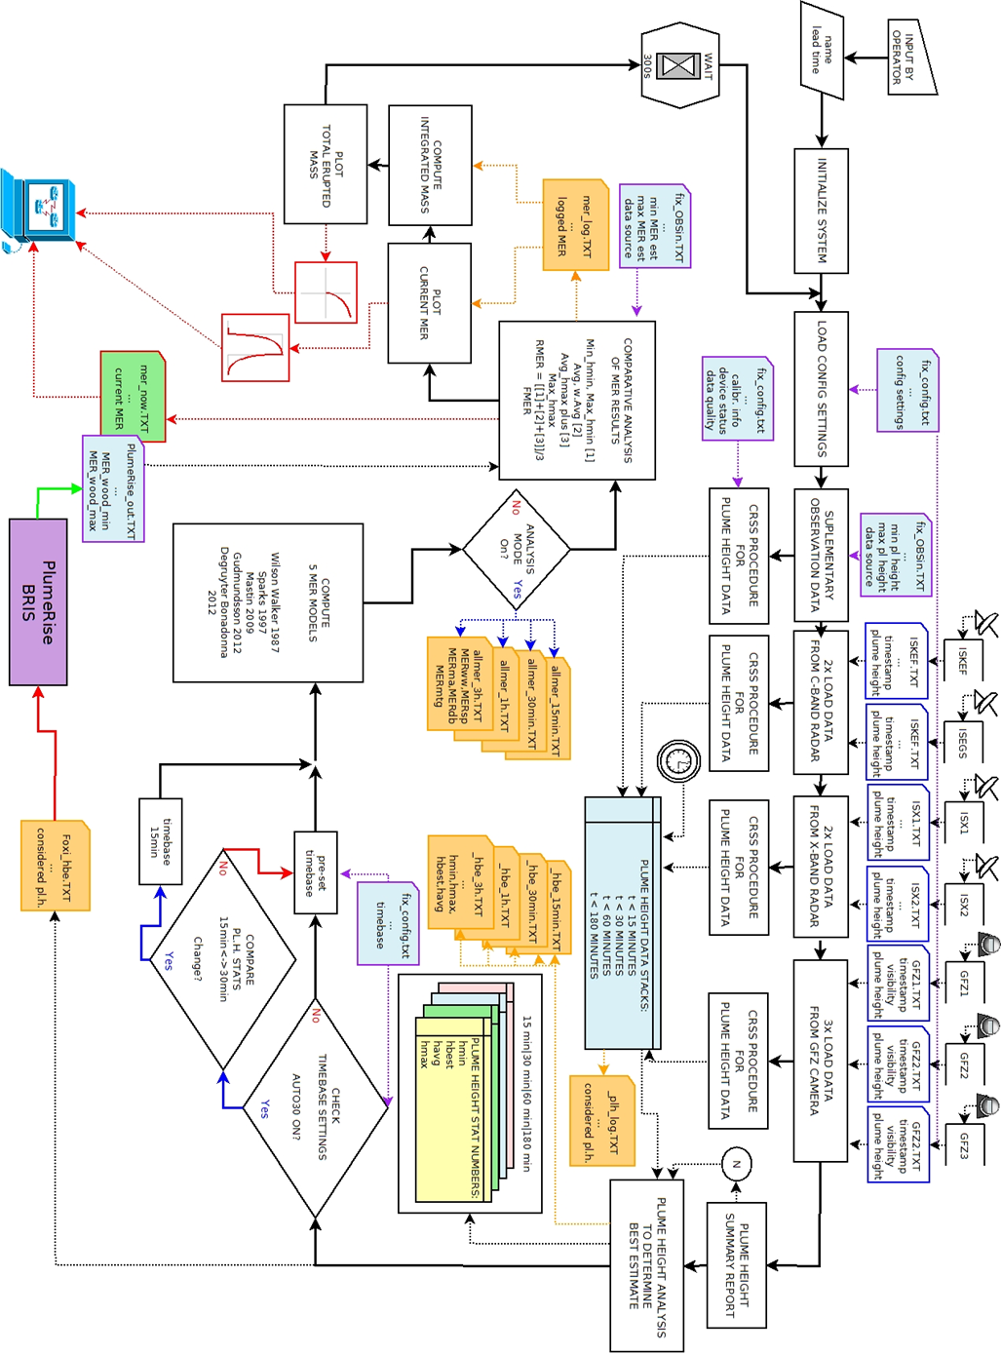

Appendix C: REFIR – Setup for Iceland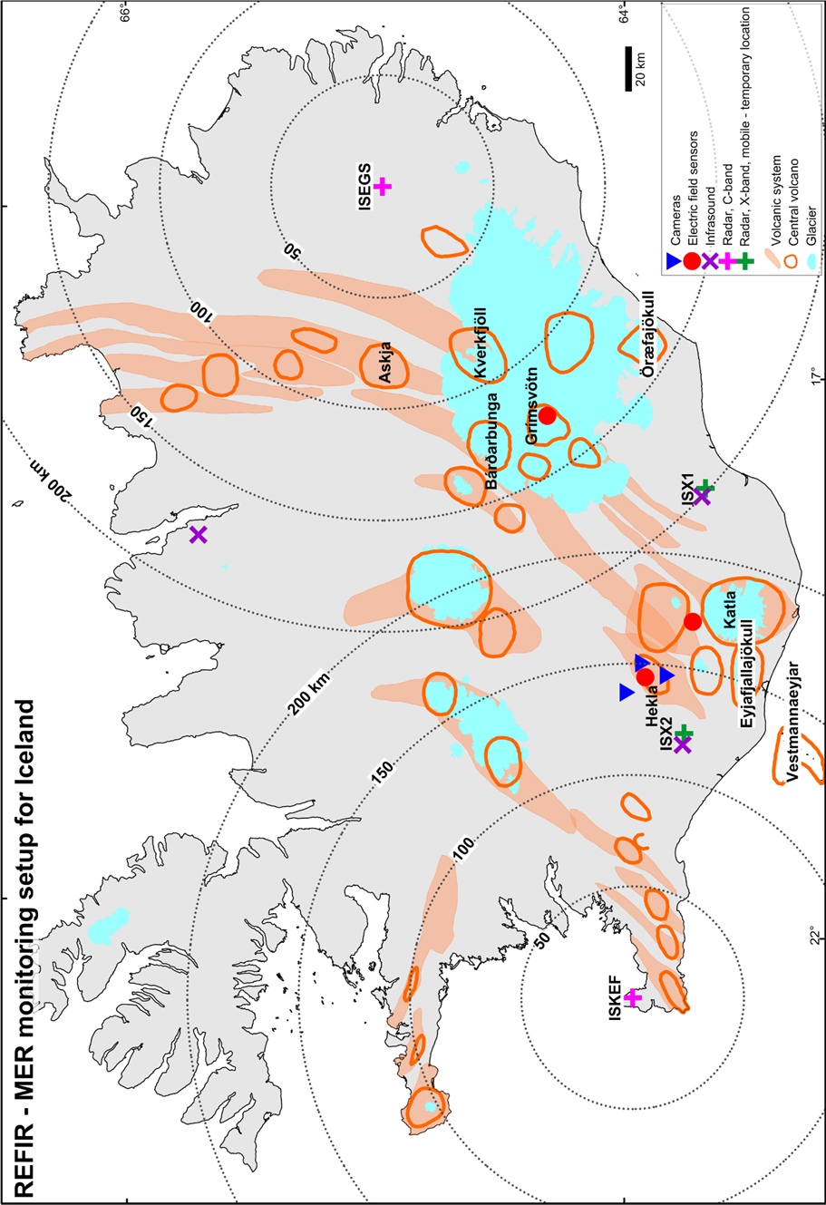

# Appendix D: Automatic plume tracking web-cameras at Hekla

In the current Icelandic “Futurevolc” setup, three automatic plume-tracking web-cameras from Mobotix (one modified D14D and two M14 web-cams) have been mounted, denoted CAM1 (located in Búrfell), CAM2 (located in in Rauðaskál) and CAM3 (located in in Mjóaskarð).

By using the camera control and communication software "MxCC" from Mobotix images are regularly downloaded to a server, where the frames are further processed by an in-house software in 3 steps:

First, the visibility is determined. For this purpose each downloaded image is compared to a reference frame taken at “best” visibility by computing the correlation coefficients between the brightness values of four fixed landmarks (one in the foreground and three at the visual slopes of Hekla). Since the correlation is reduced by darkness and bad weather conditions (such as rain, fog or clouds), a low correlation coefficient would indicate low visibility. The correlation coefficients are summed up and rounded, resulting in an integer value *y*, which ranges between 0 and 4. In REFIR, y is referred to as “visibility”. If *y* is 1 or larger, in the next step the plume height is determined by using a Sobel edge detection algorithm (see, e.g., Witt and Walter, 2017.) As a third step the velocities of visible features within the plume are assessed using a Matlab particle image velocimetry algorithm. (Note that the current version of REFIR (v. 18) does not make use of the latter function.)

For further details, the reader is referred to Witt (2018).

**References:**

Witt, T., Walter, T.R., 2017. Video monitoring reveals pulsating vents and propagation path of fissure eruption during the March 2011 Pu'u'Ō'ō eruption, Kilauea volcano. J. Volcanol. Geotherm. Res. 330, 43-55. DOI: 10.1016/j.jvolgeores.2016.11.012

Witt, T., 2018. Camera Monitoring at volcanoes: Identification and characterization of lava fountain activity and near-vent processes and their relevance for early warning systems. Deutsches GeoForschungsZentrum, Potsdam, PhD thesis (submitted 20-06-2018).

# Appendix E: Suggested settings for weight factors (FutureVolc setup)

Weight factor settings suggested for REFIR use in Iceland (with default FutureVolc configuration).

Upper row suggests ratio of the weight factors of the REFIR internal models in the following order:

**Wilson Walker : Sparks : Mastin : Gudmundsson : Degruyter & Bonadonna : Woodhouse 0D**

Lower row ratio in brackets provides suggestion for the weight factors

**[REFIR-internal models : PlumeRise (Woodhouse)]**

1Suffucient information: data available on magmatic temperature and atmospheric parameters.

|  |  |  |  |  |
| --- | --- | --- | --- | --- |
| plume | Information  available | Eruption magnitude | | |
| weak | medium | strong |
| vertical | few | 4:2:2:1:1:1  [6:1] | 4:2:2:1:1:1  [6:1] | 2:4:4:0:1:1  [6:1] |
| sufficient1 | 1:1:1:1:6  [1:5] | 1:1:1:1:6  [1:5] | 1:1:1:1:6  [1:5] |
| bent-over | few | 0:1:1:4:1  [5:1] | 1:1:1:6:1  [5:1] | 1:2:2:1:1  [5:1] |
| sufficient1 | 0:0:0:1:6  [1:5] | 0:1:1:3:6  [1:5] | 0:1:1:1:6  [1:5] |

# Appendix F: List of entries in a *_mer_LOG.txt

|  |  |  |  |  |  |
| --- | --- | --- | --- | --- | --- |
| **col.** | **entry** | **col.** | **entry** | **col.** | **entry** |
| 0 | time since start of e. | 44 | qual. fac. ISX1 | 88 | cal_ISX1_b |
| 1 | N | 45 | qual. fac. ISX2 | 89 | cal_ISX2_a |
| 2 | *havg* | 46 | qual. fac. GFZ1 | 90 | cal_ISX2_b |
| 3 | *Qabs.min* | 47 | qual. fac. GFZ2 | 91 | ISKEFm_on |
| 4 | *Qconv_upper* | 48 | qual. fac. GFZ3 | 92 | ISEGSm_on |
| 5 | MERWE | 49 | uncert ISKEF | 93 | ISX1m_on |
| 6 | MERMAX_PLUS | 50 | uncert ISEGS | 94 | ISX2m_on |
| 7 | *Qabs.max* | 51 | uncert ISX1 | 95 | hbe_min |
| 8 | w.fc. Wilson Walker | 52 | uncert ISX2 | 96 | hbe_max |
| 9 | w.fc. Sparks | 53 | vent height (m) | 97 | *Qmaxnowihmin* |
| 10 | w.fc. Mastin | 54 | ISKEF_on | 98 | *hmin 15min* |
| 11 | w.fc. Gudmundsson | 55 | ISEGS_on | 99 | *havg 15min* |
| 12 | w.fc. Degruyter Bon | 56 | ISX1_on | 100 | *hmax 15min* |
| 13 | *Q*Wilson Walker | 57 | ISX2_on | 101 | *hmin* 30min |
| 14 | *Q*Sparks | 58 | GFZ1_on | 102 | *havg* 30min |
| 15 | *Q*Mastin | 59 | GFZ2_on | 103 | *hmax* 30min |
| 16 | *Q*Gudmundsson | 60 | GFZ3_on | 104 | *hmin* 1h |
| 17 | *Q*Degruyter Bonadonna | 61 | analysis | 105 | *havg* 1h |
| 18 | *QCMER* | 62 | timebase | 106 | *hmax* 1h |
| 19 | *Qavg* | 63 | oo_exp | 107 | *hmin* 3h |
| 20 | *Q*Woodhouse min | 64 | oo_con | 108 | *havg* 3h |
| 21 | *Q*Woodhouse avg | 65 | *aexp* | 109 | *hmax* 3h |
| 22 | *Q*Woodhouse max | 66 | *aconv* | 110 | *Qlower* |
| 23 | OBS_on | 67 | *Qupper* | 111 | *Qexp_min* |
| 24 | theta_a0 | 68 | *aman* | 112 | *Qexp_wavg* |
| 25 | P_0 | 69 | min_manMER | 113 | *Qexp_max* |
| 26 | theta_0 | 70 | max_manMER | 114 | *Qman_min* |
| 27 | rho_dre | 71 | oo_wood | 115 | *Qman_wavg* |
| 28 | alpha | 72 | oo_5MER | 116 | *Qman_max* |
| 29 | beta | 73 | wtf_wood | 117 | *Qf_abs. min* |
| 30 | wtf_wil | 74 | wtf_5MER | 118 | *Qf_abs. max* |
| 31 | wtf_spa | 75 | oo_isound | 119 | *QFMER_min* |
| 32 | wtf_mas | 76 | wtf_isound | 120 | *QFMER* |
| 33 | wtf_mtg | 77 | oo_esens | 121 | *QFMER_max* |
| 34 | wtf_deg | 78 | wtf_esens | 122 | PlumeRadiusMin |
| 35 | H1 | 79 | oo_pulsan | 123 | PlumeRadiusMax |
| 36 | H2 | 80 | wtf_pulsan | 124 | empty slot (“-99”) |
| 37 | tempGrad_1 | 81 | oo_scatter | 125 | empty slot (“-99”) |
| 38 | tempGrad_2 | 82 | wtf_scatter | 126 | tiba |
| 39 | tempGrad_3 | 83 | cal_ISKEF_a | 127 | time of eruption start |
| 40 | Vmax | 84 | cal_ISKEF_b | 128 | Cband3_on |
| 41 | *kI* | 85 | cal_ISEGS_a | 129 | Cband4_on |
| 42 | qual. fac. ISKEF | 86 | cal_ISEGS_b | 130 | Cband5_on |
| 43 | qual. fac. ISEGS | 87 | cal_ISX1_a | 131 | Cband6_on |

|  |  |  |  |  |  |
| --- | --- | --- | --- | --- | --- |
| **col.** | **entry** | **col.** | **entry** | **col.** | **entry** |
| 132 | Xband3_on | 176 | qfak_Xband4 |  |  |
| 133 | Xband4_on | 177 | qfak_Xband5 |  |  |
| 134 | Xband5_on | 178 | qfak_Xband6 |  |  |
| 135 | Xband6_on | 179 | qfak_Cam4 |  |  |
| 136 | Cam4_on) | 180 | qfak_Cam5 |  |  |
| 137 | Cam5_on | 181 | qfak_Cam6 |  |  |
| 138 | Cam6_on |  |  |  |  |
| 139 | Cband3m_on |  |  |  |  |
| 140 | Cband4m_on |  |  |  |  |
| 141 | Cband5m_on |  |  |  |  |
| 142 | Cband6m_on |  |  |  |  |
| 143 | Xband3m_on |  |  |  |  |
| 144 | Xband4m_on |  |  |  |  |
| 145 | Xband5m_on |  |  |  |  |
| 146 | Xband6m_on |  |  |  |  |
| 147 | cal_Cband3a |  |  |  |  |
| 148 | cal_Cband3b |  |  |  |  |
| 149 | cal_Cband4a |  |  |  |  |
| 150 | cal_Cband4b |  |  |  |  |
| 151 | cal_Cband5a |  |  |  |  |
| 152 | cal_Cband5b |  |  |  |  |
| 153 | cal_Cband6a |  |  |  |  |
| 154 | cal_Cband6b |  |  |  |  |
| 155 | cal_Xband3a |  |  |  |  |
| 156 | cal_Xband3b |  |  |  |  |
| 157 | cal_Xband4a |  |  |  |  |
| 158 | cal_Xband4b |  |  |  |  |
| 159 | cal_Xband5a |  |  |  |  |
| 160 | cal_Xband5b |  |  |  |  |
| 161 | cal_Xband6a |  |  |  |  |
| 162 | cal_Xband6b |  |  |  |  |
| 163 | unc_Cband3 |  |  |  |  |
| 164 | unc_Cband4 |  |  |  |  |
| 165 | unc_Cband5 |  |  |  |  |
| 166 | unc_Cband6 |  |  |  |  |
| 167 | unc_Xband3 |  |  |  |  |
| 168 | unc_Xband4 |  |  |  |  |
| 169 | unc_Xband5 |  |  |  |  |
| 170 | unc_Xband6 |  |  |  |  |
| 171 | qfak_Cband3 |  |  |  |  |
| 172 | qfak_Cband4 |  |  |  |  |
| 173 | qfak_Cband5 |  |  |  |  |
| 174 | qfak_Cband6 |  |  |  |  |
| 175 | qfak_Xband3 |  |  |  |  |

# Appendix G: Example for a Status Report

ERUPTION SOURCE PARAMETER STATUS REPORT

==========================================

- - - - - output from Refir 19.0 - - - - -

+++ FUTUREVOLC EXERCISE! +++

<<<<<<<<<<<01/27/2016 19:10:00>>>>>>>>>>>>

>>> Plume Height Stats (a.v.) <<<

------------------------------------------

time frame: 60 min

tracked data N: 1

minimum pl.h.: 3300.0 m

best e. pl.h.: 4800.0 m

maximum pl.h.: 6300.0 m

>>> Mass Eruption Rate Stats <<<

------------------------------------------

minimum MER: 2.08e+04 kg/s

wt. average MER: 1.93e+05 kg/s

maximum MER: 7.49e+05 kg/s

>>> Best Estimate of Current MER <<<

==========================================

lower boundary: 5.64e+04 kg/s

*************

best est. MER: 1.93e+05 kg/s

*************

upper boundary: 4.57e+05 kg/s

==========================================

>>> Computed Total Erupted Mass <<<

------------------------------------------

lower boundary: 5.46e+10 kg

best e. total mass*: 1.57e+11 kg

upper boundary*: 2.54e+11 kg

--------------------------------------------------------------

==============================================================

*Note: Mass integrated only over monitored time period,

thus displayed numbers might be underestimates!

CAUTION !!

All values presented are automatically generated

>> PRELIMINARY RESULTS <<

and need to be confirmed by authorized staff!

==============================================================

FOXI vers.: 18.1 contact:Tobi Duerig

operator: TD tobi@hi.is

phone: +354 7838609

Institute of Earth Sciences

University of Iceland

# Appendix H: Notation

|  |  |  |
| --- | --- | --- |
| **Symbol** | **Description** | **Units** |
| $$\tilde{W_{s}}$$ | Calibrated dimensionless wind strength parameter | - |
| $$\overline{N}$$ | Plume height-averaged buoyancy frequency | s-1 |
|  | Plume height-averaged wind speed | s-1 |
|  | Dimensionless wind strength parameter | - |
| $$\dot{γ}$$ | Wind gradient from the base to the reference height | s-1 |
| *a* | Constant of the Gudmundsson 0D model | - |
| *bw* | Radar band width | m |
| *c* | Constant of the empirical MER models | varying |
| *d* | Distance from the vent | m |
| *fi* | Weight factor | - |
| *g* | Gravity acceleration | m s-2 |
| *g’* | Reduced gravity | m s-2 |
| *h* | Plume height | m |
| *H* | Plume centreline height | m |
| *H0* | Plume centreline height in a quiescent environment | m |
| *H1* | Reference height | m |
| *havg* | Best estimate of plume height | m |
| *hcal* | Calibrated plume height | m |
| *hmax* | Maximum estimate of plume height | m |
| *hmin* | Minimum estimate of plume height | m |
| *k1* | Scaling factor of Gudmundsson 0D model | - |
| *M* | Erupted mass | kg |
| *N* | Number of plume height data | - |
| *Q* | Source mass flux at the vent | kg s-1 |
| *Qabs.max* | Maximum of all MER model results fed by maximum plume heights *hmax*including Gudmundsson | kg s-1 |
| *Qabs.min* | Minimum of all MER model results (excluding Gudmundsson) fed by minimum plume heights *hmin* | kg s-1 |
| *Qavg* | Average of all MER model results fed by *havg* including Gudmundsson | kg s-1 |
| *QCMER* | The best MER estimate based on conventional models | kg s-1 |
| *Qexp_wavg* | Weighted averaged experimental MER | kg s-1 |
| *Qf_abs. max* | Maximum assumable MER calculated as the minimum of *Qabs.min,* *Qman_min* and *Qexp_min* | kg s-1 |
| *Qf_abs. min* | Lowest assumable MER calculated as the minimum of *Qabs.min,* *Qman_min* and *Qexp_min* | kg s-1 |
| *QFMER* | The weighted-average best MER estimate (FMER) suggested by FOXI | kg s-1 |
| *QFMER_max* | The upper boundary of the range of best MER estimates (FMER) suggested by FOXI | kg s-1 |
| *QFMER_min* | The lower boundary of the range of best MER estimates (FMER) suggested by FOXI | kg s-1 |
| *Qlower* | Minimum of the four values given by *Qmaxhmin*, *Qmaxnowihmin* and by the wind-affected model Degruyter & Bonadonna and Woodhouse 0D | kg s-1 |
| *Qman_max* | Maximum of manually-added MER | kg s-1 |
| *Qman_min* | Minimum averaged manually-added MER | kg s-1 |
| *Qman_wavg* | Weighted averaged manually-added MER | kg s-1 |
| *Qmaxhmin* | Maximum of all MER (excluding Gudmundsson) models fed by *hmin* | kg s-1 |
| *Qmaxnowihmin* | Minimum value of the maximum of the three “non-wind-affected” models Wilson Walker, Sparks and Mastin, fed by *hmin* | kg s-1 |
| *Qmodel* | Model-specific MER | kg s-1 |
| *QRMER* | The best MER estimate based on REFIR-internal models | kg s-1 |
| *Qupper* | Weighted average of all MER models fed by *hmax* | kg s-1 |
| *Qwavg* | Weighted average of all MER model results fed by *havg* including Gudmundsson | kg s-1 |
| *s* | Combined error of plume height estimation | m |
| *wi* | Weight factor of the MER models | - |
| *z1* | Maximum non-dimensional height of buoyant plumes by Morton et al. (1956) | - |
| *α* | Radial entrainment coefficient | - |
| *β* | Wind entrainment coefficient | - |
| *Δh* | Plume height uncertainty | m |
| $$Π$$ | Wind effect parameter | - |
| *ρ* | DRE of magma erupted | kg m-3 |
| *ρa0* | Atmospheric reference density | kg m-3 |